Lampiran 1
Sampel Penelitian
NO. | KODE | NAMA PERUSAHAAN
1 | ADES | Akasha Wira International Tbk
2 | AISA | Tiga Pilar Sejahtera Food Tbk
3 | CEKA | Wilmar Cahaya Indonesia Tbk
4 | DVLA | Darya Varia Laboratoria Tbk
5 | GGRM | Gudang Garam Tbk
6 | ICBP | Indofood CBP Sukses Makmur Tbk
7 | INDF | Indofood Sukses Makmur Tbk
8 | KAEF | Kimia Farma (Persero) Tbk
9 | KLBF | Kalbe Farma Tbk
10 | MLBI | Multi Bintang Indonesia Tbk
11 | PYFA | Pyridam Farma Tbk
12 | ROTI | Nippon Indosari Corporindo Tbk
13 | SKLT | Sekar Laut Tbk
14 | STTP | Siantar Top Tbk
15 | TCID | Mandom Indonesia Tbk
16 | TSPC | Tempo Scan Pasific Tbk
17 | ULTJ | Ultrajaya Milk Industry and Trading Company Tbk
18 | UNVR | Unilever Indonesia Tbk
19 | WIIM | Wismilak Inti Makmur Tbk

Lampiran 2
Data dan atau Instrumen Alat Pengukuran

Tahun 2014
No. | KODE | 2014
 |  | CR (X) | DER (X) | ROA (X) | PER (X) | RS (X)
1 | ADES | 1.54 | 0.71 | 0.06 | 23.94 | -0.31
2 | AISA | 2.66 | 1.05 | 0.05 | 20.48 | 0.47
3 | CEKA | 1.47 | 1.39 | 0.03 | 22.6 | 1.59
4 | DVLA | 5.18 | 0.28 | 0.06 | 23.39 | -0.23
5 | GGRM | 1.62 | 0.75 | 0.09 | 21.67 | 0.45
6 | ICBP | 2.18 | 0.66 | 0.10 | 27.67 | 0.28
7 | INDF | 1.81 | 1.08 | 0.06 | 14.67 | 0.02
8 | KAEF | 2.39 | 0.64 | 0.08 | 42.43 | 1.48
9 | KLBF | 3.40 | 0.27 | 0.17 | 43.27 | 0.46
10 | MLBI | 0.51 | 3.03 | 0.36 | 37.72 | 0
11 | PYFA | 1.63 | 0.79 | 1.54 | 27.18 | -0.08
12 | ROTI | 1.37 | 1.23 | 0.09 | 39.93 | 0.36
13 | SKLT | 1.18 | 1.16 | 0.05 | 10.29 | 0.67
14 | STTP | 1.48 | 1.08 | 0.07 | 30.54 | 0.86
15 | TCID | 1.80 | 0.44 | 0.09 | 17.44 | 0.47
16 | TSPC | 3.00 | 0.35 | 0.10 | 17.66 | -0.12
17 | ULTJ | 3.34 | 0.29 | 0.10 | 39.09 | -0.17
18 | UNVR | 0.71 | 2.11 | 0.40 | 45.65 | 0.24
19 | WIIM | 2.27 | 0.56 | 0.08 | 12.3 | -0.07

Lanjutan Lampiran 2
Data dan atau Instrumen Alat Pengukuran

Tahun 2015
No. | KODE | 2015
 |  | CR (X) | DER (X) | ROA (X) | PER (X) | RS (X)
1 | ADES | 1.39 | 0.99 | 0.05 | 18.23 | -0.26
2 | AISA | 1.62 | 1.28 | 0.04 | 12.04 | -0.42
3 | CEKA | 1.53 | 1.32 | 0.07 | 3.77 | -0.55
4 | DVLA | 3.52 | 0.41 | 0.08 | 13.49 | -0.23
5 | GGRM | 1.77 | 0.67 | 0.10 | 16.44 | -0.09
6 | ICBP | 2.33 | 0.62 | 0.11 | 26.18 | 0.03
7 | INDF | 1.71 | 1.13 | 0.04 | 15.31 | -0.23
8 | KAEF | 1.93 | 0.74 | 0.08 | 19.42 | -0.41
9 | KLBF | 3.70 | 0.25 | 0.15 | 30.87 | -0.28
10 | MLBI | 0.58 | 1.74 | 0.24 | 21.69 | -0.31
11 | PYFA | 1.99 | 0.58 | 0.02 | 14.53 | -0.17
12 | ROTI | 2.05 | 1.28 | 0.10 | 23.67 | -0.09
13 | SKLT | 1.19 | 1.48 | 0.05 | 12.52 | 0.23
14 | STTP | 1.58 | 0.90 | 0.10 | 21.26 | 0.05
15 | TCID | 4.99 | 0.21 | 0.26 | 6.09 | -0.06
16 | TSPC | 2.54 | 0.45 | 0.08 | 15.09 | -0.39
17 | ULTJ | 3.75 | 0.27 | 0.15 | 21.95 | 0.06
18 | UNVR | 0.65 | 2.26 | 0.37 | 48.24 | 0.15
19 | WIIM | 2.89 | 0.42 | 0.10 | 6.90 | -0.31

Lanjutan Lampiran 2
Data dan atau Instrumen Alat Pengukuran

Tahun 2016
No. | KODE | 2016
 |  | CR (X) | DER (X) | ROA (X) | PER (X) | RS (X)
1 | ADES | 1.64 | 1.00 | 0.07 | 13.91 | -0.01
2 | AISA | 2.38 | 1.17 | 0.08 | 13.61 | 0.61
3 | CEKA | 2.19 | 0.61 | 0.18 | 0 | 1.00
4 | DVLA | 2.85 | 0.42 | 0.10 | 10.73 | 0.35
5 | GGRM | 1.94 | 0.59 | 0.11 | 20.04 | 0.16
6 | ICBP | 2.41 | 0.56 | 0.13 | 26.48 | 0.27
7 | INDF | 1.51 | 0.87 | 0.06 | 16.11 | 0.53
8 | KAEF | 1.71 | 1.03 | 0.06 | 65.90 | 2.16
9 | KLBF | 4.13 | 0.22 | 0.15 | 31.28 | 0.15
10 | MLBI | 0.68 | 1.77 | 0.43 | 27.35 | 0.43
11 | PYFA | 2.19 | 0.58 | 0.03 | 20.79 | 0.79
12 | ROTI | 2.96 | 1.02 | 0.10 | 19.88 | 0.26
13 | SKLT | 1.32 | 0.92 | 0.04 | 10.63 | -0.17
14 | STTP | 1.65 | 1.00 | 0.07 | 30.28 | 0.06
15 | TCID | 5.26 | 0.23 | 0.07 | 13.07 | -0.24
16 | TSPC | 2.65 | 0.42 | 0.08 | 14.50 | 0.13
17 | ULTJ | 4.84 | 0.21 | 0.17 | 18.12 | 0.16
18 | UNVR | 0.61 | 2.56 | 0.38 | 46.74 | 0.05
19 | WIIM | 3.39 | 0.37 | 0.08 | 8.77 | 0.02

Lanjutan Lampiran 2
Data dan atau Instrumen Alat Pengukuran

Tahun 2017
No. | KODE | 2017
 |  | CR (X) | DER (X) | ROA (X) | PER (X) | RS (X)
1 | ADES | 1.20 | 0.99 | 0.05 | 16.90 | -0.12
2 | AISA | 1.16 | 1.56 | -0.10 | 6.62 | -0.76
3 | CEKA | 2.22 | 0.54 | 0.08 | 7.15 | -0.04
4 | DVLA | 2.66 | 0.47 | 0.10 | 9.55 | 0.12
5 | GGRM | 1.94 | 0.58 | 0.12 | 22.32 | 0.31
6 | ICBP | 2.43 | 0.56 | 0.11 | 27.34 | 0.04
7 | INDF | 1.50 | 0.88 | 0.06 | 16.06 | -0.04
8 | KAEF | 1.55 | 1.37 | 0.05 | 45.89 | -0.02
9 | KLBF | 4.51 | 0.20 | 0.15 | 33.39 | 0.12
10 | MLBI | 0.83 | 1.36 | 0.53 | 21.80 | 0.16
11 | PYFA | 3.52 | 0.47 | 0.04 | 13.74 | -0.09
12 | ROTI | 2.26 | 0.62 | 0.03 | 60.77 | -0.20
13 | SKLT | 1.26 | 1.07 | 0.04 | 34.79 | 2.57
14 | STTP | 2.64 | 0.69 | 0.09 | 25.70 | 0.37
15 | TCID | 4.91 | 0.27 | 0.08 | 20.09 | 0.43
16 | TSPC | 2.52 | 0.46 | 0.08 | 13.77 | -0.09
17 | ULTJ | 4.19 | 0.23 | 0.14 | 17.51 | 0.13
18 | UNVR | 0.63 | 2.65 | 0.37 | 60.89 | 0.44
19 | WIIM | 5.36 | 0.25 | 0.03 | 17.19 | -0.34

Lampiran 3
Hasil Pengolahan Data

- Statistik Desktiptif

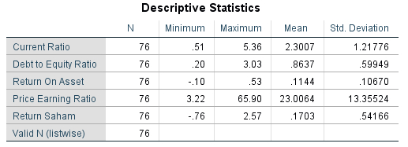

- Uji Normalitas

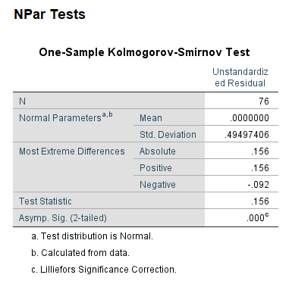

Lanjutan Lampiran 3
Hasil Pengolahan Data

- Uji Multikolinearitas

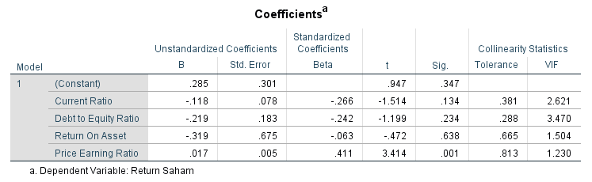

- Uji Heterokedastisitas

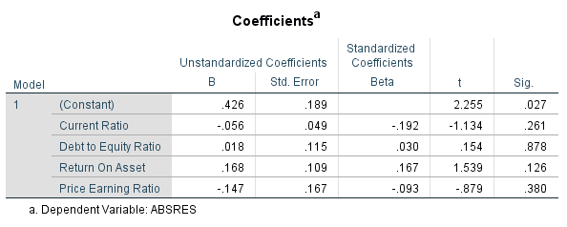

Lanjutan Lampiran 3
Hasil Pengolahan Data

- Uji Autokorelasi

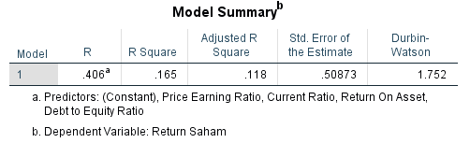

- Koefisien Determinasi (R²)

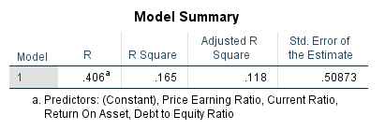

Lanjutan Lam piran 3
Hasil Pengolahan Data

- Uji F
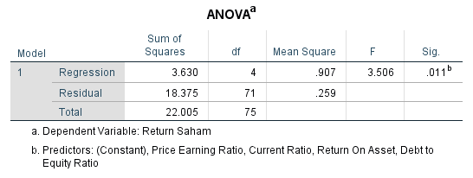

- Uji t

