Lampiran 1 :Kuesioner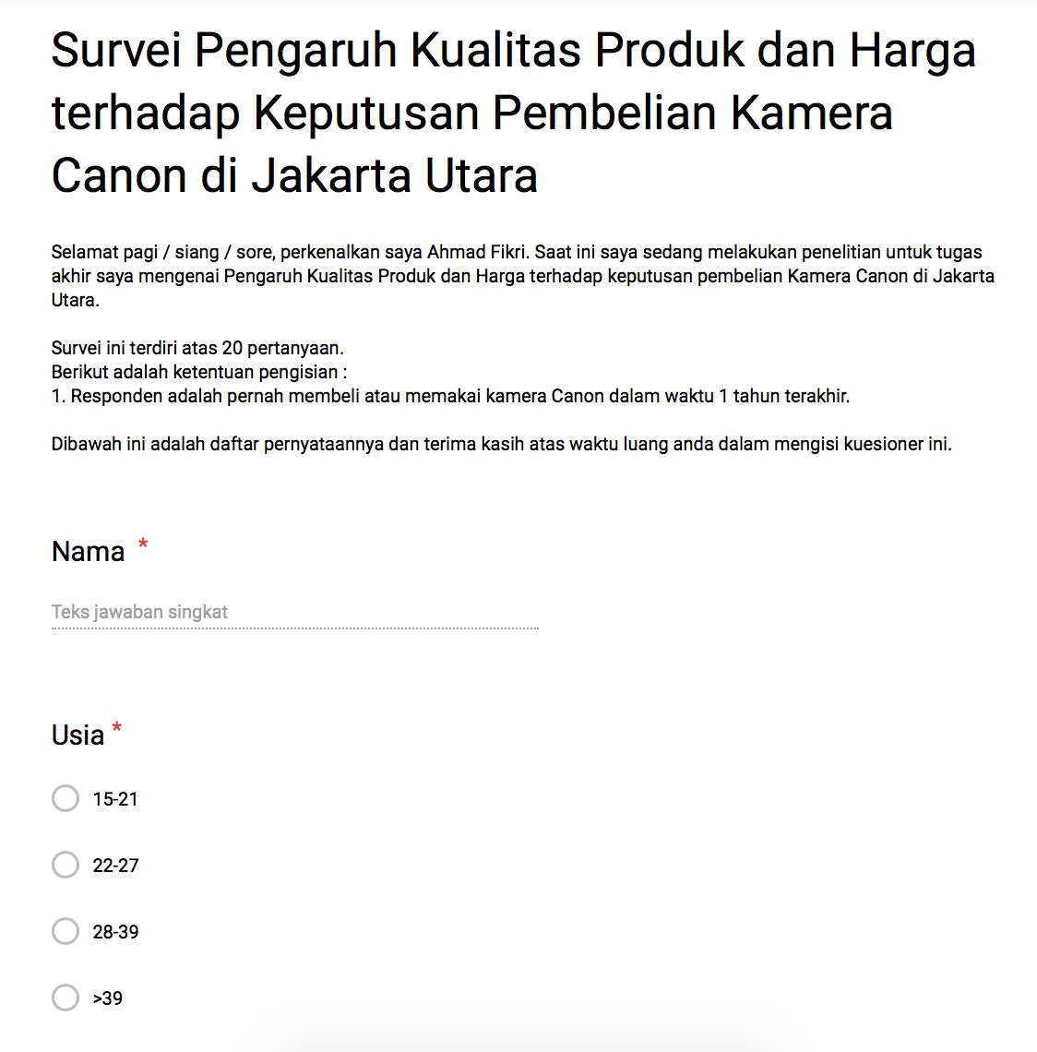
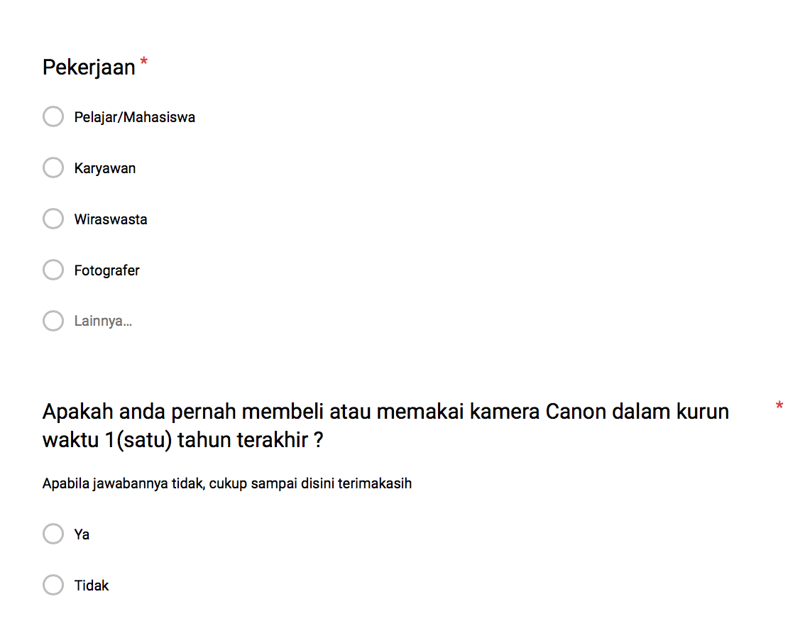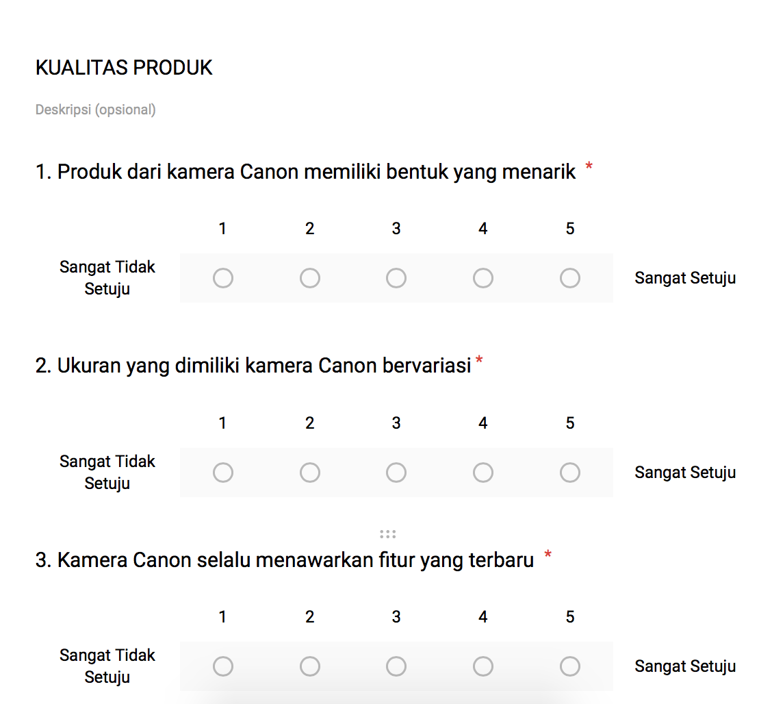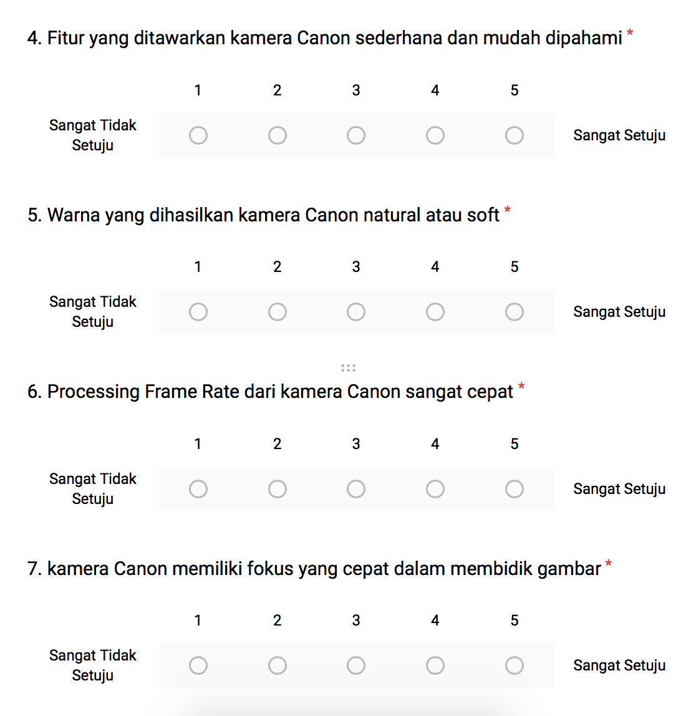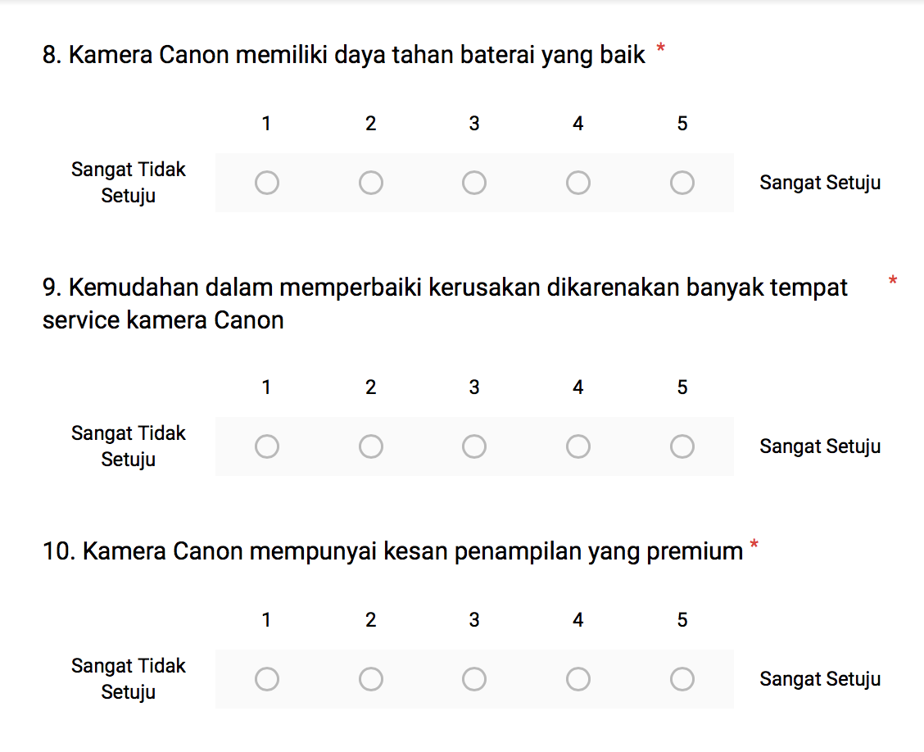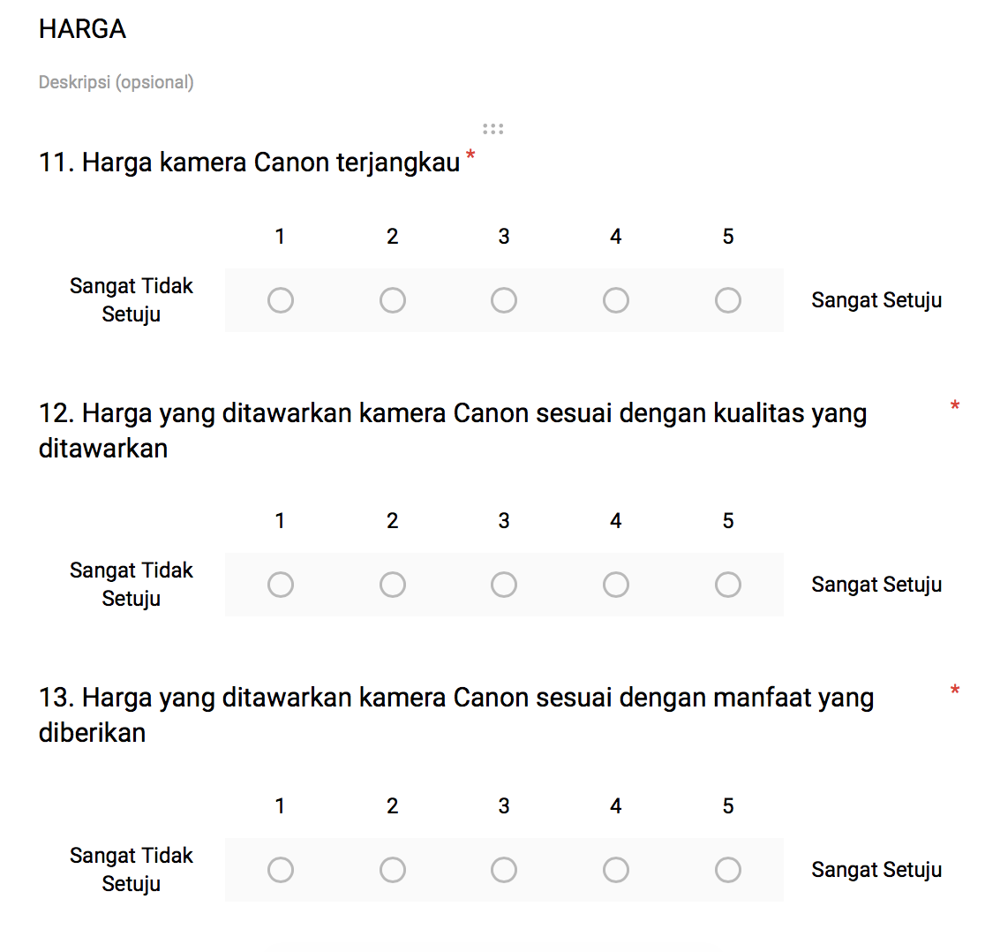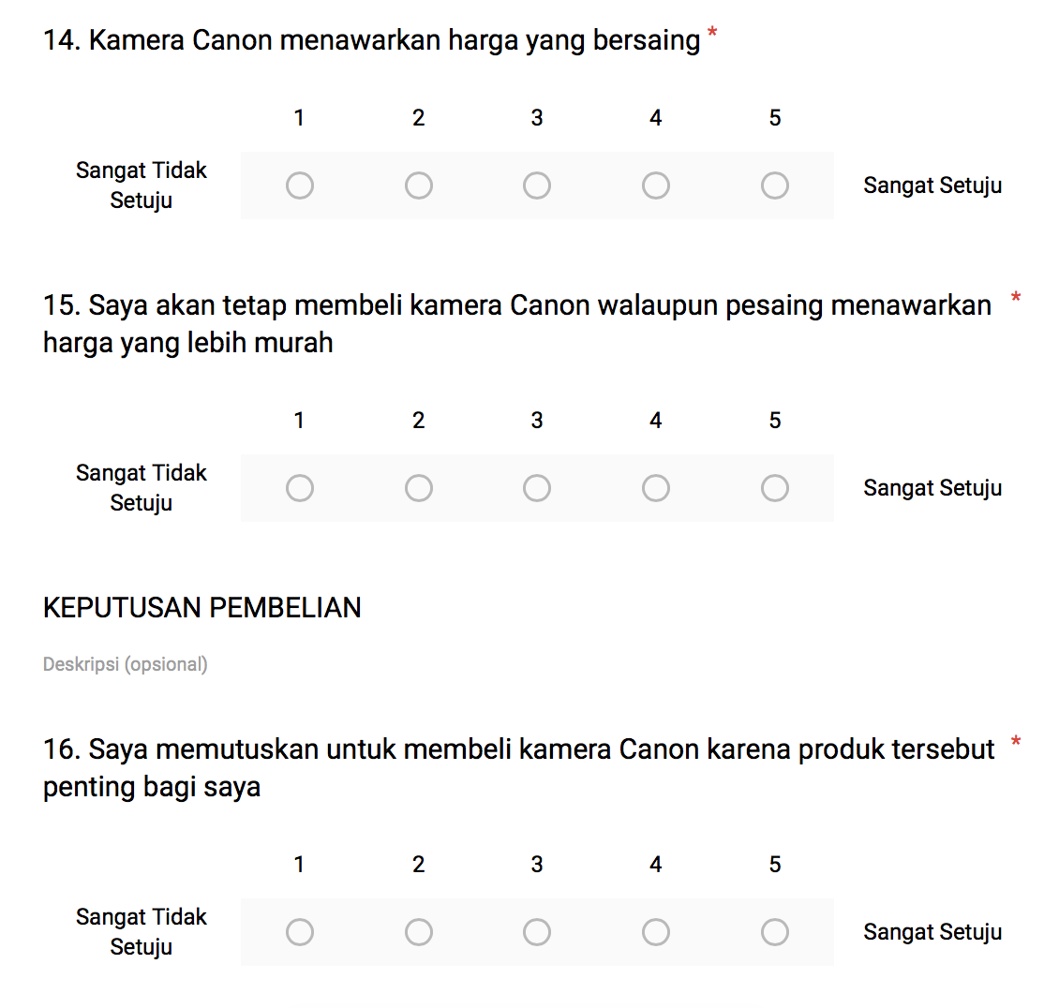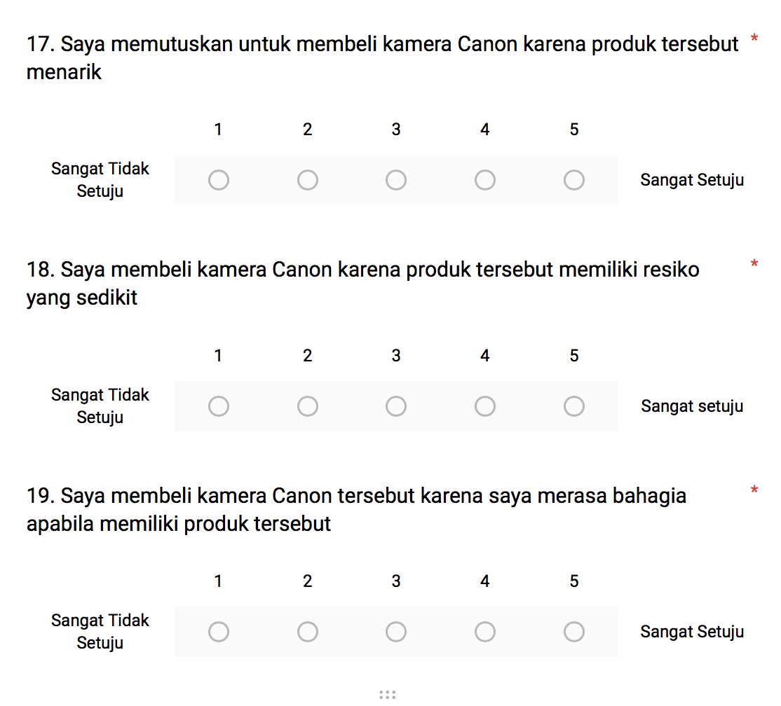

Lampiran 2: Jawaban Responden
 | Kualitas Produk |  |  |  |  |  |  |  |  |  | Persepsi Harga |  |  |  |  | Keputusan Pembelian
NO | x1a | X1b | X1c | X1d | X1e | X1f | X1g | X1h | X1i | X1j | X2a | X2b | X2c | X2d | X2e | Ya | Yb | Yc | Yd | Ye
1 | 5 | 5 | 5 | 5 | 5 | 4 | 4 | 5 | 5 | 5 | 5 | 5 | 5 | 5 | 2 | 4 | 3 | 3 | 3 | 3
2 | 2 | 2 | 2 | 2 | 3 | 2 | 2 | 3 | 2 | 2 | 2 | 2 | 2 | 2 | 1 | 2 | 2 | 2 | 1 | 2
3 | 5 | 5 | 5 | 4 | 5 | 5 | 5 | 5 | 5 | 5 | 3 | 5 | 5 | 5 | 5 | 5 | 5 | 5 | 5 | 5
4 | 5 | 5 | 5 | 5 | 5 | 5 | 5 | 5 | 5 | 5 | 4 | 5 | 4 | 5 | 5 | 5 | 5 | 5 | 5 | 5
5 | 2 | 3 | 2 | 3 | 4 | 3 | 3 | 3 | 3 | 2 | 2 | 3 | 3 | 3 | 1 | 2 | 2 | 4 | 1 | 1
6 | 3 | 4 | 4 | 4 | 3 | 3 | 3 | 3 | 4 | 3 | 4 | 4 | 4 | 3 | 2 | 2 | 3 | 3 | 3 | 3
7 | 3 | 3 | 3 | 5 | 1 | 3 | 3 | 3 | 3 | 5 | 5 | 5 | 5 | 5 | 3 | 3 | 3 | 1 | 3 | 5
8 | 2 | 5 | 3 | 4 | 5 | 1 | 1 | 3 | 3 | 2 | 3 | 3 | 3 | 3 | 1 | 1 | 3 | 3 | 1 | 1
9 | 3 | 3 | 3 | 3 | 3 | 3 | 3 | 3 | 3 | 3 | 3 | 3 | 3 | 3 | 3 | 3 | 3 | 3 | 3 | 3
10 | 4 | 4 | 4 | 4 | 4 | 4 | 4 | 4 | 4 | 4 | 4 | 4 | 4 | 4 | 4 | 4 | 4 | 4 | 4 | 5
11 | 5 | 5 | 5 | 4 | 5 | 5 | 5 | 5 | 5 | 5 | 2 | 3 | 3 | 5 | 5 | 5 | 4 | 4 | 3 | 3
12 | 4 | 5 | 4 | 5 | 5 | 4 | 4 | 5 | 5 | 4 | 5 | 4 | 5 | 3 | 4 | 3 | 3 | 5 | 4 | 3
13 | 4 | 5 | 5 | 5 | 5 | 5 | 5 | 5 | 5 | 4 | 4 | 5 | 5 | 5 | 5 | 4 | 4 | 4 | 4 | 4
14 | 5 | 5 | 5 | 5 | 5 | 5 | 5 | 5 | 5 | 5 | 5 | 5 | 5 | 5 | 5 | 5 | 5 | 5 | 5 | 5
15 | 3 | 4 | 4 | 4 | 3 | 4 | 4 | 4 | 4 | 3 | 3 | 4 | 4 | 4 | 3 | 4 | 4 | 3 | 4 | 4
16 | 5 | 4 | 5 | 4 | 3 | 5 | 5 | 5 | 5 | 5 | 3 | 3 | 5 | 4 | 4 | 5 | 5 | 5 | 4 | 5
17 | 3 | 4 | 4 | 4 | 3 | 3 | 3 | 3 | 4 | 3 | 4 | 4 | 3 | 3 | 3 | 3 | 3 | 3 | 3 | 3
18 | 5 | 5 | 5 | 5 | 5 | 5 | 5 | 5 | 5 | 5 | 5 | 4 | 5 | 5 | 5 | 4 | 5 | 5 | 4 | 5
19 | 4 | 4 | 4 | 4 | 4 | 4 | 4 | 4 | 4 | 4 | 2 | 4 | 3 | 3 | 4 | 4 | 4 | 4 | 5 | 3
20 | 4 | 5 | 4 | 5 | 3 | 3 | 4 | 4 | 5 | 4 | 5 | 4 | 4 | 4 | 4 | 3 | 4 | 3 | 4 | 3
21 | 5 | 4 | 4 | 4 | 5 | 5 | 5 | 5 | 3 | 4 | 4 | 4 | 4 | 3 | 3 | 4 | 4 | 4 | 4 | 3
22 | 4 | 5 | 5 | 4 | 3 | 4 | 4 | 5 | 4 | 5 | 2 | 4 | 5 | 3 | 4 | 4 | 5 | 3 | 4 | 4
23 | 4 | 5 | 3 | 3 | 4 | 4 | 3 | 4 | 4 | 5 | 3 | 4 | 4 | 4 | 4 | 3 | 4 | 4 | 3 | 3
24 | 3 | 2 | 1 | 3 | 1 | 4 | 3 | 4 | 4 | 2 | 2 | 3 | 2 | 3 | 2 | 3 | 2 | 3 | 3 | 3
25 | 3 | 4 | 4 | 5 | 4 | 3 | 3 | 3 | 5 | 2 | 5 | 5 | 5 | 5 | 1 | 3 | 3 | 4 | 4 | 3
26 | 4 | 4 | 4 | 5 | 4 | 4 | 4 | 4 | 4 | 4 | 3 | 5 | 5 | 4 | 4 | 4 | 4 | 4 | 5 | 4
27 | 5 | 5 | 5 | 4 | 5 | 5 | 5 | 5 | 5 | 5 | 5 | 5 | 5 | 5 | 5 | 5 | 5 | 5 | 5 | 5
28 | 4 | 5 | 4 | 3 | 3 | 4 | 4 | 5 | 5 | 4 | 2 | 5 | 5 | 3 | 5 | 5 | 4 | 3 | 3 | 2
29 | 5 | 4 | 4 | 3 | 4 | 5 | 4 | 4 | 4 | 5 | 3 | 4 | 4 | 4 | 3 | 4 | 4 | 4 | 5 | 4
30 | 3 | 5 | 1 | 3 | 3 | 3 | 3 | 3 | 4 | 3 | 3 | 2 | 2 | 3 | 1 | 1 | 2 | 2 | 1 | 2
31 | 3 | 3 | 4 | 4 | 3 | 3 | 3 | 4 | 3 | 4 | 3 | 3 | 3 | 3 | 3 | 3 | 4 | 3 | 4 | 4
32 | 3 | 3 | 3 | 4 | 4 | 3 | 4 | 4 | 3 | 3 | 3 | 4 | 3 | 4 | 2 | 4 | 4 | 3 | 3 | 3
33 | 3 | 3 | 3 | 3 | 4 | 3 | 4 | 3 | 3 | 4 | 3 | 4 | 3 | 3 | 3 | 3 | 3 | 4 | 3 | 3
34 | 3 | 3 | 4 | 3 | 5 | 4 | 4 | 5 | 4 | 4 | 4 | 4 | 4 | 4 | 3 | 4 | 4 | 4 | 4 | 4
35 | 3 | 4 | 3 | 5 | 3 | 3 | 4 | 3 | 3 | 3 | 3 | 4 | 3 | 3 | 4 | 4 | 4 | 4 | 1 | 2
36 | 3 | 4 | 4 | 4 | 5 | 4 | 5 | 4 | 4 | 3 | 3 | 3 | 4 | 4 | 4 | 4 | 4 | 5 | 4 | 4
37 | 5 | 5 | 5 | 5 | 5 | 5 | 5 | 5 | 5 | 5 | 5 | 5 | 5 | 5 | 5 | 5 | 5 | 5 | 5 | 5
38 | 4 | 4 | 4 | 5 | 5 | 4 | 5 | 4 | 5 | 5 | 4 | 4 | 4 | 4 | 4 | 4 | 5 | 4 | 4 | 4
39 | 4 | 4 | 4 | 4 | 4 | 4 | 4 | 4 | 3 | 3 | 3 | 3 | 3 | 4 | 3 | 3 | 4 | 3 | 4 | 3
40 | 4 | 4 | 5 | 5 | 4 | 4 | 4 | 5 | 5 | 4 | 4 | 4 | 5 | 5 | 5 | 5 | 5 | 5 | 4 | 4
41 | 4 | 4 | 5 | 4 | 4 | 4 | 3 | 3 | 4 | 4 | 3 | 4 | 5 | 4 | 3 | 4 | 5 | 4 | 5 | 4
42 | 4 | 3 | 3 | 3 | 4 | 4 | 3 | 4 | 3 | 3 | 3 | 3 | 3 | 3 | 3 | 3 | 3 | 3 | 3 | 3
43 | 4 | 4 | 4 | 5 | 4 | 3 | 4 | 4 | 4 | 4 | 4 | 4 | 4 | 4 | 3 | 3 | 3 | 3 | 3 | 3
44 | 5 | 2 | 5 | 5 | 5 | 4 | 3 | 5 | 5 | 5 | 5 | 5 | 5 | 5 | 5 | 5 | 5 | 5 | 5 | 5
45 | 3 | 4 | 4 | 4 | 4 | 4 | 3 | 3 | 4 | 5 | 3 | 4 | 4 | 3 | 3 | 2 | 2 | 2 | 2 | 1
46 | 4 | 4 | 4 | 4 | 5 | 4 | 4 | 5 | 3 | 5 | 4 | 4 | 4 | 4 | 3 | 4 | 4 | 4 | 3 | 3
47 | 4 | 4 | 5 | 4 | 4 | 4 | 5 | 5 | 3 | 4 | 3 | 4 | 4 | 4 | 3 | 3 | 4 | 4 | 4 | 3
48 | 3 | 5 | 4 | 3 | 3 | 4 | 3 | 3 | 3 | 5 | 3 | 5 | 5 | 4 | 4 | 3 | 3 | 3 | 4 | 4
49 | 4 | 4 | 4 | 5 | 4 | 5 | 4 | 5 | 4 | 5 | 5 | 4 | 4 | 5 | 4 | 5 | 4 | 5 | 3 | 4
50 | 4 | 4 | 4 | 4 | 3 | 3 | 3 | 3 | 3 | 3 | 4 | 4 | 4 | 4 | 2 | 3 | 4 | 3 | 3 | 3
51 | 3 | 3 | 4 | 4 | 5 | 3 | 4 | 3 | 4 | 3 | 5 | 4 | 3 | 3 | 2 | 4 | 3 | 4 | 3 | 4
52 | 3 | 4 | 3 | 3 | 3 | 3 | 3 | 3 | 3 | 2 | 3 | 3 | 3 | 3 | 3 | 2 | 2 | 2 | 2 | 2
53 | 4 | 4 | 5 | 5 | 5 | 4 | 4 | 5 | 5 | 4 | 5 | 5 | 5 | 4 | 5 | 5 | 5 | 4 | 5 | 4
54 | 2 | 3 | 3 | 4 | 3 | 3 | 2 | 4 | 3 | 2 | 3 | 3 | 3 | 4 | 1 | 1 | 2 | 3 | 3 | 3
55 | 4 | 5 | 3 | 5 | 5 | 4 | 4 | 5 | 5 | 3 | 4 | 5 | 4 | 5 | 4 | 5 | 5 | 5 | 3 | 4
56 | 3 | 2 | 4 | 4 | 4 | 3 | 4 | 4 | 5 | 3 | 3 | 4 | 4 | 4 | 4 | 3 | 2 | 4 | 2 | 2
57 | 2 | 3 | 4 | 5 | 4 | 3 | 2 | 4 | 5 | 4 | 3 | 5 | 5 | 5 | 5 | 5 | 4 | 5 | 5 | 5
58 | 4 | 4 | 4 | 4 | 4 | 4 | 4 | 4 | 4 | 4 | 3 | 3 | 3 | 3 | 3 | 4 | 4 | 4 | 4 | 4
59 | 4 | 4 | 5 | 5 | 5 | 5 | 5 | 4 | 4 | 5 | 3 | 3 | 4 | 3 | 3 | 3 | 4 | 3 | 3 | 4
60 | 4 | 5 | 5 | 3 | 4 | 5 | 5 | 3 | 3 | 3 | 2 | 5 | 5 | 3 | 3 | 2 | 3 | 1 | 3 | 3
61 | 5 | 3 | 4 | 5 | 5 | 5 | 5 | 5 | 5 | 5 | 3 | 3 | 4 | 1 | 1 | 3 | 3 | 4 | 2 | 4
62 | 5 | 4 | 4 | 4 | 4 | 4 | 4 | 4 | 4 | 4 | 4 | 4 | 4 | 4 | 4 | 4 | 3 | 3 | 4 | 4
63 | 4 | 4 | 5 | 4 | 4 | 4 | 5 | 5 | 5 | 4 | 4 | 5 | 5 | 4 | 4 | 4 | 4 | 4 | 4 | 3
64 | 3 | 4 | 4 | 4 | 4 | 4 | 4 | 4 | 5 | 5 | 4 | 4 | 4 | 4 | 4 | 4 | 4 | 4 | 4 | 4
65 | 3 | 4 | 4 | 3 | 4 | 4 | 4 | 4 | 3 | 4 | 3 | 3 | 3 | 4 | 2 | 4 | 2 | 2 | 2 | 2
66 | 4 | 5 | 5 | 3 | 3 | 3 | 4 | 4 | 4 | 4 | 3 | 2 | 4 | 4 | 3 | 2 | 4 | 3 | 3 | 3
67 | 4 | 3 | 5 | 2 | 3 | 3 | 3 | 3 | 4 | 5 | 2 | 4 | 4 | 4 | 4 | 3 | 2 | 4 | 3 | 2
68 | 4 | 4 | 4 | 5 | 5 | 4 | 4 | 5 | 5 | 4 | 4 | 4 | 4 | 4 | 3 | 3 | 3 | 3 | 4 | 4
69 | 3 | 5 | 4 | 4 | 4 | 4 | 4 | 4 | 4 | 4 | 2 | 3 | 4 | 4 | 3 | 4 | 4 | 4 | 4 | 4
70 | 4 | 5 | 5 | 3 | 3 | 4 | 4 | 5 | 4 | 5 | 5 | 4 | 3 | 4 | 2 | 2 | 3 | 4 | 2 | 2
71 | 4 | 4 | 5 | 5 | 4 | 4 | 4 | 5 | 5 | 4 | 4 | 4 | 5 | 5 | 5 | 5 | 5 | 5 | 4 | 4
72 | 5 | 4 | 3 | 4 | 5 | 3 | 4 | 2 | 5 | 3 | 3 | 4 | 3 | 5 | 2 | 4 | 5 | 4 | 5 | 2
73 | 3 | 3 | 3 | 3 | 3 | 3 | 4 | 3 | 4 | 3 | 3 | 3 | 3 | 3 | 4 | 3 | 3 | 3 | 4 | 3
74 | 5 | 5 | 5 | 4 | 5 | 5 | 5 | 5 | 5 | 5 | 5 | 4 | 5 | 5 | 5 | 4 | 5 | 5 | 5 | 5
75 | 4 | 5 | 4 | 4 | 5 | 5 | 5 | 5 | 5 | 5 | 3 | 5 | 4 | 4 | 2 | 4 | 4 | 5 | 3 | 1
76 | 5 | 5 | 5 | 5 | 5 | 5 | 5 | 5 | 5 | 5 | 5 | 4 | 5 | 5 | 5 | 4 | 5 | 5 | 4 | 5
77 | 4 | 4 | 4 | 4 | 4 | 3 | 3 | 4 | 4 | 4 | 3 | 4 | 4 | 4 | 3 | 4 | 3 | 5 | 5 | 3
78 | 4 | 4 | 3 | 4 | 3 | 3 | 2 | 3 | 4 | 3 | 4 | 4 | 5 | 4 | 2 | 2 | 2 | 2 | 1 | 1
79 | 4 | 5 | 4 | 5 | 4 | 5 | 5 | 5 | 5 | 5 | 5 | 4 | 4 | 5 | 5 | 5 | 5 | 5 | 5 | 5
80 | 4 | 4 | 4 | 4 | 4 | 4 | 4 | 3 | 3 | 4 | 3 | 4 | 4 | 4 | 4 | 3 | 3 | 3 | 3 | 3
81 | 3 | 5 | 4 | 5 | 5 | 3 | 3 | 3 | 5 | 3 | 4 | 5 | 4 | 5 | 1 | 5 | 1 | 3 | 1 | 4
82 | 4 | 5 | 5 | 4 | 5 | 5 | 4 | 5 | 4 | 4 | 5 | 5 | 4 | 4 | 5 | 4 | 4 | 5 | 5 | 4
83 | 5 | 5 | 5 | 5 | 5 | 5 | 5 | 5 | 5 | 5 | 5 | 5 | 5 | 5 | 5 | 5 | 5 | 5 | 5 | 5
84 | 4 | 4 | 4 | 3 | 3 | 4 | 4 | 4 | 2 | 4 | 3 | 3 | 3 | 4 | 2 | 2 | 3 | 3 | 3 | 3
85 | 5 | 5 | 2 | 5 | 5 | 5 | 1 | 5 | 5 | 5 | 1 | 5 | 5 | 5 | 5 | 5 | 5 | 1 | 5 | 1
86 | 3 | 4 | 5 | 5 | 5 | 5 | 4 | 5 | 5 | 4 | 2 | 4 | 4 | 3 | 3 | 3 | 3 | 5 | 3 | 3
87 | 4 | 4 | 4 | 4 | 4 | 4 | 4 | 4 | 4 | 4 | 4 | 4 | 4 | 4 | 4 | 4 | 4 | 4 | 4 | 4
88 | 5 | 5 | 5 | 4 | 4 | 4 | 4 | 5 | 5 | 4 | 3 | 5 | 3 | 4 | 1 | 5 | 4 | 3 | 4 | 1
89 | 5 | 4 | 4 | 4 | 5 | 4 | 5 | 4 | 5 | 5 | 5 | 5 | 4 | 5 | 4 | 4 | 5 | 5 | 5 | 4
90 | 3 | 4 | 4 | 5 | 4 | 4 | 5 | 5 | 5 | 5 | 4 | 5 | 5 | 5 | 4 | 4 | 3 | 3 | 4 | 4
91 | 4 | 4 | 4 | 5 | 4 | 4 | 5 | 4 | 5 | 4 | 4 | 4 | 5 | 4 | 2 | 2 | 2 | 4 | 4 | 2
92 | 4 | 4 | 4 | 3 | 4 | 3 | 3 | 3 | 3 | 3 | 3 | 4 | 4 | 4 | 3 | 3 | 3 | 3 | 3 | 3
93 | 5 | 3 | 5 | 3 | 5 | 3 | 4 | 2 | 3 | 4 | 4 | 3 | 3 | 4 | 3 | 4 | 4 | 2 | 4 | 3
94 | 5 | 5 | 5 | 4 | 4 | 4 | 5 | 5 | 5 | 5 | 4 | 5 | 5 | 5 | 5 | 4 | 4 | 3 | 4 | 3
95 | 4 | 4 | 4 | 4 | 4 | 3 | 4 | 4 | 4 | 4 | 4 | 4 | 4 | 4 | 4 | 3 | 4 | 3 | 4 | 4
96 | 4 | 4 | 5 | 5 | 5 | 4 | 4 | 5 | 5 | 5 | 4 | 5 | 5 | 4 | 3 | 4 | 5 | 5 | 5 | 2
97 | 4 | 3 | 4 | 4 | 4 | 4 | 4 | 3 | 4 | 4 | 4 | 4 | 3 | 4 | 4 | 3 | 3 | 3 | 2 | 2
98 | 4 | 5 | 5 | 4 | 3 | 3 | 4 | 4 | 5 | 4 | 3 | 4 | 4 | 5 | 3 | 3 | 4 | 4 | 3 | 3
99 | 4 | 4 | 4 | 4 | 4 | 4 | 4 | 4 | 4 | 4 | 3 | 3 | 3 | 3 | 3 | 4 | 4 | 4 | 3 | 3
100 | 3 | 4 | 3 | 4 | 5 | 4 | 4 | 3 | 4 | 5 | 4 | 3 | 5 | 4 | 4 | 3 | 4 | 3 | 4 | 3

Lampiran 3 : Uji Validitas dan Reliabilitas
Kualitas produk

Reliability Statistics
Cronbach's Alpha | N of Items
.937 | 10

Item-Total Statistics
 | Scale Mean if Item Deleted | Scale Variance if Item Deleted | Corrected Item-Total Correlation | Cronbach's Alpha if Item Deleted
x1 | 35.97 | 50.309 | .906 | .923
x2 | 35.57 | 54.392 | .678 | .934
x3 | 35.97 | 49.275 | .833 | .926
x4 | 35.80 | 56.786 | .528 | .940
x5 | 36.00 | 53.586 | .558 | .941
x6 | 35.93 | 51.582 | .788 | .929
x7 | 36.00 | 50.690 | .864 | .925
x8 | 35.70 | 52.838 | .856 | .927
x9 | 35.63 | 54.240 | .747 | .931
x10 | 35.93 | 50.616 | .775 | .930

Persepsi harga

Reliability Statistics
Cronbach's Alpha | N of Items
.834 | 5

Item-Total Statistics
 | Scale Mean if Item Deleted | Scale Variance if Item Deleted | Corrected Item-Total Correlation | Cronbach's Alpha if Item Deleted
x11 | 15.27 | 12.961 | .497 | .839
x12 | 14.77 | 12.392 | .797 | .766
x13 | 14.73 | 11.651 | .794 | .757
x14 | 14.90 | 12.645 | .720 | .783
x15 | 15.40 | 11.421 | .505 | .859

Keputusan pembelian

Reliability Statistics
Cronbach's Alpha | N of Items
.915 | 5

Item-Total Statistics
 | Scale Mean if Item Deleted | Scale Variance if Item Deleted | Corrected Item-Total Correlation | Cronbach's Alpha if Item Deleted
x16 | 14.37 | 14.999 | .831 | .886
x17 | 14.23 | 16.047 | .864 | .884
x18 | 14.27 | 17.375 | .633 | .924
x19 | 14.40 | 14.179 | .860 | .880
x20 | 14.47 | 15.361 | .754 | .903

Lampiran 4 : Rata-rata Skor Indikator
Rata-rata skor indikator Kualitas Produk
Descriptive Statistics
 | N | Mean
x1a | 100 | 3.86
x1b | 100 | 4.09
x1c | 100 | 4.06
x1d | 100 | 4.09
x1e | 100 | 4.07
x1f | 100 | 3.88
x1g | 100 | 3.91
x1h | 100 | 4.09
x1i | 100 | 4.16
x1j | 100 | 4.01
Valid N (listwise) | 100

Rata-rata Skor indikator Harga
Descriptive Statistics
 | N | Mean
x2a | 100 | 3.56
x2b | 100 | 4.00
x2c | 100 | 4.02
x2d | 100 | 3.98
x2e | 100 | 3.38
Valid N (listwise) | 100

Rata-rata Skor Indikator Keputusan Pembelian
Descriptive Statistics
 | N | Mean
ya | 100 | 3.60
yb | 100 | 3.70
yc | 100 | 3.69
yd | 100 | 3.56
ye | 100 | 3.33
Valid N (listwise) | 100

Lampiran 5 : Analisis Deskriptif
Descriptive Statistics
 | N | Range | Minimum | Maximum | Mean |  | Std. Deviation | Variance | Skewness |  | Kurtosis
 | Statistic | Statistic | Statistic | Statistic | Statistic | Std. Error | Statistic | Statistic | Statistic | Std. Error | Statistic | Std. Error
RataRata_X1 | 100 | 2.80 | 2.20 | 5.00 | 4.0220 | .06001 | .60010 | .360 | -.386 | .241 | -.140 | .478
RataRata_X2 | 100 | 3.20 | 1.80 | 5.00 | 3.7880 | .06945 | .69446 | .482 | -.216 | .241 | -.199 | .478
RataRata_Y | 100 | 3.40 | 1.60 | 5.00 | 3.5760 | .08458 | .84580 | .715 | -.228 | .241 | -.295 | .478
Valid N (listwise) | 100

One Sample Test
 | Test Value = 0
 | t | df | Sig. (2-tailed) | Mean Difference | 95% Confidence Interval of the Difference
 |  |  |  |  | Lower | Upper
RataRata_X1 | 67.022 | 99 | .000 | 4.02200 | 3.9029 | 4.1411
RataRata_X2 | 54.546 | 99 | .000 | 3.78800 | 3.6502 | 3.9258
RataRata_Y | 42.279 | 99 | .000 | 3.57600 | 3.4082 | 3.7438

Lampiran 6 : Uji Analisis Regresi Berganda

Coefficientsª
Model |  | Unstandardized Coefficients |  | Standardized Coefficients | t | Sig.
 |  | B | Std. Error | Beta
1 | (Constant) | -.753 | .372 |  | -2.026 | .045
 | RataRata_X1 | .612 | .128 | .435 | 4.794 | .000
 | RataRata_X2 | .493 | .110 | .404 | 4.462 | .000
a. Dependent Variable: RataRata_Y

Lampiran 7 : Uji Normalitas
One-Sample Kolmogorov-Smirnov Test
 |  | Unstandardized Residual
N |  | 100
Normal Parameters^{a,b} | Mean | .0000000
 | Std. Deviation | .53442964
Most Extreme Differences | Absolute | .077
 | Positive | .037
 | Negative | -.077
Test Statistic |  | .077
Asymp. Sig. (2-tailed) |  | .146^{c}
a. Test distribution is Normal.
b. Calculated from data.
c. Lilliefors Significance Correction.

Lampiran 8 : Uji otokorelasi

Model Summary^{b}
Model | R | R Square | Adjusted R Square | Std. Error of the Estimate | Durbin-Watson
1 | .775ª | .601 | .593 | .53991 | 2.165
a. Predictors: (Constant), RataRata_X2, RataRata_X1
b. Dependent Variable: RataRata_Y

Lampiran 9 : Uji Heteroskedastisitas

Coefficientsª
Model |  | Unstandardized Coefficients |  | Standardized Coefficients | t | Sig.
 |  | B | Std. Error | Beta
1 | (Constant) | .603 | .218 |  | 2.767 | .007
 | RataRata_X1 | -.065 | .075 | -.123 | -.862 | .391
 | RataRata_X2 | .023 | .065 | .051 | .354 | .724
a. Dependent Variable: Absolute (ABSRES)

Lampiran 10 : Uji Multikolineritas

Coefficientsª
Model |  | Unstandardized Coefficients |  | Standardized Coefficients | t | Sig. | Collinearity Statistics
 |  | B | Std. Error | Beta |  |  | Tolerance | VIF
1 | (Constant) | -.753 | .372 |  | -2.026 | .045
 | RataRata_X1 | .612 | .128 | .435 | 4.794 | .000 | .501 | 1.996
 | RataRata_X2 | .493 | .110 | .404 | 4.462 | .000 | .501 | 1.996
a. Dependent Variable: RataRata_Y

Lampiran 11 : Uji F

ANOVAª
Model |  | Sum of Squares | df | Mean Square | F | Sig.
1 | Regression | 42.547 | 2 | 21.273 | 72.978 | .000^{b}
 | Residual | 28.276 | 97 | .292
 | Total | 70.822 | 99
a. Dependent Variable: RataRata_Y
b. Predictors: (Constant), RataRata_X2, RataRata_X1

Lampiran 12 : Uji T

Coefficientsª
Model |  | Unstandardized Coefficients |  | Standardized Coefficients | t | Sig. | Collinearity Statistics
 |  | B | Std. Error | Beta |  |  | Tolerance | VIF
1 | (Constant) | -.753 | .372 |  | -2.026 | .045
 | RataRata_X1 | .612 | .128 | .435 | 4.794 | .000 | .501 | 1.996
 | RataRata_X2 | .493 | .110 | .404 | 4.462 | .000 | .501 | 1.996
a. Dependent Variable: RataRata_Y

