LAMPIRAN

LAMPIRAN 1
Daftar Perusahaan yang menjadi Sampel Penelitian
No | Kode Perusahaan | Nama Perusahaan
1 | ADES | PT Akasha Wira International Tbk
2 | BUDI | PT Budi Starch & Sweetener Tbk
3 | CEKA | PT Wilmar Cahaya Indonesia Tbk
4 | CINT | PT Chitose Internasional Tbk
5 | DLTA | PT Delta Djakarta Tbk
6 | DVLA | PT Darya-Varia Laboratoria Tbk
7 | GGRM | PT Gudang Garam Tbk
8 | HMSP | PT H.M. Sampoerna Tbk
9 | ICBP | PT Indofood CBP Sukses Makmur Tbk
10 | INDF | PT Indofood Sukses Makmur Tbk
11 | KAEF | PT Kimia Farma Tbk
12 | KINO | PT Kino Indonesia Tbk
13 | KLBF | PT Kalbe Farma Tbk
14 | MERK | PT Merck Tbk
15 | MLBI | PT Multi Bintang Indonesia Tbk
16 | MYOR | PT Mayora Indah Tbk
17 | PYFA | PT Pyridam Farma Tbk
18 | ROTI | PT Nippon Indosari Corpindo Tbk
19 | SIDO | PT Industri Jamu dan Farmasi Sido
20 | SKBM | PT Sekar Bumi Tbk
21 | SKLT | PT Sekar Laut Tbk
22 | STTP | PT Siantar Top Tbk
23 | TCID | PT Mandom Indonesia Tbk
24 | TSPC | PT Tempo Scan Pacific Tbk
25 | ULTJ | PT Ultra Jaya Milk Industry & Tra
26 | UNVR | PT Unilever Indonesia Tbk
27 | WIIM | PT Wismilak Inti Makmur Tbk

LAMPIRAN 2
Total Aktiva Perusahaan
No | Nama Perusahaan | 2015 | 2016 | 2017
1 | PT Akasha Wira International Tbk | 653,224 | 767,479 | 840,236
2 | PT Budi Starch & Sweetener Tbk | 3,265,953 | 2,931,807 | 2,939,456
3 | PT Wilmar Cahaya Indonesia Tbk | 1,485,826 | 1,425,964 | 1,392,636
4 | PT Chitose Internasional Tbk | 382,807 | 399,337 | 476,578
5 | PT Delta Djakarta Tbk | 1,038,322 | 1,197,797 | 1,340,843
6 | PT Darya-Varia Laboratoria Tbk | 1,376,278 | 1,531,366 | 1,640,886
7 | PT Gudang Garam Tbk | 63,505,413 | 62,951,634 | 66,759,930
8 | PT H.M. Sampoerna Tbk | 38,010,724 | 42,508,277 | 43,141,063
9 | PT Indofood CBP Sukses Makmur Tbk | 26,560,624 | 28,901,948 | 31,619,514
10 | PT Indofood Sukses Makmur Tbk | 91,831,526 | 82,174,515 | 87,939,488
11 | PT Kimia Farma Tbk | 3,236,224 | 4,612,563 | 6,096,149
12 | PT Kino Indonesia Tbk | 3,211,235 | 3,284,504 | 3,237,595
13 | PT Kalbe Farma Tbk | 13,696,417 | 15,226,009 | 16,616,239
14 | PT Merck Tbk | 641,647 | 743,935 | 847,067
15 | PT Multi Bintang Indonesia Tbk | 2,100,853 | 2,275,038 | 2,510,078
16 | PT Mayora Indah Tbk | 11,342,716 | 12,922,422 | 14,915,850
17 | PT Pyridam Farma Tbk | 159,952 | 167,063 | 159,564
18 | PT Nippon Indosari Corpindo Tbk | 2,706,324 | 2,919,641 | 4,559,574
19 | PT Industri Jamu dan Farmasi Sido | 2,796,111 | 2,987,614 | 3,158,198
20 | PT Sekar Bumi Tbk | 764,484 | 1,001,657 | 1,623,027
21 | PT Sekar Laut Tbk | 377,111 | 568,240 | 636,284
22 | PT Siantar Top Tbk | 1,919,568 | 2,336,411 | 2,342,432
23 | PT Mandom Indonesia Tbk | 2,082,097 | 2,185,101 | 2,361,807
24 | PT Tempo Scan Pacific Tbk | 6,284,729 | 6,585,807 | 7,434,900
25 | PT Ultra Jaya Milk Industry & Tra | 3,539,996 | 4,239,200 | 5,186,940
26 | PT Unilever Indonesia Tbk | 15,729,945 | 16,745,695 | 18,906,413
27 | PT Wismilak Inti Makmur Tbk | 1,342,700 | 1,353,634 | 1,225,712

LAMPIRAN 3
Ln Total Aktiva Perusahaan
No | Nama Perusahaan | 2015 | 2016 | 2017
1 | PT Akasha Wira International Tbk | 13.39 | 13.55 | 13.64
2 | PT Budi Starch & Sweetener Tbk | 15.00 | 14.89 | 14.89
3 | PT Wilmar Cahaya Indonesia Tbk | 14.21 | 14.17 | 14.15
4 | PT Chitose Internasional Tbk | 12.86 | 12.90 | 13.07
5 | PT Delta Djakarta Tbk | 13.85 | 14.00 | 14.11
6 | PT Darya-Varia Laboratoria Tbk | 14.13 | 14.24 | 14.31
7 | PT Gudang Garam Tbk | 17.97 | 17.96 | 18.02
8 | PT H.M. Sampoerna Tbk | 17.45 | 17.57 | 17.58
9 | PT Indofood CBP Sukses Makmur Tbk | 17.09 | 17.18 | 17.27
10 | PT Indofood Sukses Makmur Tbk | 18.34 | 18.22 | 18.29
11 | PT Kimia Farma Tbk | 14.99 | 15.34 | 15.62
12 | PT Kino Indonesia Tbk | 14.98 | 15.00 | 14.99
13 | PT Kalbe Farma Tbk | 16.43 | 16.54 | 16.63
14 | PT Merck Tbk | 13.37 | 13.52 | 13.65
15 | PT Multi Bintang Indonesia Tbk | 14.56 | 14.64 | 14.74
16 | PT Mayora Indah Tbk | 16.24 | 16.37 | 16.52
17 | PT Pyridam Farma Tbk | 11.98 | 12.03 | 11.98
18 | PT Nippon Indosari Corpindo Tbk | 14.81 | 14.89 | 15.33
19 | PT Industri Jamu dan Farmasi Sido | 14.84 | 14.91 | 14.97
20 | PT Sekar Bumi Tbk | 13.55 | 13.82 | 14.30
21 | PT Sekar Laut Tbk | 12.84 | 13.25 | 13.36
22 | PT Siantar Top Tbk | 14.47 | 14.66 | 14.67
23 | PT Mandom Indonesia Tbk | 14.55 | 14.60 | 14.67
24 | PT Tempo Scan Pacific Tbk | 15.65 | 15.70 | 15.82
25 | PT Ultra Jaya Milk Industry & Tra | 15.08 | 15.26 | 15.46
26 | PT Unilever Indonesia Tbk | 16.57 | 16.63 | 16.76
27 | PT Wismilak Inti Makmur Tbk | 14.11 | 14.12 | 14.02

LAMPIRAN 4
Current Ratio (%)
No | Nama Perusahaan | 2015 | 2016 | 2017
1 | PT Akasha Wira International Tbk | 138.6 | 163.51 | 120.15
2 | PT Budi Starch & Sweetener Tbk | 100.08 | 100.14 | 100.74
3 | PT Wilmar Cahaya Indonesia Tbk | 153.47 | 218.93 | 222.44
4 | PT Chitose Internasional Tbk | 348.08 | 316.04 | 319
5 | PT Delta Djakarta Tbk | 642.37 | 760.39 | 863.78
6 | PT Darya-Varia Laboratoria Tbk | 352.29 | 285.49 | 266.21
7 | PT Gudang Garam Tbk | 177.04 | 193.79 | 193.55
8 | PT H.M. Sampoerna Tbk | 656.74 | 523.41 | 527.23
9 | PT Indofood CBP Sukses Makmur Tbk | 232.6 | 240.68 | 242.83
10 | PT Indofood Sukses Makmur Tbk | 170.53 | 150.81 | 150.27
11 | PT Kimia Farma Tbk | 193.02 | 171.37 | 154.55
12 | PT Kino Indonesia Tbk | 161.88 | 153.69 | 165.39
13 | PT Kalbe Farma Tbk | 369.78 | 413.11 | 450.94
14 | PT Merck Tbk | 365.22 | 421.66 | 308.1
15 | PT Multi Bintang Indonesia Tbk | 58.42 | 67.95 | 82.57
16 | PT Mayora Indah Tbk | 236.53 | 225.02 | 238.6
17 | PT Pyridam Farma Tbk | 199.12 | 219.08 | 352.28
18 | PT Nippon Indosari Corpindo Tbk | 205.34 | 296.23 | 225.86
19 | PT Industri Jamu dan Farmasi Sido | 927.65 | 831.82 | 781.22
20 | PT Sekar Bumi Tbk | 114.51 | 110.72 | 163.53
21 | PT Sekar Laut Tbk | 119.25 | 131.53 | 126.31
22 | PT Siantar Top Tbk | 157.89 | 165.45 | 264.09
23 | PT Mandom Indonesia Tbk | 499.11 | 525.95 | 491.32
24 | PT Tempo Scan Pacific Tbk | 253.76 | 265.21 | 252.14
25 | PT Ultra Jaya Milk Industry & Tra | 374.55 | 484.36 | 419.19
26 | PT Unilever Indonesia Tbk | 65.4 | 60.56 | 63.37
27 | PT Wismilak Inti Makmur Tbk | 289.38 | 339.42 | 535.59

LAMPIRAN 5
Return on Equity (%)
No | Nama Perusahaan | 2015 | 2016 | 2017
1 | PT Akasha Wira International Tbk | 10 | 14.56 | 9.04
2 | PT Budi Starch & Sweetener Tbk | 1.91 | 3.32 | 3.82
3 | PT Wilmar Cahaya Indonesia Tbk | 16.65 | 28.12 | 11.9
4 | PT Chitose Internasional Tbk | 9.36 | 6.32 | 7.76
5 | PT Delta Djakarta Tbk | 22.6 | 25.14 | 24.44
6 | PT Darya-Varia Laboratoria Tbk | 11.08 | 14.09 | 14.53
7 | PT Gudang Garam Tbk | 16.98 | 16.87 | 18.38
8 | PT H.M. Sampoerna Tbk | 32.37 | 37.34 | 37.14
9 | PT Indofood CBP Sukses Makmur Tbk | 17.84 | 19.63 | 17.43
10 | PT Indofood Sukses Makmur Tbk | 8.6 | 11.99 | 11
11 | PT Kimia Farma Tbk | 13.59 | 11.96 | 12.89
12 | PT Kino Indonesia Tbk | 14.81 | 9.28 | 5.34
13 | PT Kalbe Farma Tbk | 18.81 | 18.86 | 17.66
14 | PT Merck Tbk | 30.1 | 26.4 | 23.95
15 | PT Multi Bintang Indonesia Tbk | 64.83 | 119.68 | 124.15
16 | PT Mayora Indah Tbk | 24.07 | 22.16 | 22.18
17 | PT Pyridam Farma Tbk | 3.05 | 4.88 | 6.55
18 | PT Nippon Indosari Corpindo Tbk | 22.76 | 19.39 | 4.8
19 | PT Industri Jamu dan Farmasi Sido | 16.84 | 17.42 | 18.43
20 | PT Sekar Bumi Tbk | 11.67 | 6.12 | 2.53
21 | PT Sekar Laut Tbk | 13.2 | 6.97 | 7.47
22 | PT Siantar Top Tbk | 18.41 | 14.91 | 15.6
23 | PT Mandom Indonesia Tbk | 31.75 | 9.09 | 9.64
24 | PT Tempo Scan Pacific Tbk | 12.2 | 11.77 | 10.97
25 | PT Ultra Jaya Milk Industry & Tra | 18.7 | 20.34 | 16.91
26 | PT Unilever Indonesia Tbk | 121.22 | 135.85 | 135.4
27 | PT Wismilak Inti Makmur Tbk | 13.89 | 10.72 | 4.15

LAMPIRAN 6
Price to Book Value
No | Nama Perusahaan | 2015 | 2016 | 2017
1 | PT Akasha Wira International Tbk | 1.82 | 1.64 | 1.28
2 | PT Budi Starch & Sweetener Tbk | 0.26 | 0.34 | 0.35
3 | PT Wilmar Cahaya Indonesia Tbk | 0.63 | 0 | 0.85
4 | PT Chitose Internasional Tbk | 1.07 | 0.99 | 0.98
5 | PT Delta Djakarta Tbk | 4.9 | 4.37 | 3.48
6 | PT Darya-Varia Laboratoria Tbk | 1.5 | 1.84 | 1.95
7 | PT Gudang Garam Tbk | 2.78 | 3.27 | 4.04
8 | PT H.M. Sampoerna Tbk | 13.66 | 14.51 | 16.13
9 | PT Indofood CBP Sukses Makmur Tbk | 4.79 | 5.61 | 5.11
10 | PT Indofood Sukses Makmur Tbk | 1.05 | 1.55 | 1.43
11 | PT Kimia Farma Tbk | 2.59 | 6.84 | 5.83
12 | PT Kino Indonesia Tbk | 3.09 | 2.25 | 1.53
13 | PT Kalbe Farma Tbk | 5.66 | 6.01 | 5.97
14 | PT Merck Tbk | 6.41 | 7.44 | 6.24
15 | PT Multi Bintang Indonesia Tbk | 22.54 | 47.54 | 27.06
16 | PT Mayora Indah Tbk | 5.25 | 6.38 | 6.71
17 | PT Pyridam Farma Tbk | 0.59 | 1.03 | 0.9
18 | PT Nippon Indosari Corpindo Tbk | 5.39 | 5.97 | 5.39
19 | PT Industri Jamu dan Farmasi Sido | 3.18 | 3.05 | 2.99
20 | PT Sekar Bumi Tbk | 2.57 | 1.65 | 1.23
21 | PT Sekar Laut Tbk | 1.68 | 1.27 | 2.46
22 | PT Siantar Top Tbk | 3.92 | 3.82 | 4.26
23 | PT Mandom Indonesia Tbk | 1.93 | 1.44 | 1.94
24 | PT Tempo Scan Pacific Tbk | 1.82 | 1.94 | 1.66
25 | PT Ultra Jaya Milk Industry & Tra | 4.07 | 3.95 | 3.59
26 | PT Unilever Indonesia Tbk | 58.48 | 46.67 | 82.44
27 | PT Wismilak Inti Makmur Tbk | 0.96 | 0.96 | 0.62

LAMPIRAN 7
Hasil Olahan Data dengan SPSS 20

LAMPIRAN 7.1
Hasil Analisis Statistik Deskriptif
Descriptive Statistics
 | N | Minimum | Maximum | Mean | Std. Deviation
PBV | 81 | .00 | 82.44 | 6.6832 | 13.15726
SIZE | 81 | 11.98 | 18.34 | 15.0383 | 1.55855
CR | 81 | 58.42 | 927.65 | 289.8788 | 197.80499
ROE | 81 | 1.91 | 135.85 | 22.6485 | 28.67509
Valid N (listwise) | 81

LAMPIRAN 7.2
Coefficientsª
Model |  | Unstandardized Coefficients |  | Standardized Coefficients | t | Sig.
 |  | B | Std. Error | Beta
1 | (Constant) | -13.455 | 9.686 |  | -1.389 | .169
 | SIZE | .829 | .629 | .098 | 1.319 | .192
 | CR | -.004 | .005 | -.065 | -.888 | .378
 | ROE | .430 | .031 | .937 | 13.813 | .000
 | D1 | 5.727 | 13.290 | .206 | .431 | .668
 | D2 | 10.937 | 13.544 | .394 | .808 | .422
 | D1SIZE | -.552 | .880 | -.300 | -.628 | .532
 | D1CR | .001 | .007 | .017 | .191 | .849
 | D1ROE | .043 | .053 | .054 | .802 | .425
 | D2SIZE | -.756 | .888 | -.413 | -.851 | .398
 | D2CR | .002 | .007 | .023 | .240 | .811
 | D2ROE | -.055 | .045 | -.088 | -1.235 | .221
a. Dependent Variable: PBV

Hasil Uji Pooling Data
LAMPIRAN 7.3
Hasil Uji Autokorelasi
Model Summary^{b}
Model | R | R Square | Adjusted R Square | Std. Error of the Estimate | Durbin-Watson
1 | .933ª | .870 | .865 | 4.82679 | 1.941
a. Predictors: (Constant), ROE, CR, SIZE
b. Dependent Variable: PBV

LAMPIRAN 8
Hasil Olahan Data dengan SmartPLS 3

LAMPIRAN 8.1
Hasil Uji Multikolinearitas
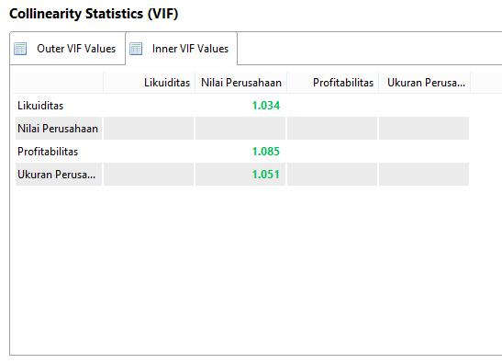

LAMPIRAN 8.2
R Square
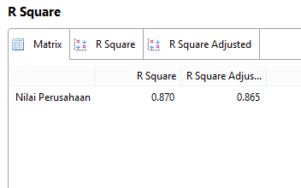
LAMPIRAN 8.3
f Square
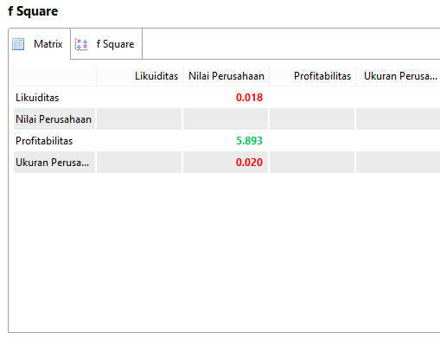

LAMPIRAN 8.4
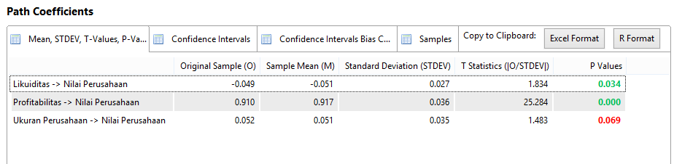
Path Coefficients

