Lampiran I
Data EPS, BVPS dan CFOPS
 | KODE | EPS |  |  | BVPS |  |  | CFOPS
No |  | 2015 | 2016 | 2017 | 2015 | 2016 | 2017 | 2015 | 2016 | 2017
1 | SMBR | 36,00 | 26,00 | 15,00 | 299,80 | 317,23 | 343,87 | 53,13 | 8,87 | 18,46
2 | SMGR | 762,00 | 762,00 | 340,00 | 4626,27 | 5154,56 | 5131,75 | 1228,79 | 873,30 | 462,81
3 | AMFG | 786,00 | 600,00 | 89,00 | 7811,57 | 8293,24 | 8177,14 | 845,25 | 767,38 | 689,13
4 | ARNA | 9,51 | 12,32 | 16,46 | 121,87 | 129,14 | 140,22 | 15,24 | 13,02 | 33,45
5 | INAI | 90,33 | 112,23 | 61,00 | 757,01 | 814,45 | 437,82 | 148,40 | -472,73 | 81,07
6 | LION | 88,00 | 81,00 | 18,00 | 873,96 | 904,73 | 869,55 | 95,40 | 102,47 | 18,57
7 | DPNS | 33,10 | 34,08 | 21,31 | 728,71 | 795,05 | 808,85 | 15,42 | 42,67 | -12,06
8 | EKAD | 67,00 | 126,00 | 108,00 | 417,82 | 847,20 | 948,54 | 144,45 | 120,91 | 73,85
9 | CPIN | 112,00 | 135,00 | 152,00 | 779,77 | 863,35 | 957,61 | 108,70 | 253,51 | 99,06
10 | ASII | 357,00 | 374,00 | 466,00 | 3125,54 | 3455,87 | 3861,54 | 639,74 | 479,38 | 575,17
11 | AUTO | 66,00 | 87,00 | 114,00 | 2104,56 | 2186,13 | 2232,30 | 179,84 | 219,80 | 81,79
12 | SMSM | 74,00 | 79,00 | 87,00 | 25,01 | 274,38 | 317,47 | 92,38 | 101,21 | 77,45
13 | RICY | 17,21 | 17,88 | 19,58 | 623,45 | 642,80 | 670,49 | 207,65 | 128,55 | 331,64
14 | TRIS | 25,63 | 6,32 | 1,42 | 323,13 | 331,53 | 340,05 | 60,62 | 12,60 | 42,37
15 | SCCO | 773,00 | 1656,00 | 1310,00 | 4486,51 | 5936,38 | 5936,38 | 963,02 | 2541,68 | -341,71
16 | MYOR | 55,00 | 61,00 | 71,00 | 5808,10 | 280,22 | 328,93 | 2612,84 | 29,49 | 57,05
17 | DVLA | 97,00 | 136,00 | 145,00 | 869,21 | 0,96 | 1,00 | 191,22 | 0,17 | 0,21
18 | KAEF | 47.07 | 48,15 | 58,84 | 370,28 | 408,97 | 463,18 | 31,68 | 35,66 | 0,94
19 | KLBF | 42.76 | 49,06 | 51,28 | 233,35 | 265,89 | 296,41 | 51,79 | 46,08 | 42,84
20 | TSPC | 116,00 | 119,00 | 121,00 | 963,81 | 1030,06 | 1129,34 | 172,97 | 109,26 | 120,93

Lampiran II
Data Harga Saham
 | KODE | CP
No |  | 2015 | 2016 | 2017
1 | SMBR | 401,60 | 3476,00 | 3388,00
2 | SMGR | 9825,00 | 8840,00 | 10065,00
3 | AMFG | 6720,00 | 6990,00 | 5425,00
4 | ARNA | 571,00 | 488,80 | 338,80
5 | INAI | 176,80 | 351,00 | 412,00
6 | LION | 882,00 | 950,00 | 630,00
7 | DPNS | 313,60 | 379,60 | 396,40
8 | EKAD | 433,60 | 708,00 | 688,00
9 | CPIN | 3547,00 | 3300,00 | 3440,00
10 | ASII | 7210,00 | 8480,00 | 8100,00
11 | AUTO | 1898,00 | 2724,00 | 1736,00
12 | SMSM | 1179,75 | 1197,00 | 1345,00
13 | RICY | 141,80 | 152,60 | 168,00
14 | TRIS | 274,20 | 264,00 | 295,60
15 | SCCO | 4896,00 | 10740,00 | 10315,00
16 | MYOR | 1279,20 | 2036,00 | 2970,00
17 | DVLA | 1348,00 | 1770,00 | 1989,00
18 | KAEF | 1277,00 | 2928,00 | 2180,00
19 | KLBF | 1323,00 | 1563,00 | 1541,00
20 | TSPC | 1952,00 | 2036,00 | 1618,00

Lampiran III
Hasil Uji Statisik Deskriptif
Descriptive Statistics
 | N | Minimum | Maximum | Mean | Std. Deviation
EPS | 60 | 1,42 | 1.656,00 | 190,7090 | 316,63017
BVPS | 60 | ,96 | 8.293,24 | 1.694,5718 | 2.219,09800
CFOPS | 60 | -472,73 | 2.612,84 | 262,0805 | 524,71520
CP | 60 | 141,80 | 10.740,00 | 2.701,0725 | 3.011,71478
Valid N (listwise) | 60

Hasil Uji Pooling Data
Coefficientsª
Model |  | Unstandardized Coefficients |  | Standardized Coefficients | t | Sig.
 |  | B | Std. Error | Beta
1 | (Constant) | 590,241 | 428,737 |  | 1,377 | ,175
 | EPS | 9,417 | 2,434 | ,990 | 3,870 | ,000
 | BVPS | -,134 | ,434 | -,099 | -,309 | ,759
 | CFOPS | ,531 | 1,045 | ,092 | ,508 | ,614
 | DT1 | 481,293 | 607,001 | ,076 | ,793 | ,432
 | DT2 | -98,355 | 618,024 | -,016 | -,159 | ,874
 | DT1_EPS | -6,245 | 4,325 | -,512 | -1,444 | ,155
 | DT1_BVPS | ,732 | ,499 | ,368 | 1,468 | ,148
 | DT1_CFOPS | ,191 | 2,356 | ,023 | ,081 | ,936
 | DT2_EPS | -,925 | 3,213 | -,056 | -,288 | ,775
 | DT2_BVPS | ,332 | ,530 | ,167 | ,626 | ,534
 | DT2_CFOPS | 4,717 | 2,709 | ,224 | 1,741 | ,088
a. Dependent Variable: CP

Lampiran IV
Hasil Uji Normalitas
One-Sample Kolmogorov-Smirnov Test
 |  | Unstandardized Residual
N |  | 60
Normal Parameters^{a,b} | Mean | ,0000000
 | Std. Deviation | 1486,16484066
Most Extreme Differences | Absolute | ,152
 | Positive | ,152
 | Negative | -,088
Kolmogorov-Smirnov Z |  | 1,177
Asymp. Sig. (2-tailed) |  | ,125
a. Test distribution is Normal.
b. Calculated from data.
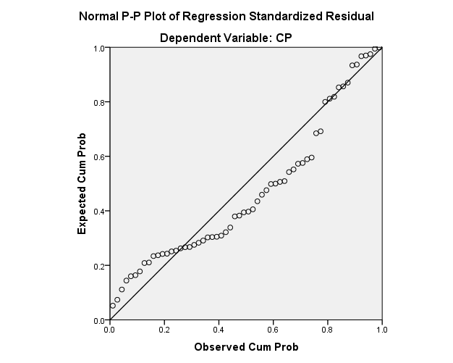

Lampiran V
Hasil Uji Multikolonieritas
Coefficientsª
Model |  | Unstandardized Coefficients |  | Standardized Coefficients | t | Sig. | Collinearity Statistics
 |  | B | Std. Error | Beta |  |  | Tolerance | VIF
1 | (Constant) | 821,427 | 249,157 |  | 3,297 | ,002
 | EPS | 5,505 | ,907 | ,579 | 6,066 | ,000 | ,478 | 2,093
 | BVPS | ,586 | ,144 | ,432 | 4,077 | ,000 | ,388 | 2,581
 | CFOPS | -,623 | ,515 | -,109 | -1,210 | ,231 | ,540 | 1,854
a. Dependent Variable: CP

Hasil Uji Autokorelasi
Model Summary^{b}
Model | R | R Square | Adjusted R Square | Std. Error of the Estimate | Durbin-Watson
1 | .870ª | ,756 | ,743 | 1.525,45350 | 1,520
a. Predictors: (Constant), CFOPS, EPS, BVPS
b. Dependent Variable: CP

Hasil Uji Heteroskedasitas
Coefficientsª
Model |  | Unstandardized Coefficients |  | Standardized Coefficients | t | Sig.
 |  | B | Std. Error | Beta
1 | (Constant) | 11.967 | .513 |  | 23.319 | .000
 | EPS | -.001 | .002 | -.119 | -.508 | .613
 | BVPS | .000 | .000 | .099 | .431 | .668
 | CFOPS | .000 | .001 | .043 | .249 | .804
 | CP | .000 | .000 | .347 | 1.362 | .179
a. Dependent Variable: LnCP

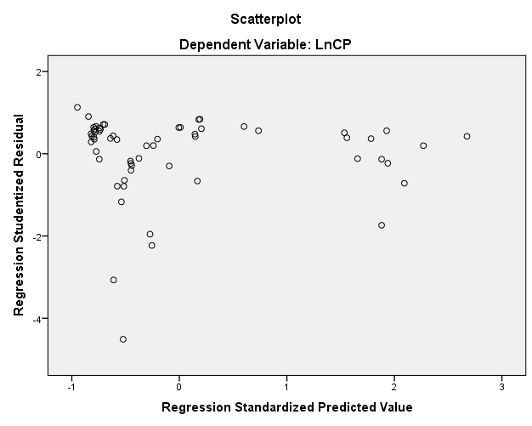

Lampiran VI
Hasil Uji Signifikansi Simultan (Uji Statistik F)
ANOVAª
Model |  | Sum of Squares | df | Mean Square | F | Sig.
1 | Regression | 404842657,324 | 3 | 134947552,441 | 57,992 | .000^{b}
 | Residual | 130312470,083 | 56 | 2327008,394
 | Total | 535155127,407 | 59
a. Dependent Variable: CP
b. Predictors: (Constant), CFOPS, EPS, BVPS

Hasil Uji Koefisien Regresi Secara Parsial (Uji t)
Coefficientsª
Model |  | Unstandardized Coefficients |  | Standardized Coefficients | t | Sig. | Collinearity Statistics
 |  | B | Std. Error | Beta |  |  | Tolerance | VIF
1 | (Constant) | 821,427 | 249,157 |  | 3,297 | ,002
 | EPS | 5,505 | ,907 | ,579 | 6,066 | ,000 | ,478 | 2,093
 | BVPS | ,586 | ,144 | ,432 | 4,077 | ,000 | ,388 | 2,581
 | CFOPS | -,623 | ,515 | -,109 | -1,210 | ,231 | ,540 | 1,854
a. Dependent Variable: CP

Hasil Uji Koefisien Determinasi
Model Summary^{b}
Model | R | R Square | Adjusted R Square | Std. Error of the Estimate
1 | .897ª | ,804 | ,759 | 1.478,34609
a. Predictors: (Constant), DT2_CFOPS, DT2_EPS, DT1_CFOPS, DT1, BVPS, DT2, CFOPS, DT1_BVPS, EPS, DT2_BVPS, DT1_EPS
b. Dependent Variable: CP

