LAMPIRAN
Lampiran 1
DAFTAR NAMA PERUSAHAAN
Sektor | No | Kode Perusahaan | Nama Perusahaan
Properti dan Real Estate | 1 | APLN | Agung Podomoro Land Tbk
 | 2 | BAPA | Bekasi Asri Pemula Tbk
 | 3 | BEST | Bekasi Fajar Industrial Estate Tbk
 | 4 | BIKA | Binakarya Jasa Abadi Tbk
 | 5 | BIPP | Bhuwanatala Indah Permai Tbk
 | 6 | BKDP | Bukit Darmo Property Tbk
 | 7 | BKSL | Sentul City Tbk
 | 8 | BSDE | Bumi Serpong Damai Tbk
 | 9 | COWL | Cowell Development Tbk
 | 10 | CTRA | Ciputra Development Tbk
 | 11 | DART | Duta Anggada Realty Tbk
 | 12 | DILD | Intiland Development Tbk
 | 13 | DUTI | Duta Pertiwi Tbk
 | 14 | EMDE | Megapolitan Developments Tbk
 | 15 | FMII | Fortune Mate Indonesia Tbk
 | 16 | GAMA | Gading Development Tbk
 | 17 | GPRA | Perdana Gapuraprima Tbk
 | 18 | GWSA | Greenwood Sejahtera Tbk
 | 19 | JRPT | Jaya Real Property Tbk
 | 20 | KIJA | Kawasan Industry Jabebeka Tbk
 | 21 | LPCK | Lippo Cikarang Tbk
 | 22 | LPKR | Lippo Karawaci Tbk
 | 23 | MDLN | Modernland Realty Ltd Tbk
 | 24 | MKPI | Metropolitan Kentjana Tbk
 | 25 | MMLP | Mega Manunggal Property Tbk
 | 26 | MTLA | Metropolitan Land Tbk
 | 27 | MTSM | Metro Realty Tbk
 | 28 | MYRX | Hanson International Tbk
 | 29 | NIRO | City Retail Developments Tbk
 | 30 | MORE | Indonesia Prima Property Tbk
 | 31 | PLIN | Plaza Indonesia Realty Tbk
 | 32 | PPRO | PP Properti Tbk
 | 33 | PWON | Pakuwon Jati Tbk
 | 34 | RBMS | Ristia Bintang Mahkotasejati Tbk
 | 35 | RDTX | Roda Vivatex Tbk
 | 36 | RODA | Pikko Land Development Tbk
 | 37 | SCBD | Danayasa Arthatama Tbk
 | 38 | SMDM | Suryamas Dutamakmur Tbk
 | 39 | SMRA | Summarecon Agung Tbk
Konstruksi Bangunan | 40 | ACST | Acset Indonusa Tbk
 | 41 | DGIK | Nusa Konstruksi Enjiniring Tbk
 | 42 | IDPR | Indonesia Pondasi Raya Tbk
 | 43 | JKON | Jaya Konstruksi Manggala Pratama Tbk
 | 44 | NRCA | Nusa Raya Cipta Tbk
 | 45 | PTPP | PP (Persero ) Tbk
 | 46 | SSIA | Surya Semesta Internusa Tbk
 | 47 | TOTL | Total Bangun Persada Tbk
 | 48 | WIKA | Wijaya Karya (Persero) Tbk
 | 49 | WSKT | Waskita Karya (Persero) Tbk

Lampiran 2
Data Penelitian
KODE | TAHUN | AD | UKPER | OA | REKAP | SOLVA
ACST | 2016 | 51 | 14.7331 | 1 | 1 | 0.48017
 | 2017 | 57 | 15.4844 | 0 | 1 | 0.72918
 | 2018 | 56 | 16.0056 | 0 | 1 | 0.84034
APLN | 2016 | 116 | 17.0625 | 1 | 1 | 0.61221
 | 2017 | 86 | 17.1755 | 1 | 1 | 0.60066
 | 2018 | 87 | 17.2027 | 1 | 0 | 0.58736
BAPA | 2016 | 79 | 12.0966 | 0 | 0 | 0.40276
 | 2017 | 60 | 12.0953 | 0 | 0 | 0.3289
 | 2018 | 87 | 12.0571 | 0 | 0 | 0.2578
BEST | 2016 | 81 | 15.4652 | 0 | 0 | 0.34859
 | 2017 | 66 | 15.5593 | 0 | 0 | 0.32712
 | 2018 | 77 | 15.6545 | 0 | 0 | 0.33674
BIKA | 2016 | 88 | 14.6913 | 0 | 0 | 0.72114
 | 2017 | 82 | 14.6803 | 0 | 0 | 0.70703
 | 2018 | 86 | 14.6629 | 0 | 0 | 0.71773
BIPP | 2016 | 79 | 14.3151 | 0 | 0 | 0.26954
 | 2017 | 78 | 14.3743 | 0 | 0 | 0.30583
 | 2018 | 87 | 14.5398 | 0 | 0 | 0.45172
BKDP | 2016 | 86 | 13.5736 | 0 | 0 | 0.30461
 | 2017 | 74 | 13.5715 | 0 | 0 | 0.36214
 | 2018 | 77 | 13.5457 | 0 | 0 | 0.3931
BKSL | 2016 | 75 | 16.2456 | 1 | 0 | 0.36967
 | 2017 | 81 | 16.522 | 1 | 0 | 0.33615
 | 2018 | 86 | 16.6038 | 0 | 0 | 0.3465
BSDE | 2016 | 48 | 17.4608 | 0 | 0 | 0.36402
 | 2017 | 45 | 17.6431 | 1 | 0 | 0.36461
 | 2018 | 46 | 17.7687 | 0 | 0 | 0.50113
COWL | 2016 | 76 | 15.0663 | 0 | 0 | 0.65642
 | 2017 | 57 | 15.0905 | 1 | 0 | 0.68485
 | 2018 | 119 | 15.1327 | 1 | 0 | 0.75401
CTRA | 2016 | 88 | 17.1858 | 1 | 1 | 0.50862
 | 2017 | 87 | 17.272 | 0 | 1 | 0.51269
 | 2018 | 86 | 17.3503 | 0 | 1 | 0.51459
DART | 2016 | 86 | 15.6183 | 0 | 1 | 0.4027
 | 2017 | 86 | 15.6657 | 0 | 1 | 0.44041
 | 2018 | 87 | 15.7478 | 1 | 1 | 0.48215
DGIK | 2016 | 111 | 14.257 | 1 | 0 | 0.51338
 | 2017 | 85 | 14.4148 | 0 | 0 | 0.5681
 | 2018 | 101 | 14.3624 | 1 | 0 | 0.61548
DILD | 2016 | 86 | 16.287 | 0 | 0 | 0.57285
 | 2017 | 85 | 16.3879 | 0 | 0 | 0.51818
 | 2018 | 85 | 16.4698 | 0 | 0 | 0.54165
DUTI | 2016 | 48 | 16.0868 | 0 | 0 | 0.19596
 | 2017 | 45 | 16.1741 | 0 | 0 | 0.21188
 | 2018 | 46 | 16.3526 | 0 | 0 | 0.25532
EMDE | 2016 | 82 | 14.1257 | 0 | 0 | 0.49547
 | 2017 | 68 | 14.4407 | 0 | 0 | 0.57887
 | 2018 | 81 | 14.5558 | 0 | 0 | 0.61624
FMII | 2016 | 86 | 13.5562 | 0 | 0 | 0.1281
 | 2017 | 80 | 13.5942 | 0 | 0 | 0.14921
 | 2018 | 81 | 13.7547 | 0 | 0 | 0.28212
GAMA | 2016 | 88 | 14.1118 | 0 | 0 | 0.18381
 | 2017 | 87 | 14.1538 | 0 | 0 | 0.21703
 | 2018 | 88 | 14.1335 | 1 | 0 | 0.19839
GPRA | 2016 | 86 | 14.2662 | 0 | 0 | 0.35629
 | 2017 | 68 | 14.2206 | 0 | 0 | 0.31088
 | 2018 | 79 | 14.245 | 0 | 0 | 0.29577
GWSA | 2016 | 89 | 15.7562 | 0 | 1 | 0.06872
 | 2017 | 87 | 15.7897 | 0 | 1 | 0.07282
 | 2018 | 87 | 15.8292 | 0 | 0 | 0.07976
IDPR | 2016 | 83 | 14.2522 | 0 | 0 | 0.28485
 | 2017 | 85 | 14.4281 | 0 | 0 | 0.34338
 | 2018 | 79 | 14.47 | 0 | 0 | 0.36448
JKON | 2016 | 83 | 15.2036 | 1 | 0 | 0.45083
 | 2017 | 82 | 15.2512 | 0 | 0 | 0.4282
 | 2018 | 81 | 15.385 | 0 | 0 | 0.46246
JRPT | 2016 | 88 | 15.9537 | 0 | 0 | 0.42172
 | 2017 | 79 | 16.0639 | 0 | 0 | 0.37634
 | 2018 | 79 | 16.1709 | 0 | 0 | 0.365
KIJA | 2016 | 86 | 16.1889 | 0 | 0 | 0.47469
 | 2017 | 86 | 16.2373 | 0 | 0 | 0.47629
 | 2018 | 86 | 16.2822 | 0 | 0 | 0.48637
LPCK | 2016 | 53 | 15.5477 | 0 | 0 | 0.2495
 | 2017 | 94 | 16.3314 | 0 | 0 | 0.37626
 | 2018 | 60 | 15.9661 | 1 | 0 | 0.1974
LPKR | 2016 | 58 | 17.6355 | 0 | 0 | 0.51594
 | 2017 | 94 | 17.8546 | 1 | 0 | 0.47403
 | 2018 | 60 | 17.7237 | 0 | 0 | 0.48862
MDLN | 2016 | 61 | 16.4924 | 0 | 0 | 0.5464
 | 2017 | 46 | 16.4965 | 0 | 0 | 0.51523
 | 2018 | 87 | 16.5386 | 0 | 0 | 0.55148
MKPI | 2016 | 48 | 15.7044 | 0 | 0 | 0.43817
 | 2017 | 52 | 15.7365 | 0 | 0 | 0.3334
 | 2018 | 59 | 15.7626 | 0 | 0 | 0.2535
MMLP | 2016 | 81 | 15.1932 | 0 | 1 | 0.17185
 | 2017 | 88 | 15.4952 | 0 | 1 | 0.12929
 | 2018 | 88 | 15.6224 | 0 | 1 | 0.12856
OMRE | 2016 | 86 | 15.2659 | 0 | 1 | 0.03446
 | 2017 | 87 | 15.2608 | 0 | 1 | 0.05395
 | 2018 | 86 | 15.2631 | 0 | 1 | 0.09524
MTLA | 2016 | 83 | 15.1848 | 0 | 1 | 0.36367
 | 2017 | 85 | 15.3994 | 0 | 1 | 0.3846
 | 2018 | 91 | 15.463 | 0 | 1 | 0.33793
MTSM | 2016 | 86 | 11.3462 | 0 | 0 | 0.1168
 | 2017 | 82 | 11.2927 | 0 | 0 | 0.13391
 | 2018 | 84 | 11.227 | 0 | 0 | 0.16521
MYRX | 2016 | 88 | 15.945 | 1 | 1 | 0.28493
 | 2017 | 155 | 16.119 | 1 | 1 | 0.30434
 | 2018 | 88 | 16.2687 | 1 | 0 | 0.31834
NIRO | 2016 | 86 | 15.1484 | 0 | 1 | 0.2158
 | 2017 | 87 | 15.4032 | 0 | 1 | 0.25275
 | 2018 | 88 | 15.8378 | 0 | 1 | 0.19068
NRCA | 2016 | 89 | 14.5736 | 1 | 0 | 0.46507
 | 2017 | 87 | 14.6912 | 0 | 0 | 0.47462
 | 2018 | 64 | 14.6285 | 0 | 0 | 0.46413
PLIN | 2016 | 59 | 15.3386 | 0 | 1 | 0.50175
 | 2017 | 71 | 15.3501 | 0 | 1 | 0.78728
 | 2018 | 88 | 15.4337 | 0 | 1 | 0.75572
PPRO | 2016 | 76 | 15.9932 | 0 | 0 | 0.66374
 | 2017 | 50 | 16.2634 | 0 | 0 | 0.57841
 | 2018 | 49 | 16.6172 | 0 | 0 | 0.64696
PTPP | 2016 | 45 | 17.257 | 0 | 0 | 0.65433
 | 2017 | 51 | 17.548 | 0 | 1 | 0.65912
 | 2018 | 51 | 17.7773 | 0 | 0 | 0.68952
PWON | 2016 | 83 | 16.8444 | 0 | 1 | 0.46698
 | 2017 | 78 | 16.9665 | 0 | 1 | 0.45239
 | 2018 | 84 | 17.0351 | 0 | 1 | 0.38798
RBMS | 2016 | 75 | 12.0287 | 0 | 0 | 0.03352
 | 2017 | 79 | 12.2957 | 0 | 0 | 0.1948
 | 2018 | 78 | 13.7079 | 0 | 0 | 0.2993
RDTX | 2016 | 86 | 14.5583 | 0 | 0 | 0.13003
 | 2017 | 82 | 14.6399 | 0 | 0 | 0.09888
 | 2018 | 79 | 14.7423 | 0 | 0 | 0.08433
RODA | 2016 | 76 | 15.0477 | 0 | 0 | 0.19321
 | 2017 | 82 | 15.0821 | 1 | 0 | 0.22918
 | 2018 | 85 | 15.197 | 1 | 0 | 0.31523
SCBD | 2016 | 75 | 15.5585 | 0 | 0 | 0.27867
 | 2017 | 82 | 15.5705 | 0 | 0 | 0.25461
 | 2018 | 81 | 15.5687 | 0 | 0 | 0.23846
SMDM | 2016 | 54 | 14.9466 | 0 | 0 | 0.20107
 | 2017 | 54 | 14.9603 | 0 | 0 | 0.20492
 | 2018 | 67 | 14.9657 | 0 | 0 | 0.1919
SMRA | 2016 | 83 | 16.851 | 0 | 1 | 0.60762
 | 2017 | 85 | 16.8911 | 0 | 1 | 0.61437
 | 2018 | 85 | 16.9639 | 0 | 1 | 0.61112
SSIA | 2016 | 89 | 15.789 | 1 | 0 | 0.53403
 | 2017 | 87 | 15.9961 | 0 | 0 | 0.49423
 | 2018 | 64 | 15.8176 | 0 | 0 | 0.40777
TOTL | 2016 | 62 | 14.8975 | 0 | 0 | 0.68053
 | 2017 | 72 | 14.9917 | 0 | 0 | 0.68875
 | 2018 | 73 | 14.9876 | 0 | 0 | 0.67414
WIKA | 2016 | 52 | 17.2526 | 0 | 0 | 0.59807
 | 2017 | 58 | 17.6373 | 0 | 0 | 0.67972
 | 2018 | 67 | 17.8969 | 0 | 0 | 0.70935
WSKT | 2016 | 45 | 17.9333 | 0 | 0 | 0.72693
 | 2017 | 66 | 18.3994 | 0 | 1 | 0.76756
 | 2018 | 51 | 18.6389 | 0 | 0 | 0.76777

Lampiran 3
Hasil Uji Statistik Deskriptif
Descriptive Statistics
 | N | Minimum | Maximum | Mean | Std. Deviation
AD | 147 | 45.00 | 155.00 | 76.9320 | 16.36931
UPKER | 147 | 11.2270 | 18.6389 | 15.474761 | 1.4283687
OA | 147 | 0 | 1 | .16 | .365
REKAP | 147 | 0 | 1 | .26 | .439
SOLVA | 147 | .0335 | .8403 | .408598 | .1953980
Valid N (listwise) | 147

Lampiran 4
Pooling Data
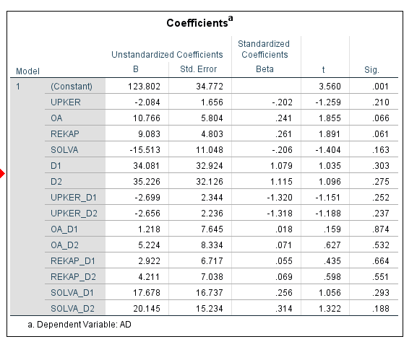
Lampiran 5
Uji Normalitas
One-Sample Kolmogorov-Smirnov Test
 |  | Unstandardized Residual
N |  | 147
Normal Parameters^{a,b} | Mean | 0.0000000
 | Std. Deviation | 13.37136560
Most Extreme Differences | Absolute | 0.064
 | Positive | 0.064
 | Negative | -0.060
Test Statistic |  | 0.064
Asymp. Sig. (2-tailed) |  | .200c,d
a. Test distribution is Normal.
b. Calculated from data.
c. Lilliefors Significance Correction.

Lampiran 6
Uji Heterokadastisitas
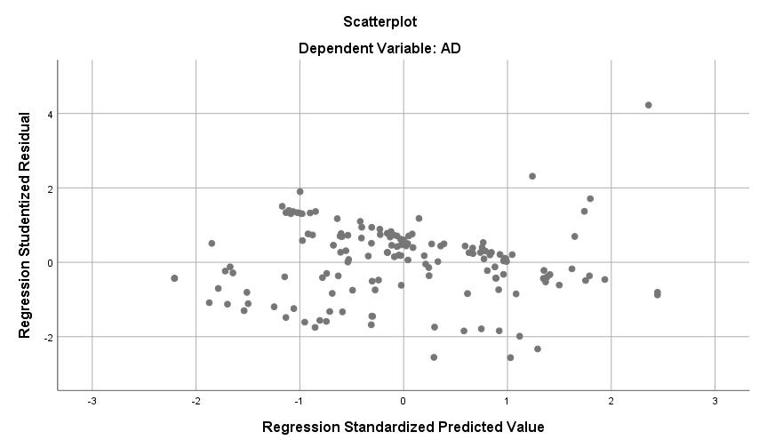
Lampiran 7
Uji Auto Korelasi

Model Summary^{b}
Model | R | R Square | Adjusted R Square | Std. Error of the Estimate | Durbin-Watson
1 | .577ª | .333 | .314 | 13.55839 | 1.804
a. Predictors: (Constant), SOLVA, REKAP, OA, UPKER
b. Dependent Variable: AD

Lampiran 8
Uji Multikolinearitas

Coefficientsª
Model |  | Unstandardized Coefficients |  | Standardized Coefficients | T | Sig. | Collinearity Statistics
 |  | B | Std. Error | Beta |  |  | Tolerance | VIF
1 | (Constant) | 130.190 | 12.984 |  | 10.027 | .000
 | UPKER | -3.697 | .910 | -.323 | -4.060 | .000 | .744 | 1.343
 | OA | 17.812 | 2.877 | .429 | 6.192 | .000 | .980 | 1.020
 | REKAP | 10.223 | 2.664 | .274 | 3.838 | .000 | .920 | 1.088
 | SOLVA | -5.104 | 6.444 | -.061 | -.792 | .430 | .794 | 1.259
a. Dependent Variable: AD

Lampiran 9
Uji Koefisien Determinasi
Model Summary^{b}
Model | R | R Square | Adjusted R Square
1 | .577a | 0.333 | 0.314
a. Predictors: (Constant), SOLVA, REKAP, OA, UPKER
b. Dependent Variable: AD

Lampiran 10
Uji F
ANOVAª
Model |  | Sum of Squares | df | Mean Square | F | Sig.
1 | Regression | 13017.481 | 4 | 3254.370 | 17.703 | .000^{b}
 | Residual | 26103.839 | 142 | 183.830
 | Total | 39121.320 | 146
a. Dependent Variable: AD
b. Predictors: (Constant), SOLVA, REKAP, OA, UPKER

Lampiran 11
Uji T
Coefficientsª
Model |  | Unstandardized Coefficients |  | Standardized Coefficients | T | Sig.
 |  | B | Std. Error | Beta
1 | (Constant) | 130.190 | 12.984 |  | 10.027 | 0.000
 | UPKER | -3.697 | 0.910 | -0.323 | -4.060 | 0.000
 | OA | 17.812 | 2.877 | 0.429 | 6.192 | 0.000
 | REKAP | 10.223 | 2.664 | 0.274 | 3.838 | 0.000
 | SOLVA | -5.104 | 6.444 | -0.061 | -0.792 | 0.430
a. Dependent Variable: AD

Lampiran 12
Laporan Keuangan

