LAMPIRAN III
Hasil Pooling Data
Coefficientsª
Model |  | Unstandardized Coefficients |  | Standardized Coefficients | t | Sig.
 |  | B | Std. Error | Beta
1 | (Constant) | -1.160 | .515 |  | -2.253 | .034
 | SIZE | .065 | .020 | .428 | 3.210 | .004
 | PROF | -.262 | .138 | -.206 | -1.895 | .071
 | DEKOM | .119 | .041 | .790 | 2.931 | .008
 | LEV | .051 | .069 | .107 | .737 | .469
 | ME | .011 | .102 | .023 | .106 | .917
 | X1D1 | .006 | .008 | .337 | .741 | .466
 | X2D1 | .707 | .593 | .140 | 1.192 | .245
 | X3D1 | -.024 | .055 | -.220 | -.444 | .661
 | X4D1 | -.044 | .106 | -.102 | -.413 | .683
 | X5D1 | -.063 | .142 | -.111 | -.446 | .660
 | X1D2 | .007 | .007 | .378 | .870 | .393
 | X2D2 | -.371 | .404 | -.104 | -.920 | .367
 | X3D2 | -.069 | .048 | -.651 | -1.428 | .167
 | X4D2 | -.005 | .098 | -.013 | -.053 | .958
 | X5D2 | .039 | .133 | .069 | .294 | .771
a. Dependent Variable: CSRD

Hasil Uji Statistik Deskriptif
Descriptive Statistics
 | N | Minimum | Maximum | Mean | Std. Deviation
CSRD (Y) | 39 | .022 | .956 | .18292 | .245278
SIZE (X1) | 39 | 25.646 | 31.044 | 28.31703 | 1.543120
PROFIT (X2) | 39 | -.362 | .922 | .00274 | .183792
DEKOM (X3) | 39 | 2.000 | 8.000 | 4.05128 | 1.555106
LEVERAGE (X4) | 39 | .042 | 2.226 | .98472 | .488926
ME (X5) | 39 | .000 | 1.000 | .61538 | .492864
Valid N (listwise) | 39

Hasil Uji Normalitas
One-Sample Kolmogorov-Smirnov Test
 |  | Unstandardized Residual
N |  | 39
Normal Parameters^{a,b} | Mean | ,0000000
 | Std. Deviation | ,11869404
Most Extreme Differences | Absolute | ,136
 | Positive | ,136
 | Negative | -,117
Test Statistic |  | ,136
Asymp. Sig. (2-tailed) |  | ,065^{c}
a. Test distribution is Normal.
b. Calculated from data.
c. Lilliefors Significance Correction.

Hasil Uji Multikolinieritas
Coefficientsª
Model |  | Unstandardized Coefficients |  | Standardized Coefficients | t | Sig. | Collinearity Statistics
 |  | B | Std. Error | Beta |  |  | Tolerance | VIF
1 | (Constant) | -1.179 | .497 |  | -2.374 | .024
 | SIZE | .071 | .018 | .471 | 3.920 | .000 | .541 | 1.849
 | PROF | -.248 | .121 | -.195 | -2.050 | .048 | .862 | 1.161
 | DEKOM | .072 | .021 | .479 | 3.494 | .001 | .416 | 2.405
 | LEV | .025 | .046 | .053 | .541 | .592 | .829 | 1.206
 | ME | .036 | .056 | .077 | .656 | .517 | .569 | 1.759
a. Dependent Variable: CSRD

Hasil Uji Heteroskedastisitas
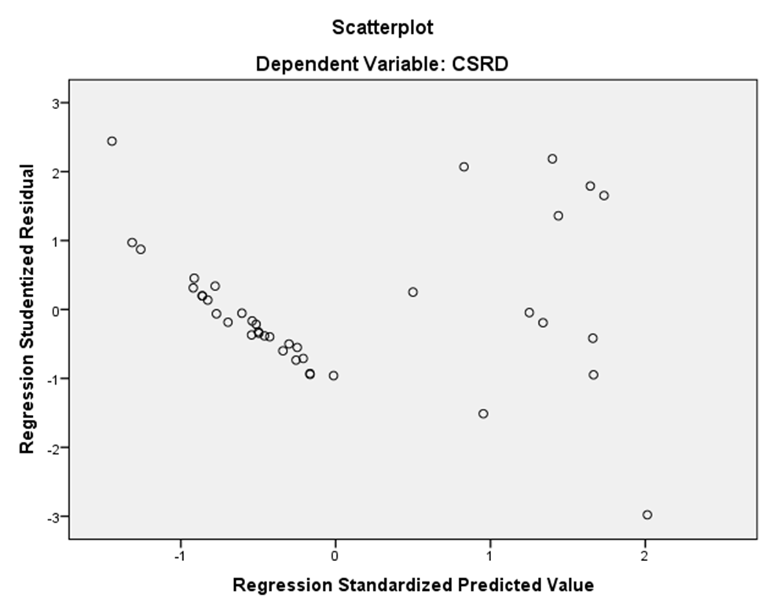

Hasil Uji Autokorelasi
Model Summary^{b}
Model | R | R Square | Adjusted R Square | Std. Error of the Estimate | Durbin-Watson
1 | .862ª | .742 | .703 | .127369 | 2.087
a. Predictors: (Constant), ME, LEV, PROF, SIZE, DEKOM
b. Dependent Variable: CSRD

Hasil Uji F
ANOVAª
Model |  | Sum of Squares | df | Mean Square | F | Sig.
1 | Regression | 1.542 | 5 | .308 | 19.015 | .000^{b}
 | Residual | .535 | 33 | .016
 | Total | 2.078 | 38
a. Dependent Variable: CSRD
b. Predictors: (Constant), ME, LEV, PROF, SIZE, DEKOM

Hasil Uji T
Coefficientsª
Model |  | Unstandardized Coefficients |  | Standardized Coefficients | t | Sig.
 |  | B | Std. Error | Beta
1 | (Constant) | -1.179 | .497 |  | -2.374 | .024
 | SIZE | .071 | .018 | .471 | 3.920 | .000
 | PROF | -.248 | .121 | -.195 | -2.050 | .048
 | DEKOM | .072 | .021 | .479 | 3.494 | .001
 | LEV | .025 | .046 | .053 | .541 | .592
 | ME | .036 | .056 | .077 | .656 | .517
a. Dependent Variable: CSRD

Koefisien Determinasi (R²)
Model Summary^{b}
Model | R | R Square | Adjusted R Square | Std. Error of the Estimate | Durbin-Watson
1 | .862ª | .742 | .703 | .127369 | 2.087
a. Predictors: (Constant), ME, LEV, PROF, SIZE, DEKOM
b. Dependent Variable: CSRD

