LAMPIRAN
Lampiran 1
Data Perusahaan Sampel
No. | Kode Perusahaan | Nama Perusahaan | Sub Sektor Industri | SCI Code | Tanggal Go Public
1 | AKPI | PT Argha Karya Prima Industry Tbk | Plastik & Kemasan | 35 | 18-Dec-92
2 | ALDO | PT Alkindo Naratama Tbk | Pulp & Kertasnya | 38 | 12-Jul-11
3 | ALTO | PT Tri Banyan Tirta Tbk | Makanan & Minuman | 51 | 10-Jul-12
4 | APLI | PT Asiaplast Industries Tbk | Plastik & Kemasan | 35 | 01-May-00
5 | AUTO | PT Astra Autopart Tbk | Otomotif & Komponen | 42 | 15-Jun-98
6 | BIMA | PT Primarindo Asia Infrastructure Tbk | Alas Kaki | 44 | 30-Aug-94
7 | BRNA | PT Berlina Tbk | Plastik & Kemasan | 35 | 06-Nov-89
8 | BUDI | PT Budi Strach & Sweetener Tbk | Kimia | 34 | 08-May-95
9 | CEKA | PT Wilmar Cahaya Indonesia Tbk | Makanan & Minuman | 51 | 09-Jul-96
10 | CPIN | PT Charoen Pokphand Indonesia Tbk | Pakan Ternak | 36 | 18-Mar-91
11 | DPNS | PT Duta Pertiwi Nusantara | Kimia | 34 | 08-Aug-90
12 | DVLA | PT Darya Varia Laboratoria Tbk | Farmasi | 53 | 11-Nov-94
13 | EKAD | PT Ekadharma International Tbk | Kimia | 34 | 14-Aug-90
14 | FASW | PT Fajar Surya Wisesa Tbk | Pulp & Kertasnya | 38 | 01-Dec-94
15 | GGRM | PT Gudang Garam Tbk | Rokok | 52 | 27-Aug-90
16 | HMSP | PT Hanjaya Mandala Sampoerna Tbk | Rokok | 52 | 15-Aug-90
17 | ICBP | PT Indofood CBP Sukses Makmur Tbk | Makanan & Minuman | 51 | 07-Oct-10
18 | IGAR | PT Champion Pasific Indonesia Tbk | Plastik & Kemasan | 35 | 05-Nov-90
19 | IMAS | PT Indomobil Sukses International Tbk | Otomotif & Komponen | 42 | 15-Sep-93
20 | INCI | PT Intan Wijaya International Tbk | Kimia | 34 | 24-Jul-90
21 | INDF | PT Indofood Sukses Makmur Tbk | Makanan & Minuman | 51 | 14-Jul-94
22 | INDS | PT Indospring Tbk | Otomotif & Komponen | 42 | 10-Aug-90
23 | INTP | PT Indocement Tunggal Prakasa Tbk | Semen | 31 | 05-Dec-89
24 | JECC | PT Jembo Cable Company Tbk | Kabel | 45 | 18-Nov-92
25 | JPFA | PT Japfa Comfeed Indonesia Tbk | Pakan Ternak | 36 | 23-Oct-89
26 | KBLI | PT KMI Wire and Cable Tbk | Kabel | 45 | 06-Jul-92
27 | KBLM | PT Kabelindo Murni Tbk | Kabel | 45 | 01-Jun-92
28 | KBRI | PT Kertas Basuki Rachmat Indonesia Tbk | Pulp & Kertasnya | 38 | 11-Jul-08
29 | KLBF | PT Kalbe Farma Tbk | Farmasi | 53 | 30-Jul-91
30 | LION | PT Lion Metal Works Tbk | Logam & Sejenisnya | 33 | 20-Aug-93
31 | LMPI | PT Langgeng Makmur Industri Tbk | Peralatan Rumah Tangga | 55 | 17-Oct-94
32 | LMSH | PT Lionmesh Prima Tbk | Logam & Sejenisnya | 33 | 04-Jun-90
33 | MBTO | PT Martina Berto Tbk | Komestik & Barang Keperluan Rumah Tangga | 54 | 27-Jul-95
34 | MERK | PT Merck Tbk | Farmasi | 53 | 23-Jul-81
35 | MLBI | PT Multi Bintang Indonesia Tbk | Makanan & Minuman | 51 | 17-Jan-94
36 | MRAT | PT Mustika Ratu Tbk | Komestik & Barang Keperluan Rumah Tangga | 54 | 27-Jul-95
37 | MYOR | PT Mayora Indah Tbk | Makanan & Minuman | 51 | 04-Jul-90
38 | MYTX | PT Asia Pacific Investama Tbk | Tekstil & Garment | 43 | 10-Oct-89
39 | NIPS | PT Nippres Tbk | Otomotif & Komponen | 42 | 24-Jul-91
40 | PSDN | PT Prashida Aneka Niaga Tbk | Makanan & Minuman | 51 | 18-Oct-94
41 | PYFA | PT Pyridam Farma Tbk | Farmasi | 53 | 16-Oct-01
42 | RICY | PT Ricky Putra Globalindo Tbk | Tekstil & Garment | 43 | 22-Jan-98
43 | RMBA | PT Bentoel International Investama Tbk | Rokok | 52 | 05-Mar-90
44 | ROTI | PT Nippon Indosari Corporindo Tbk | Makanan & Minuman | 51 | 28-Jun-10
45 | SKBM | PT Sekar Bumi Tbk | Makanan & Minuman | 51 | 05-Jan-93
46 | SKLT | PT Sekar Laut Tbk | Makanan & Minuman | 51 | 08-Sep-93
47 | SMBR | PT Semen Baturaja Tbk | Semen | 31 | 28-Jun-13
48 | SMCB | PT Holcim Indonesia Tbk | Semen | 31 | 10-Aug-97
49 | SMGR | PT Semen Indonesia Tbk | Semen | 31 | 08-Jul-91
50 | SMSM | PT Selamat Sempurna Tbk | Otomotif & Komponen | 42 | 09-Sep-96
51 | SRSN | PT Indo Acidatama Tbk | Kimia | 34 | 11-Jan-93
52 | SSTM | PT Sunson Textile Manufacturer Tbk | Tekstil & Garment | 43 | 20-Aug-97
53 | TALF | PT Tunas Alfin Tbk | Plastik & Kemasan | 35 | 12-Feb-01
54 | TCID | PT Mandom Indonesia Tbk | Komestik & Barang Keperluan Rumah Tangga | 54 | 23-Sep-93
55 | TIRT | PT Tirta Mahakam Resources Tbk | Kayu & Pengolahannya | 37 | 13-Dec-99
56 | TOTO | PT Surya Toto Indonesia Tbk | Keramik, Porselen, Kaca | 32 | 30-Oct-90
57 | TRIS | PT Trisula International Tbk | Tekstil & Garment | 43 | 28-Jun-12
58 | TRST | PT Trias Sentosa Tbk | Plastik & Kemasan | 35 | 02-Jul-90
59 | TSPC | PT Tempo Scan Pasific Tbk | Farmasi | 53 | 17-Jan-94
60 | ULTJ | PT Ultrajaya Milk Industry & Trading Company Tbk | Makanan & Minuman | 51 | 02-Jul-90
61 | VOKS | PT Voksel Electric Tbk | Kabel | 45 | 20-Dec-90
62 | WIIM | PT Wismilak Inti Makmur Tbk | Rokok | 52 | 18-Dec-92
63 | YPAS | PT Yanaprima Hastapersada Tbk | Plastik & Kemasan | 35 | 15-Mar-08

Lampiran 2
Data Pengujian Tahun 2015-2017
Kode Emiten | EPS | BVPS | SIZE | Cit | LnCP
AKPI | 45.00 | 1628.77 | 28.69 | 61573786000 | 6.80
ALDO | 24.99 | 310.78 | 26.63 | 230241542932 | 6.61
ALTO | -11.11 | 231.86 | 27.80 | -76206153119 | 5.79
APLI | 1.35 | 168.58 | 26.67 | -38418376938 | 4.36
AUTO | 66.00 | 2104.56 | 30.29 | -1038901000000 | 7.55
BIMA | -30.70 | -234.90 | 25.32 | -42963705935 | 5.15
BRNA | -17.00 | 1090.80 | 28.23 | 74148399000 | 6.70
BUDI | 4.55 | 245.68 | 28.81 | -55777000000 | 4.25
CEKA | 179.00 | 1075.45 | 28.03 | -86642688944 | 6.47
CPIN | 112.00 | 779.77 | 30.85 | -542593000000 | 8.19
DPNS | 33.10 | 728.71 | 26.34 | 5114904954 | 5.74
DVLA | 97.00 | 872.39 | 27.95 | -179190211000 | 7.21
EKAD | 67.00 | 417.82 | 26.69 | -80581171398 | 6.04
FASW | -124.66 | 986.87 | 29.58 | 587572096007 | 7.23
GGRM | 3345.00 | 19753.73 | 31.78 | 5005266000000 | 11.14
HMSP | 93.00 | 6033.45 | 31.27 | 10198610000000 | 8.28
ICBP | 257.00 | 2809.85 | 30.91 | -1159214000000 | 8.93
IGAR | 31.07 | 319.34 | 26.67 | -38865026750 | 5.50
IMAS | -16.54 | 2421.85 | 30.85 | -1332740753859 | 7.58
INCI | 94.00 | 850.95 | 25.86 | -245812158659 | 5.65
INDF | 338.00 | 4911.10 | 32.15 | -1793974000000 | 8.89
INDS | 1.44 | 2924.25 | 28.57 | -64836440608 | 6.08
INTP | 1183.48 | 6483.14 | 30.95 | -1744232000000 | 9.94
JECC | 16.42 | 2432.25 | 27.94 | 165965397000 | 7.65
JPFA | 44.00 | 574.22 | 30.47 | -1088156000000 | 6.64
KBLI | 28.79 | 256.38 | 28.07 | 46602396172 | 5.03
KBLM | 11.00 | 584.27 | 27.21 | -37118284754 | 4.89
KBRI | -17.93 | 60.00 | 28.01 | -85248656665 | 3.91
KLBF | 42.76 | 233.35 | 30.25 | -657819692840 | 7.20
LION | 88.00 | 873.96 | 27.18 | -12346757257 | 6.88
LMPI | 3.93 | 397.82 | 27.40 | -16711428216 | 4.71
LMSH | 20.00 | 1171.26 | 25.62 | -12286723148 | 6.35
MBTO | -13.14 | 606.45 | 27.20 | -34469386241 | 4.87
MERK | 2463.00 | 375.23 | 27.19 | -5760000 | 8.86
MLBI | 236.00 | 363.78 | 26.07 | -220774000000 | 8.97
MRAT | 2.00 | 880.90 | 26.93 | -2361894064 | 5.30
MYOR | 55.00 | 5808.10 | 30.06 | -1539130173144 | 7.14
MYTX | -81.00 | -387.22 | 28.30 | -183713400000 | 4.22
NIPS | 21.00 | 342.38 | 28.07 | -231803001000 | 6.40
PSDN | -32.36 | 225.22 | 27.15 | -43072173661 | 4.88
PYFA | 5.77 | 189.17 | 25.80 | -21589663523 | 4.77
RICY | 17.21 | 623.18 | 27.81 | -158723803531 | 4.93
RMBA | -226.32 | -87.47 | 30.17 | 4675192000000 | 6.16
ROTI | 53.45 | 234.80 | 28.63 | -404428518976 | 7.15
SKBM | 44.48 | 101.20 | 27.36 | -33851131581 | 6.28
SKLT | 29.55 | 220.12 | 26.66 | -27502473735 | 5.89
SMBR | 36.00 | 253.55 | 28.82 | -265319252000 | 6.00
SMCB | 23.00 | 1102.70 | 30.48 | -1309715000000 | 6.98
SMGR | 762.00 | 4626.27 | 31.27 | -4125597566000 | 9.22
SMSM | 74.00 | 250.06 | 28.43 | -205156000000 | 7.09
SRSN | 2.58 | 56.49 | 27.08 | 84263914000 | 3.91
SSTM | -9.00 | 236.74 | 27.31 | -77755773797 | 4.36
TALF | 25.00 | 258.75 | 26.80 | 16725831781 | 6.00
TCID | 2708.00 | 8528.87 | 28.36 | 319241907095 | 9.68
TIRT | -0.86 | 90.10 | 27.36 | -16598504846 | 4.08
TOTO | 282.00 | 1445.29 | 28.52 | 10946744029 | 6.43
TRIS | 23.37 | 323.13 | 27.08 | -44040650624 | 5.61
TRST | 9.00 | 696.91 | 28.84 | -96066309641 | 5.69
TSPC | 116.00 | 963.81 | 29.47 | -362094051576 | 7.57
ULTJ | 180.00 | 968.67 | 28.90 | -298183175687 | 6.86
VOKS | 0.33 | 613.21 | 28.06 | -46582584994 | 5.30
WIIM | 62.34 | 449.41 | 27.93 | 19363080253 | 5.99
YPAS | -15.00 | 225.15 | 26.36 | -57871223343 | 6.68
AKPI | 86.00 | 1647.11 | 28.59 | -452008985000 | 6.94
ALDO | 25.92 | 746.06 | 26.74 | -26032957911 | 6.40
ALTO | -11.00 | 219.90 | 27.78 | -79783745690 | 5.78
APLI | 16.43 | 177.16 | 26.67 | -23938029659 | 4.74
AUTO | 87.00 | 2186.13 | 30.31 | -1032057000000 | 7.92
BIMA | 29.00 | -15.98 | 25.10 | -1076422313 | 4.65
BRNA | 15.00 | 1050.29 | 28.37 | -244916098000 | 7.04
BUDI | 7.70 | 258.94 | 28.71 | -365435000000 | 4.56
CEKA | 420.00 | 1492.30 | 27.99 | 50397087520 | 7.49
CPIN | 135.00 | 863.35 | 30.82 | -2707320000000 | 8.07
DPNS | 34.08 | 795.05 | 26.41 | 2201782263381 | 5.94
DVLA | 136.00 | 967.43 | 28.06 | -1985482000 | 7.45
EKAD | 126.00 | 847.20 | 27.28 | 207983015520 | 6.55
FASW | 313.98 | 1274.65 | 29.78 | -1650230198382 | 8.43
GGRM | 3470.00 | 20562.59 | 31.77 | 1734000000000 | 11.11
HMSP | 110.00 | 216.98 | 31.38 | -822216000000 | 8.29
ICBP | 309.00 | 1586.43 | 30.99 | -4973420000000 | 9.00
IGAR | 48.12 | 264.82 | 26.81 | -89760554 | 6.16
IMAS | -104.66 | 2426.45 | 30.87 | -600729795206 | 7.05
INCI | 55.00 | 1341.32 | 26.32 | 91327097698 | 5.89
INDF | 472.00 | 5004.47 | 32.04 | -4846382000000 | 8.98
INDS | 75.81 | 3151.34 | 28.54 | -148445654074 | 6.76
INTP | 1051.37 | 7100.53 | 31.04 | -750074000000 | 9.74
JECC | 675.81 | 3110.70 | 28.09 | -76967593000 | 8.85
JPFA | 189.00 | 822.91 | 30.59 | -575045000000 | 7.40
KBLI | 83.43 | 329.74 | 28.26 | -95424287918 | 6.62
KBLM | 19.00 | 570.62 | 27.18 | -31812009960 | 6.17
KBRI | -11.75 | 48.25 | 27.87 | -231799535545 | 3.91
KLBF | 49.06 | 265.90 | 30.35 | -159286128354 | 7.35
LION | 81.00 | 904.73 | 27.25 | -28110416928 | 6.80
LMPI | 7.00 | 404.72 | 27.42 | -32114623686 | 5.01
LMSH | 65.00 | 1222.04 | 25.82 | -3857295859 | 6.35
MBTO | 8.24 | 663.51 | 27.29 | -23722775381 | 5.16
MERK | 343.00 | 1300.61 | 27.34 | 96719916000 | 9.13
MLBI | 466.00 | 389.48 | 28.45 | -73101000000 | 9.37
MRAT | -13.00 | 862.36 | 26.90 | 996965758 | 5.35
MYOR | 61.00 | 280.22 | 30.19 | 171723138972 | 7.64
MYTX | -110.00 | -630.66 | 28.11 | -484177000000 | 4.98
NIPS | 40.00 | 515.23 | 28.21 | 119415285000 | 6.15
PSDN | -32.36 | 194.64 | 27.21 | -84177315503 | 4.98
PYFA | 9.62 | 197.18 | 25.84 | -11947018234 | 5.34
RICY | 17.88 | 642.52 | 27.88 | -109996618262 | 5.04
RMBA | -86.19 | 262.25 | 30.23 | 4942381000000 | 6.11
ROTI | 55.31 | 285.03 | 28.70 | -267009551667 | 7.39
SKBM | 30.43 | 393.36 | 27.63 | 34240820717 | 6.19
SKLT | 30.01 | 428.74 | 27.07 | 151084182246 | 6.61
SMBR | 26.00 | 317.23 | 29.11 | 95944045000 | 8.17
SMCB | -37.00 | 1051.90 | 30.61 | -2387347000000 | 6.80
SMGR | 762.00 | 5154.56 | 31.42 | -2864669317000 | 9.10
SMSM | 79.00 | 274.38 | 28.44 | -217762000000 | 7.06
SRSN | 1.84 | 66.79 | 27.30 | -63248642000 | 3.91
SSTM | -13.00 | 203.19 | 27.20 | -75608644722 | 6.21
TALF | 22.00 | 555.55 | 27.51 | 377309243852 | 6.19
TCID | 806.00 | 8868.49 | 28.41 | -224597819119 | 9.62
TIRT | 28.65 | 125.33 | 27.43 | 15703063491 | 5.00
TOTO | 16.33 | 1136.44 | 28.35 | -236525176324 | 6.12
TRIS | 5.34 | 331.53 | 27.18 | -14611671906 | 5.60
TRST | 12.00 | 688.16 | 28.82 | -430878533648 | 5.77
TSPC | 119.00 | 1030.06 | 29.52 | -143199723515 | 7.60
ULTJ | 243.00 | 1208.18 | 29.08 | -230971000000 | 6.94
VOKS | 192.57 | 804.99 | 28.14 | 306508989535 | 5.70
WIIM | 50.56 | 471.98 | 27.93 | -87843714679 | 6.11
YPAS | -16.00 | 212.58 | 26.36 | -38800095161 | 6.68
AKPI | 22.00 | 1656.78 | 28.64 | -226311963000 | 6.70
ALDO | 23.95 | 906.73 | 26.94 | 2659017429 | 6.52
ALTO | -11.00 | 191.75 | 27.73 | -103727896991 | 5.97
APLI | 9.10 | 166.72 | 26.71 | -17351794257 | 4.43
AUTO | 114.00 | 2232.30 | 30.32 | -421428000000 | 7.49
BIMA | 21.00 | -139.17 | 27.52 | 1680040187 | 4.23
BRNA | -176.00 | 1123.89 | 28.31 | -330629991000 | 7.13
BUDI | 9.13 | 265.55 | 28.71 | -171889000000 | 4.66
CEKA | 181.00 | 1517.72 | 27.96 | -128729630534 | 7.24
CPIN | 152.00 | 957.61 | 30.83 | 17501000000 | 8.15
DPNS | 21.31 | 808.85 | 26.45 | 7990744106 | 6.11
DVLA | 145.00 | 1000.34 | 28.13 | -35630086000 | 7.60
EKAD | 108.00 | 948.54 | 27.40 | 10443130581 | 6.53
FASW | 240.47 | 1327.06 | 29.87 | -740794223249 | 8.59
GGRM | 4030.00 | 21926.06 | 31.83 | 1743036000000 | 11.26
HMSP | 109.00 | 216.59 | 31.40 | -2028329000000 | 8.46
ICBP | 326.00 | 1742.80 | 31.08 | -2468381000000 | 9.06
IGAR | 53.50 | 324.40 | 26.96 | -26619633399 | 6.01
IMAS | -39.64 | 3356.35 | 31.08 | 2803799143621 | 7.15
INCI | 91.00 | 1482.47 | 26.44 | 2300176106 | 6.41
INDF | 475.00 | 5325.11 | 32.11 | -3916443000000 | 8.89
INDS | 173.75 | 3268.30 | 28.52 | -309128316021 | 7.35
INTP | 505.22 | 7840.77 | 30.99 | -2134136000000 | 9.78
JECC | 551.29 | 3620.12 | 28.29 | 57281476000 | 8.61
JPFA | 88.00 | 860.32 | 30.68 | -413915000000 | 7.38
KBLI | 90.22 | 752.08 | 28.73 | 192600812606 | 6.13
KBLM | 39.00 | 706.63 | 27.84 | 466107525563 | 5.83
KBRI | -14.51 | 33.73 | 27.79 | -163999737463 | 3.91
KLBF | 51.28 | 296.41 | 30.44 | 32975604530 | 7.31
LION | 88.00 | 869.55 | 27.25 | -19927595644 | 6.45
LMPI | -31.00 | 373.08 | 27.45 | -32593676004 | 5.19
LMSH | 135.00 | 1350.23 | 25.81 | -4741036930 | 6.66
MBTO | -23.07 | 385.74 | 27.38 | -21501978089 | 4.99
MERK | 323.00 | 1300.61 | 27.46 | 42488359000 | 8.78
MLBI | 627.00 | 505.41 | 28.55 | -972210300000 | 9.62
MRAT | -3.00 | 856.85 | 26.93 | -734203961 | 5.30
MYOR | 71.00 | 328.93 | 30.33 | -244834624210 | 7.98
MYTX | -92.00 | 238.01 | 28.87 | 937573000000 | 5.17
NIPS | 23.00 | 537.82 | 28.27 | 39418365000 | 5.81
PSDN | 14.68 | 207.98 | 27.26 | 35952539466 | 5.85
PYFA | 13.32 | 203.44 | 25.80 | -24647958551 | 5.18
RICY | 17.88 | 670.19 | 27.95 | -240846079545 | 5.13
RMBA | -13.19 | 1239.44 | 30.28 | 823559000000 | 5.85
ROTI | 27.66 | 455.85 | 29.15 | -366999940790 | 7.09
SKBM | 15.40 | 592.84 | 28.12 | 91516661543 | 6.02
SKLT | 33.60 | 445.28 | 27.18 | -5699673669 | 7.05
SMBR | 15.00 | 343.87 | 29.25 | -197642831000 | 8.06
SMCB | -99.00 | 939.19 | 30.61 | -2706452000000 | 6.59
SMGR | 340.00 | 5131.75 | 31.52 | -2773412909000 | 9.17
SMSM | 87.00 | 317.47 | 28.52 | -983359000000 | 7.22
SRSN | 2.94 | 69.02 | 27.20 | -84208688000 | 3.91
SSTM | -20.00 | 181.44 | 27.13 | -93820522100 | 6.23
TALF | 16.00 | 566.09 | 27.55 | 2513387353 | 5.93
TCID | 891.00 | 9242.34 | 28.49 | -322597916657 | 9.79
TIRT | 0.99 | 122.38 | 27.48 | -1767117885 | 4.57
TOTO | 27.02 | 2090.70 | 28.19 | -236142553961 | 5.74
TRIS | 1.42 | 340.05 | 27.02 | -47225723385 | 5.68
TRST | 14.00 | 703.55 | 28.83 | -333540395160 | 5.96
TSPC | 121.00 | 1129.34 | 29.64 | -270431514345 | 7.39
ULTJ | 61.00 | 364.33 | 29.28 | -520910000000 | 7.20
VOKS | 39.99 | 979.55 | 28.38 | 77768572834 | 5.40
WIIM | 19.31 | 465.79 | 27.83 | -226641873306 | 5.58
YPAS | -22.00 | 190.26 | 26.44 | -1065360021 | 6.80

Lampiran 3
Data Hasil Pengujian Tahun 2015-2017
- Statistik Deskriptif
Lampiran 3 A
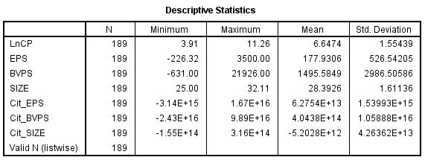
Hasil Uji Statistik Deskriptif

- Hasil Pengujian Regresi Tanpa Moderasi
Lampiran 3 B.1
Hasil Uji Fixed Effect
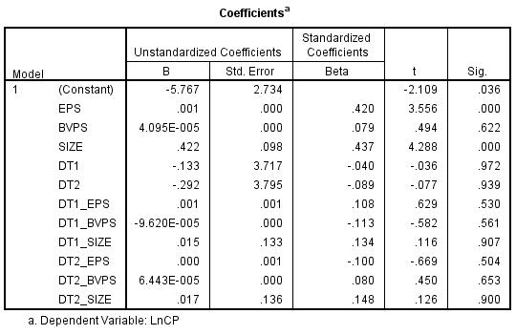

Lampiran 3 B.2
Hasil Uji Normalitas
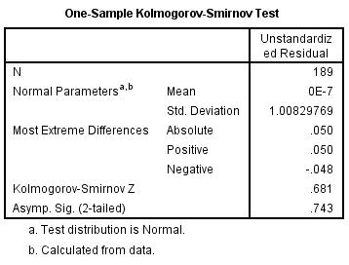

Lampiran 3 B.3
Hasil Uji Multikolinearitas
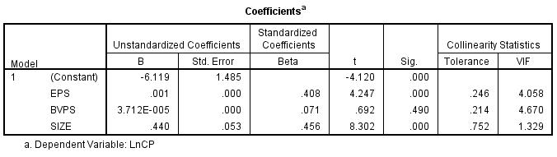

Lampiran 3 B.4
Hasil Uji Heterokedastisitas
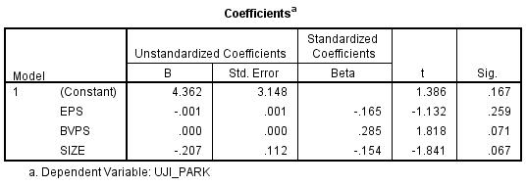

Lampiran 3 B.5
Hasil Uji Autokorelasi
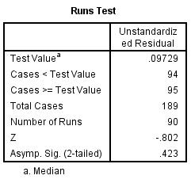
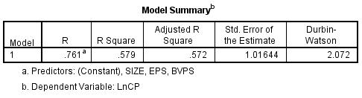
Lampiran 3 B.6
Hasil Uji Koefisien Determinasi yang Disesuaikan (Adjusted R²)
Lampiran 3 B.7
Hasil Uji Statistik F
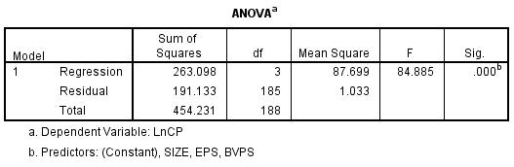

Lampiran 3 B.8
Hasil Uji Signifikansi t
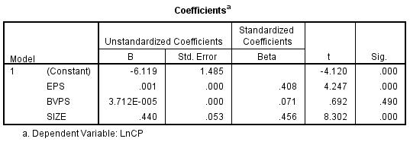

- Hasil Pengujian Regresi Tanpa Moderasi
Lampiran 3 C.1
Hasil Uji Koefisien Determinasi yang Disesuaikan (Adjusted R²)
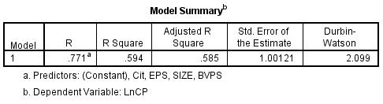
Lampiran 3 C.2
Hasil Uji Statistik F
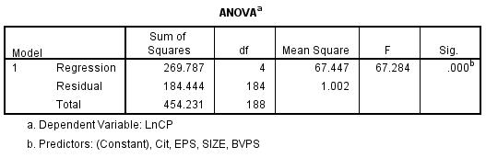

Lampiran 3 C.3
Hasil Uji Signifikansi t
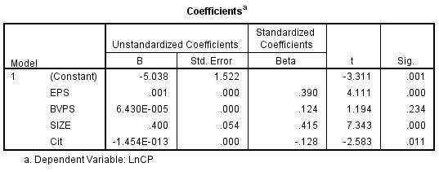

- Hasil Uji Regresi Dengan Moderasi
Lampiran 3 D.1
Hasil Uji Koefisien Determinasi yang Disesuaikan (Adjusted R²)
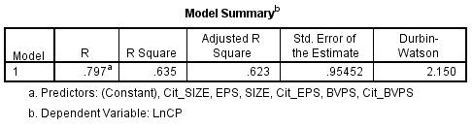
Lampiran 3 D.2
Hasil Uji Statistik F
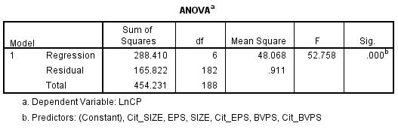

Lampiran 3 D.3
Hasil Uji Signifikansi t
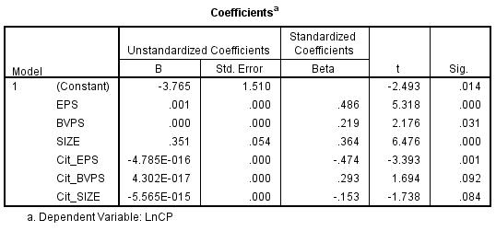

Lampiran 4
Matriks Penelitian
Penelitian Relevansi Nilai
No. | Penelitian dan Judul Penelitian | Variabel | Pengukuran | Data | Hasil Penelitian
1 | Almilia dan Susilowati, 2007. “Analisa Terhadap Relevansi Nilai Laba, Arus Kas Operasi Dan Nilai Buku Ekuitas Pada Periode Disekitar Krisis Keuangan Pada Perusahaan Manufaktur Di BEJ” | Dependen:  Harga Saham (P)  Independen:  1. Nilai laba akuntansi  2.Arus kas operasi  3. Nilai buku ekuitas | Dependen:  Harga saham penutupan  Independen:  1. Laba per lembar saham perusahaan i pada periode t  2. Nilai buku ekuitas per lembar perusahaan i pada periode t  3. Arus kas operasi per lembar saham perusahaan i pada periode t | Perusahaan manufaktur yang terdaftar di Bursa Efek Jakarta secara parsial pada tahun 1995-1998 dan tahun 2003-2004 dengan total sampel penelitian sebanyak 60 perusahaan. | 1.Variabel laba dan arus kas operasi mempunyai pengaruh yang signifikan terhadap variabel harga saham.  2.Variabel nilai buku mempunyai pengaruh yang sifnifikan terhadap harga saham pada tingkat signifikansi 5%.
2 | Kwon, 2009. “The Value Relevance Of Book Value, Earnings, And Cash Flows: Evidence From Korea” | Dependent:  Stock Price (Pt)  Independent:  1. BVPS  2. EPS  3. OCFS | Dependent:  Stock price 3 months after the end of fiscal year t, where year t is the event year.  Independent:  1. Book value at the end of year t-1  2. Earnings in period t  3. Operating Cash Flows in period t | Data from the KIS-FAS and KISRI stock databases. These data sets span the 12-year period from 1994 to 2005. | 1.Book value is more value relevance than earnings and cash flows  2.The value relevance of book value, earnings, and cash flows has declined.  3. The combined value relevance of book value and cash flows increase, while that of book value and earnings decrease.
3 | Viandita, 2013. “Pengaruh Debt Ratio (DR), Price To Earning Ratio (PER), Earning Per Share (EPS), dan Size Terhadap Harga Saham” | Dependen:  Harga saham  Independen:  1. Debt Ratio  2. Price To Earning Ratio  3. Earning Per Share  4.Size | Dependen:  Harga saham  Independen:  1. Debt Ratio  2. Price To Earning Ratio  3. Earning Per Share  4.Size | Perusahaan manufaktur di Bursa Efek Indonesia pada 38 perusahaan | 1. Secara simultan maupun secara parsial rasio-rasio keuangan yang diujikan terbukti berpengaruh secara signifikan terhadap harga  saham  2. Analisis parsial menunjukkan bahwa dari antara rasio-rasio keuangan  tersebut, earnings per share (EPS) memiliki pengaruh dominan terhadap harga  saham
4 | Vijitha and Nimalathasan B., 2014. "Value relevance of accounting information and share price: A study of listed manufacturing companies in Sri Lanka" | Dependent:  1. Share price  Independent:  1. EPS  2. NAVPS  3. ROE  4. PER | Dependent:  1. Share price  Independent:  1. EPS  2. NAVPS  3. ROE  4. PER | Listing manufacturing companies in Colombo Stock Exchange (CSE) during the periode 2009-2013 | 1. EPS, NAVPS, and ROE strong positive and significant  2. There is a week negative relationship between PER and share price
5 | Omokhudu, 2015. "The Value Relevance of Accounting Information: Evidence from Nigeria" | Dependent:  1. SHP1  2. SHP2  Independent:  1. EPS  2. BVPS  3. CFOPS | Dependent:  1. Share price 6 months after year end (SHP1)  2. Share price 3 months after year end (SHP2)  Independent:  1. Net income divided by number of share outstanding  2. Total shareholder equity divided by number of share outstanding | All companies listed in the Nigerian Stock Exchange (NSE) during the twenty year period 1994-2013 with a total sample of 940 firm years consists of 47 firms per year | 1. Accounting information especially form price model has value relevance in Nigerian Stock Exchange  2. The coefficient estimates from earnings, cash flow from operation are significants across all models, which means that these variables are strongly associated with firm value and thus value relevance 3. The focus of investor should be on earnings, cash flow from operation, and less emphasis should be on book value, that's why book value statistically insignificant with share price.
6 | Permana, 2015. “Pengaruh Relevansi Nilai Terhadap Keputusan Investor” | Dependen:  1. Harga Saham (P)  2. Return Saham (R)  Independen:  1. Earning Per Share  2. Book Value Per Share | Dependen:  1.Harga saham penutupan Desember  2.Return saham tahunan  Independen:  1. Laba bersih per lembar saham  2. Nilai buku per lembar saham | Perusahaan manufaktur dan non  manufaktur yang tercatat di BEI yang masuk di indeks LQ45 pada tahun 2010-2014. Sampel sebanyak 24 perusahanan dan total observasi sebesar 120 data sampel | 1. Relevansi BVPS dan EPS tidak berpengaruh terhadap harga saham  2. Relevansi BVPS dan EPS secara simultan dan parsial berpengaruh terhadap  return saham
7 | Pertiwi, dan Suhardianto, 2015. “Relevansi Nilai Selisih Loans Book Value dan Loans Fair Value, Book Value Per Share, Earnings Per Share dan Ukuran Perusahaan” | Dependen:  Harga Saham  Independen:  1. Selisih loans book value dan loans fair value  2. Book value per share  3. Earning Per Share  4. Size | Dependen:  Harga Saham  Independen:  1. Selisih loans book value dan loans fair value  2. Book value per share  3. Earning Per Share  4. Size | Sampel yang digunakan adalah 108 bank yang terdaftar di Bursa Efek Indonesia selama periode 2010-2013. | 1. Hasil penelitian ini adalah selisih book value dan loans fair value berpengaruh.  2. Variabel book value per share berpengaruh dan mempunyai relevansi nilai  3. Variabel earnings per share berpengaruh dan mempunyai relevansi nilai dalam menjelaskan harga saham.  4. Variabel ukuran perusahaan berpengaruh dan mempunyai relevansi nilai dalam menjelaskan harga saham.
8 | Uwuigbe et al, 2016. "Value relevance of financial statements and share price: a study of listed banks in Nigeria" | Dependent:  Share price  Independent:  1. Book value 2. Earnings per share  3. Return on net worth | Dependent:  Last day share price  Independent:  1. Book value of equity capital  2. Earnings per share  3. Return on net worth | 15 listed banks from the Nigerian Stock Exchange period 2010-2014 | 1. Significant positive relationship existed between earnings per sahre and last day share price  2. Significant negative relationship exist between book value per share and last day share price 3. The relationship between return on net worth and last day share price was not significant
9 | Acaranupong, 2017. "Comparative Value Relevance of Earnings, Book Values and Cash Flows: Empirical Evidence from Listed Companies on SET100 in Thailand" | Dependent: Stock prices  Independent:  1. Earnings  2. Book value 3. Cash flow | Dependent:  Stock's price per share of firm i three month after fiscal year ended t  Independent:  1. Earning per share of firm i year t  2. Book value of equity per share of firm i year t 3. Net cash flow from operation per share of firm i year t | 67 companies listed on SET 100. The period of study is years 2011-2015 | Earnings, book values, and cash flows, each of them is positively and signigicantly related to stock price

Penelitian Konservatisme Akuntansi
No. | Penelitian dan Judul Penelitian | Variabel | Pengukuran | Data | Hasil Penelitian
1 | Kousenidis, 2009. “Value relevance of conservative and non-conservative accounting information” | Dependent:  1.Price  2.Return  Independent:  1. Book value  2. Earning per share  3. Earning per share per price  4. Difference of earning per share per price | Dependent:  1.Share price of firm at year end  2. Return of shares at year end  Independent:  1. Book value of equity of firm at year end  2. Earning per share at firm at year end  3. Earning per share per price of firm divided by previous year’s share price  4. Difference of earning per share divided by previous year’s share price | Sample consist of companies in Greek (Athena Stock Exchange) over the period from 1989 to 2003. Total sample of 1035 observations, consist of 127 firms per year | 1.The result reveal that conservatism is a salient feature of the Greek financial reporting system.  2. The result also clearly indicate an increase in conservatism in the post-crash period.  3. The result non-linear relation between conservatism and value relevance for the whole period and increases when moving from the low conservatism portfolio to the medium conservatism portfolio and drops to lower levels when moving further to the high conservatism portfolio.
2 | Darsono, 2012. “Dampak Konservatisme Terhadap Relevansi Nilai Informasi di Indonesia” | Dependen:  Harga Saham  Independen:  1. Nilai Buku Ekuitas  2. Kinerja Perusahaan (laba bersih) (EPS)  3. Laba komprehensif lain  4. Pertumbuhan aset lancar operasi  5. Pertumbuhan aset tetap  6. Aset tak berwujud  Moderasi: Konservatisme Akuntansi | Dependen:  Harga Saham  Independen:  1. Nilai Buku Ekuitas akhir tahun – laba bersih tahun berjalan – pos surplus kotor  2. Laba bersih per saham  3. Pos surplus kotor dari NBE  4. Perubahan aset lancar operasi per saham  5. Perubahan aset tetap akhir tahun dibagi jumlah saham beredar  6. Dummy, dimana 1 berarti aset tetap tak berwujud dan 0 berarti tidak berwujud | Perusahaan manufaktur yang terdaftar di Bursa Efek Indonesia selama periode tahun 2000-2009, dengan total observasi sebanyak 840 data sampel | 1. Nilai buku ekuitas, kinerja perusahaan, laba komperhensif lain, pertumbuhan aset tetap, dan aset tak berwujud berpengaruh positif terhadap harga saham. Sedangkan aset lancar operasi memiliki pengaruh yang negatif terhadap harga saham  2. Konservatisme akuntansi terbukti memperkuat relevansi nilai buku ekuitas dan laba komprehensif terhadap harga saham, namu memperlemah relevansi nilai kinerja perusahaan, aset lancar operasi, pertumbuhan aset tetap, dan aset tak berwujud terhadap harga saham
3 | Sari, 2014. “Pengaruh Tingkat Konservatisme Terhadap Relevansi Nilai Informasi Laba Akuntansi” | Dependen:  Return Saham  Independen:  1. Earnings  2. Earnings change  Moderasi: Konservatisme Akuntansi | Dependen:  Selisih antara harga saham tahun berjalan dengan harga saham sebelumnya dibagi dengan harga saham tahun sebelumnya  Independen:  1. Laba per saham dibagi harga saham awal tahun fiskal  2. Perubahan laba per saham dibagi harga saham awal tahun fiskal  Moderasi:  Model (Basu,1997) | Perusahaan manufaktur yang terdaftar di Bursa Efek Indonesia selama periode 2009-2012. Sampel yang diperoleh 63 perusahaan sampel | Hasil penelitian membuktikan bahwa penerapan konservatisme berpengaruh positif terhadap relevansi nilai informasi laba akuntansi. Relevansi nilai informasi laba akuntansi meningkat dari perusahaan tergolong low conservatism ke medium conservatism, dan kembali mengalami peningkatan dari perusahaan medium conservatism ke high conservatism.

