LAMPIRAN
Lampiran 1 – Promosi
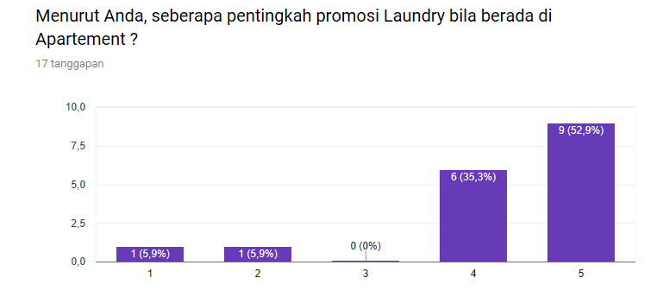
Lampiran 2 – Lokasi
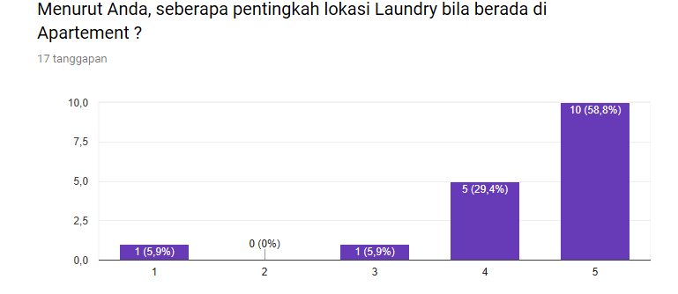
Lampiran 3 – Harga
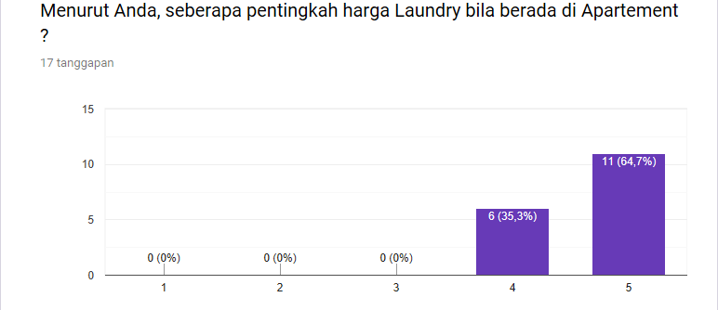
Lampiran 4 – Kualitas Cucian
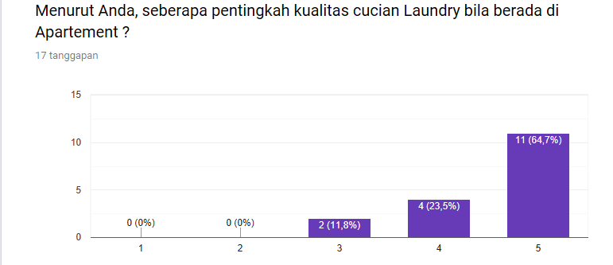
Lampiran 5 – Pelayanan
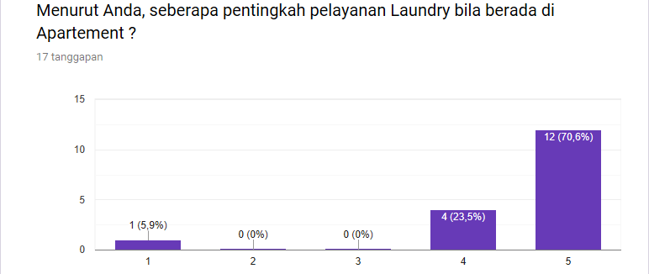

Lampiran 6 – Blue Laundry
