**LAMPIRAN RESPON KUESIONER KEDAI *PHAO-PHAO THAI TEA***

LAMPIRAN 1 – Jenis Kelamin

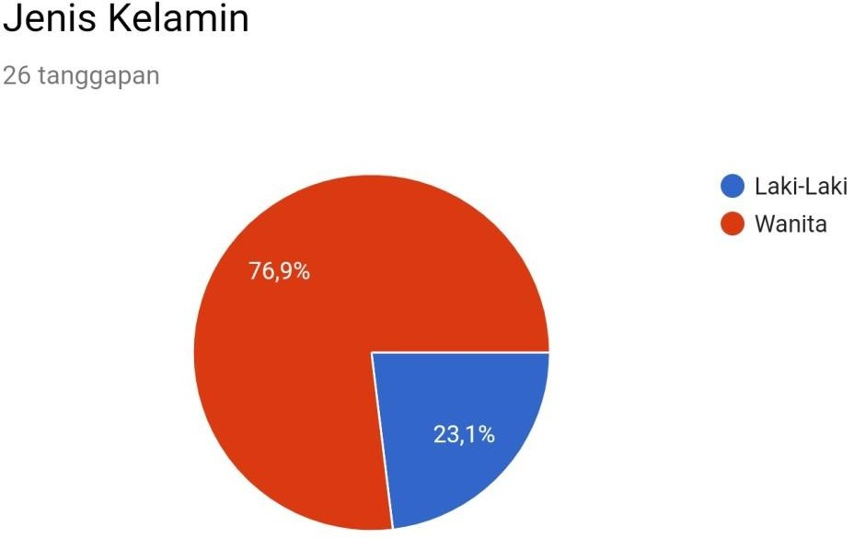

LAMPIRAN 2 - Usia

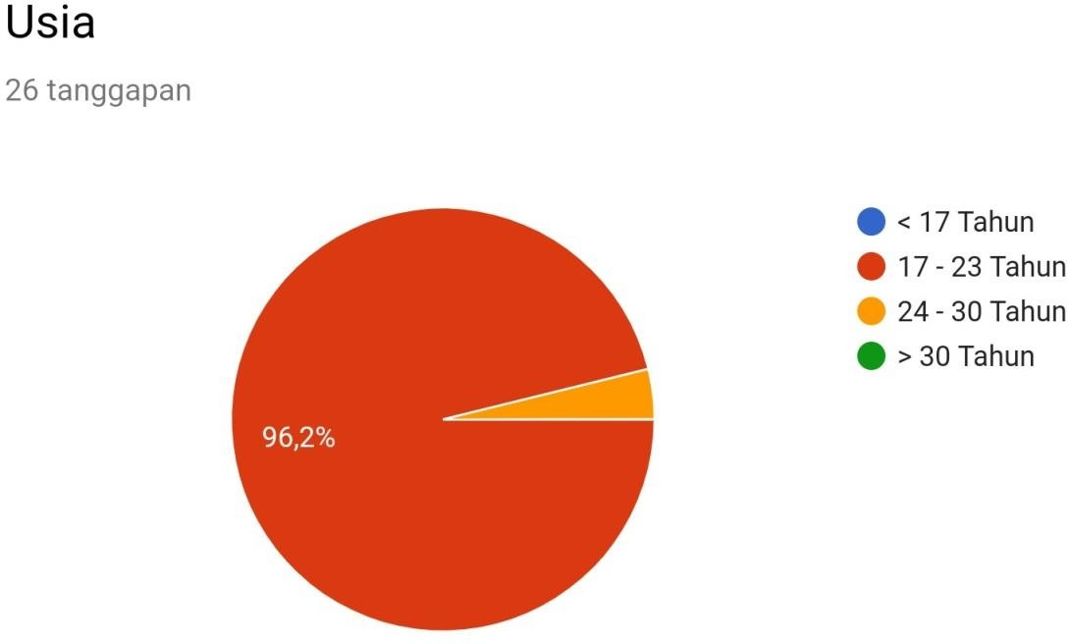

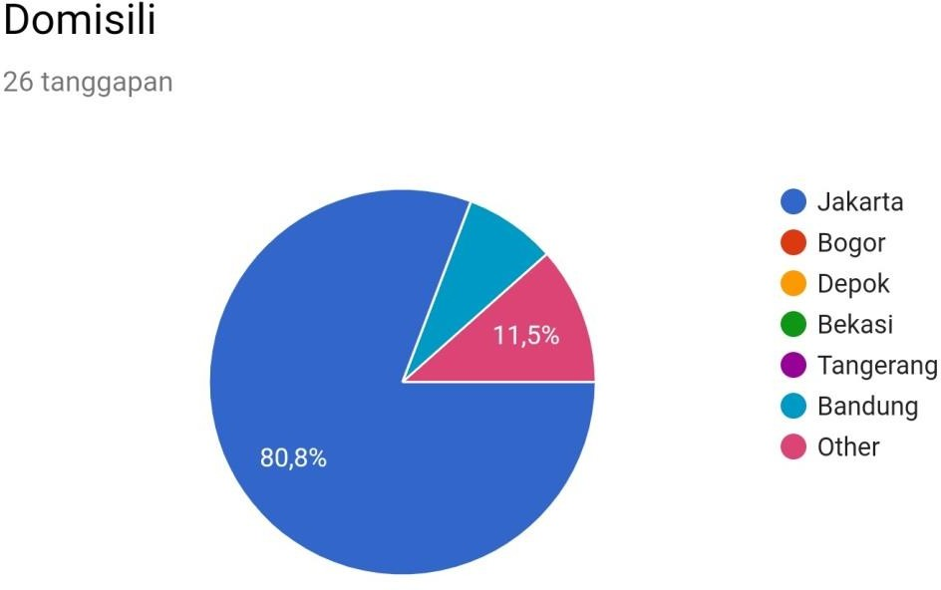

LAMPIRAN 4 - Pekerjaan

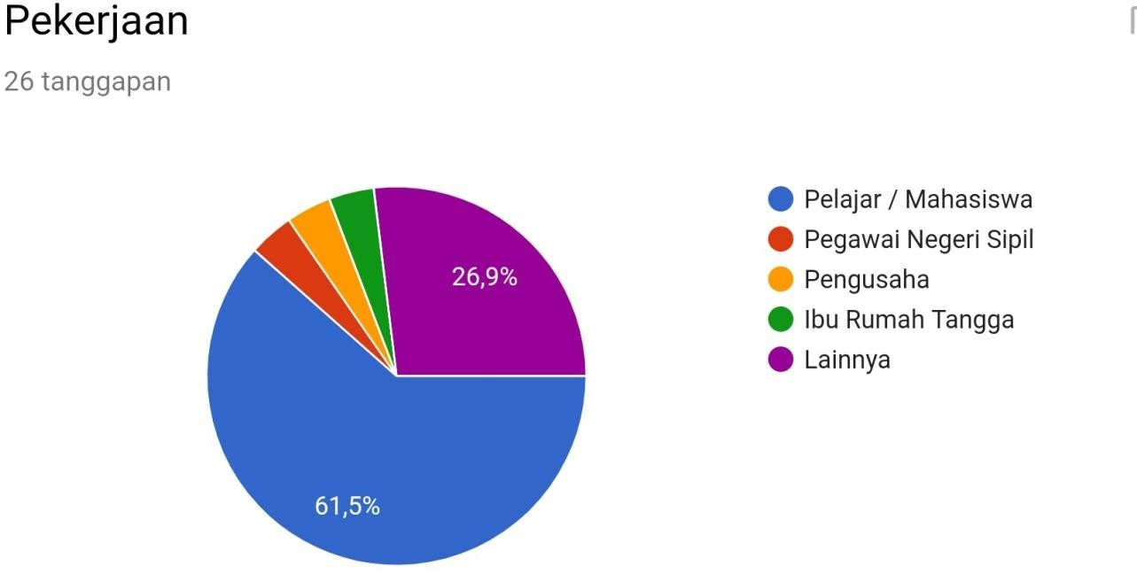

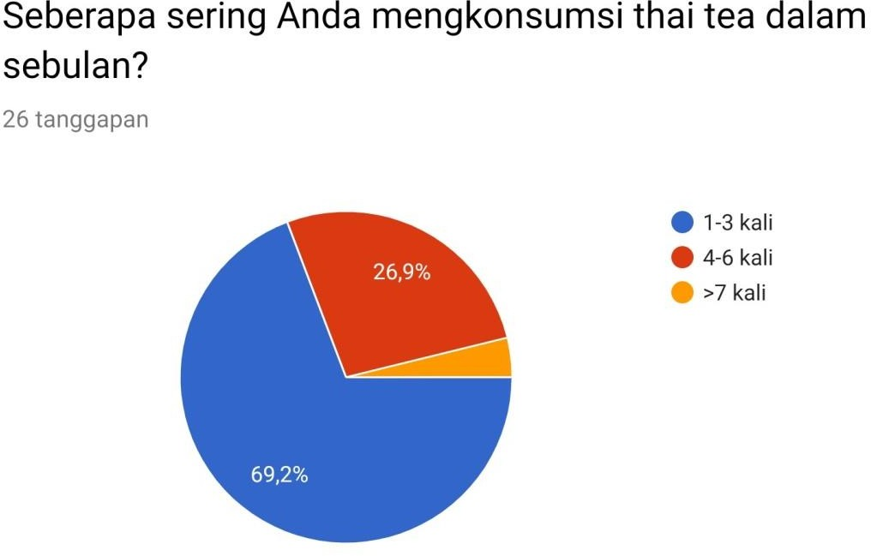

LAMPIRAN 6 - Lokasi

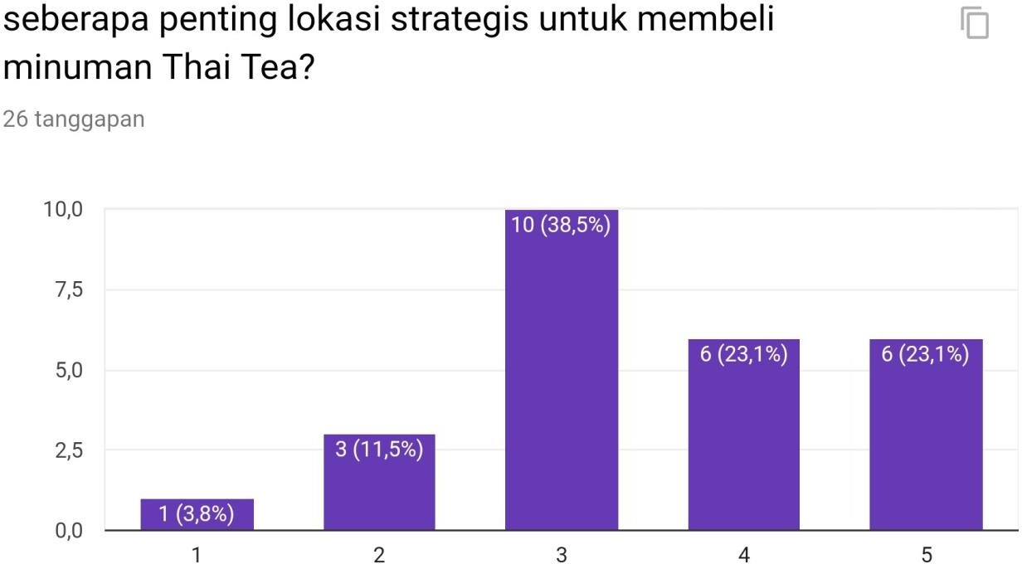

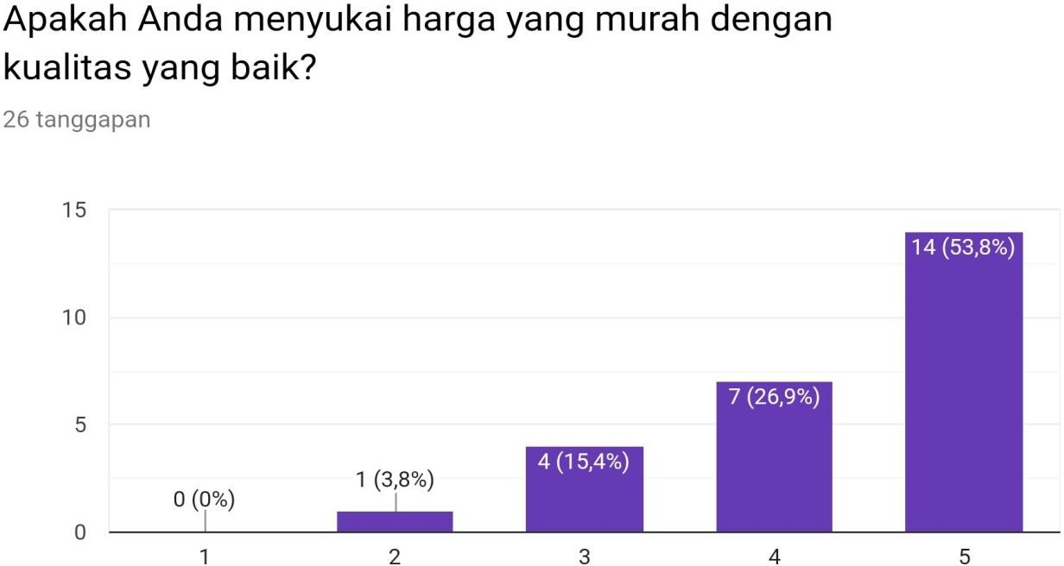

LAMPIRAN 8 – Varian rasa

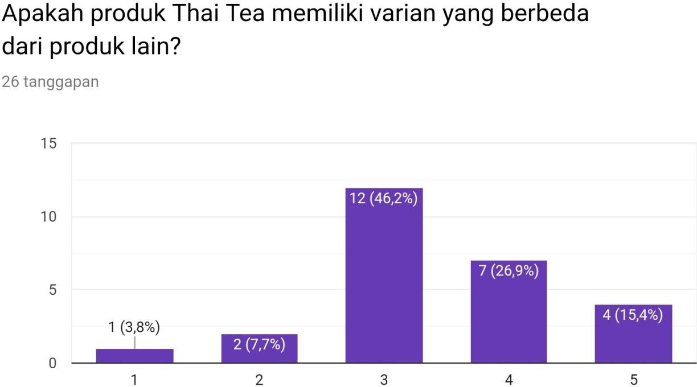

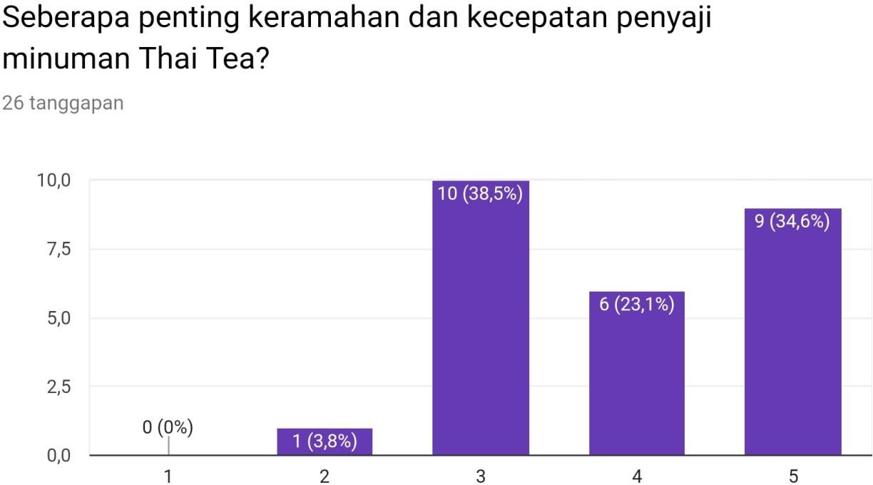

LAMPIRAN 10 – Informasi Thai Tea

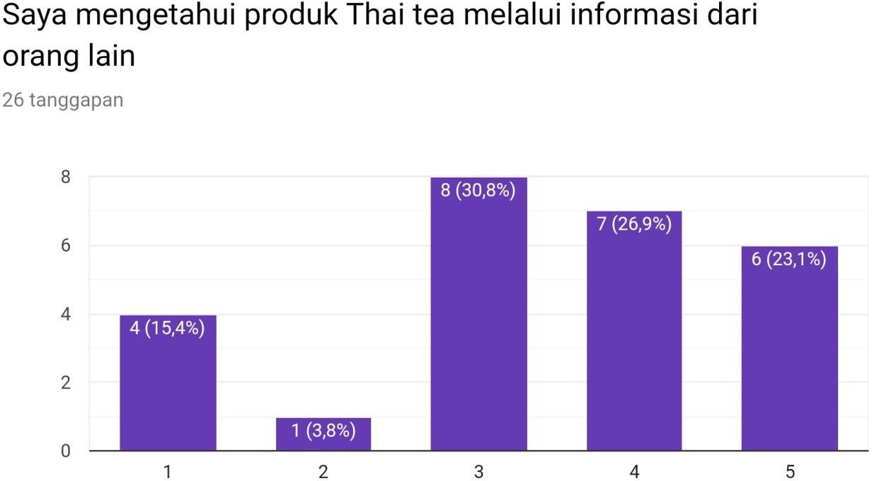

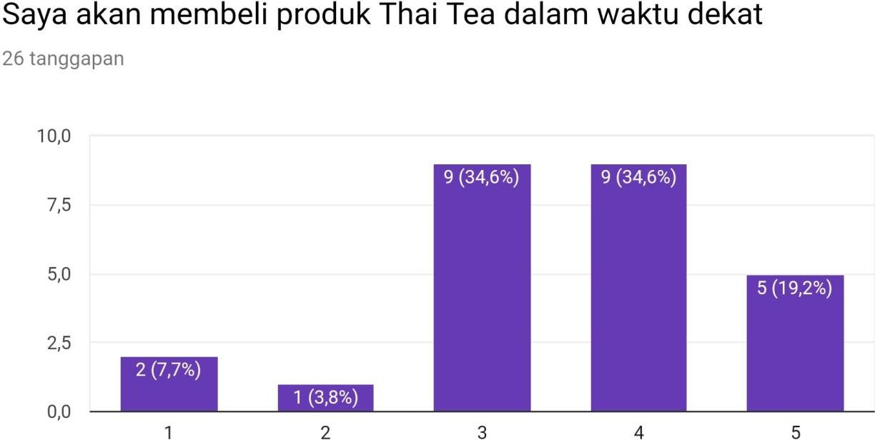

**LAMPIRAN 12 – Media Sosial *Instagram***

