**LAMPIRAN**

**Lampiran 1 – Biaya Bahan Baku Kedai Kopi “Yuk Ngopi?!” Tahun 2020**

|  |  |  |  |  |
| --- | --- | --- | --- | --- |
| **No** | **Keterangan Bahan Pokok** | **Harga** | **Jumlah Unit** | **Total** |
| 1 | Air Galon/19L | Rp 5,000 | 24 | Rp 120,000 |
| 2 | Es batu/kantong | Rp 17,000 | 30 | Rp 510,000 |
| 3 | Beans-Arabica/kg | Rp 235,000 | 1 | Rp 235,000 |
| 4 | Beans-Arabica/kg | Rp 250,000 | 1 | Rp 250,000 |
| 5 | Beans-Robusta/kg | Rp 148,600 | 1 | Rp 148,600 |
| 6 | Beras/5 kg | Rp 80,000 | 1 | Rp 80,000 |
| 7 | Biji Wijen/pack | Rp 6,000 | 1 | Rp 6,000 |
| 8 | Chicken Pokpok/500gr | Rp 46,000 | 1 | Rp 46,000 |
| 9 | Classic Black Tea/pack | Rp 50,000 | 1 | Rp 50,000 |
| 10 | Cookies Chocochips/pc | Rp 750 | 100 | Rp 75,000 |
| 11 | Cookies Plain/pc | Rp 750 | 100 | Rp 75,000 |
| 12 | Cookies Hungarian Cheese/pc | Rp 1,500 | 25 | Rp 37,500 |
| 13 | Brioche | Rp 8,000 | 10 | Rp 80,000 |
| 14 | Creamer/dus | Rp 600,000 | 3 | Rp 1,800,000 |
| 15 | Daging Ayam/kg | Rp 65,000 | 1 | Rp 65,000 |
| 16 | Filter V60/pc | Rp 1,000 | 100 | Rp 100,000 |
| 17 | French Fries/kg | Rp 95,000 | 1 | Rp 95,000 |
| 18 | Gula Jawa/dus | Rp 150,000 | 2 | Rp 300,000 |
| 19 | Gula Pasir/bags | Rp 12,500 | 1 | Rp 12,500 |
| 20 | Lipton Geinmacha/pack | Rp 62,900 | 1 | Rp 62,900 |
| 21 | Lipton English Breakfast/pack | Rp 70,000 | 1 | Rp 70,000 |
| 22 | Lipton Sencha/pack | Rp 70,000 | 1 | Rp 70,000 |
| 23 | Mayonais/pack | Rp 54,000 | 1 | Rp 54,000 |
| 24 | Minyak/L | Rp 30,000 | 1 | Rp 30,000 |
| 25 | Monin Caramel Syrup/btl | Rp 121,000 | 2 | Rp 242,000 |
| 26 | Monin Hazelnut Syrup/btl | Rp 121,000 | 2 | Rp 242,000 |
| 27 | Monin Lemon Syrup/btl | Rp 121,000 | 2 | Rp 242,000 |
| 28 | Monin Lychee Syrup/btl | Rp 121,000 | 2 | Rp 242,000 |
| 29 | Monin Vanilla Syrup/btl | Rp 121,000 | 2 | Rp 242,000 |
| 30 | Naraya Lychee/kaleng | Rp 26,000 | 2 | Rp 52,000 |
| 31 | Onion Rings/pack | Rp 70,000 | 1 | Rp 70,000 |
| 32 | Potato Nugget/2kg | Rp 130,000 | 1 | Rp 130,000 |
| 33 | Powder Strwaberry/kg | Rp 150,000 | 1 | Rp 150,000 |
| 34 | Powder Cokelat/kg | Rp 100,000 | 1 | Rp 100,000 |
| 35 | Powder Greentea/kg | Rp 270,000 | 1 | Rp 270,000 |
| 36 | Rumput Laut/pack | Rp 60,000 | 1 | Rp 60,000 |

*Lanjutan Lampiran 1*

|  |  |  |  |  |
| --- | --- | --- | --- | --- |
| 37 | Saori Teriyaki/pack | Rp 22,000 | 1 | Rp 22,000 |
| 38 | Saori Blackpaper/pack | Rp 22,000 | 1 | Rp 22,000 |
| 39 | Saus Sambal/btl | Rp 16,000 | 2 | Rp 32,000 |
| 40 | Saus Tomat/btl | Rp 16,000 | 2 | Rp 32,000 |
| 41 | Kulit Ayam/kantong | Rp 35,000 | 1 | Rp 35,000 |
| 42 | Susu Kental Manis/dus | Rp 390,000 | 3 | Rp 1,170,000 |
| 43 | Susu Segar/dus | Rp 152,460 | 3 | Rp 457,380 |
| 44 | Telur/kg | Rp 25,000 | 1 | Rp 25,000 |
| 45 | Thai Tea/dus | Rp 590,000 | 1 | Rp 590,000 |
| 46 | Timun Jepang/buah | Rp 10,500 | 1 | Rp 10,500 |
| 47 | Selada/kg | Rp 12,000 | 1 | Rp 12,000 |
| 48 | Kol Ungu/kg | Rp 6,000 | 1 | Rp 6,000 |
| 49 | Jagung Pipil Rebus/kg | Rp 16,000 | 1 | Rp 16,000 |
| 50 | Wortel/kg | Rp 10,000 | 1 | Rp 10,000 |
| 51 | Bawang Bombay/kg | Rp 16,000 | 1 | Rp 16,000 |
| 52 | Tofu/kg | Rp 15,000 | 1 | Rp 15,000 |
| 53 | Powder Orange/kg | Rp 150,000 | 1 | Rp 150,000 |
| **Total 1 Bulan** | | | | **Rp 9,035,380** |
| **Total 1 Tahun** | | | | **Rp 108,424,560** |

Sumber: *Biru Air, CV. Sentral Es Kristal, Juno, PT. Toffin Indonesia, Otten Coffee, Pasar Impres, Prima Fiesta, Beverage Marketplace, Melati Baked House, Susana Djuniwar, Tokopedia, Toko Akong, Lipton, Mama Suka, Prima Group, Indomaret, PT. Sukanda Djaya, Lottemart, data diolah.*

**Lampiran 2 – Proyeksi Biaya Bahan Baku Kedai Kopi “Yuk Ngopi?!” Tahun 2020 – 2024**

Sumber: *Kedai kopi “Yuk Ngopi?!”*

**Lampiran 3 – Data Inflasi**

|  |  |
| --- | --- |
| **Bulan Tahun** | **Tingkat Inflasi** |
| Oktober 2018 | 3.16 % |
| September 2018 | 2.88 % |
| Agustus 2018 | 3.20 % |
| Juli 2018 | 3.18 % |
| Juni 2018 | 3.12 % |
| Mei 2018 | 3.23 % |
| April 2018 | 3.41 % |
| Maret 2018 | 3.40 % |
| Februari 2018 | 3.18 % |
| Januari 2018 | 3.25 % |
| Desember 2017 | 3.61 % |
| Nopember 2017 | 3.30 % |
| Oktober 2017 | 3.58 % |
| September 2017 | 3.72 % |
| Agustus 2017 | 3.82 % |
| Juli 2017 | 3.88 % |
| Juni 2017 | 4.37 % |
| Mei 2017 | 4.33 % |
| April 2017 | 4.17 % |
| Maret 2017 | 3.61 % |

Rata-rata inflasi 3,52%

**Lampiran 4 – Tarif Dasar Air**

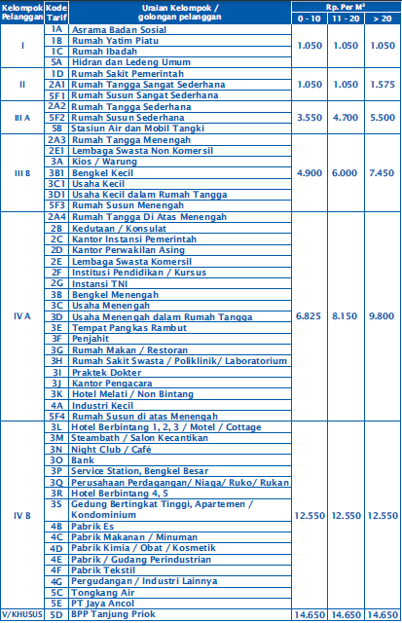

**Lampiran 5 – Tarif Dasar Listrik**

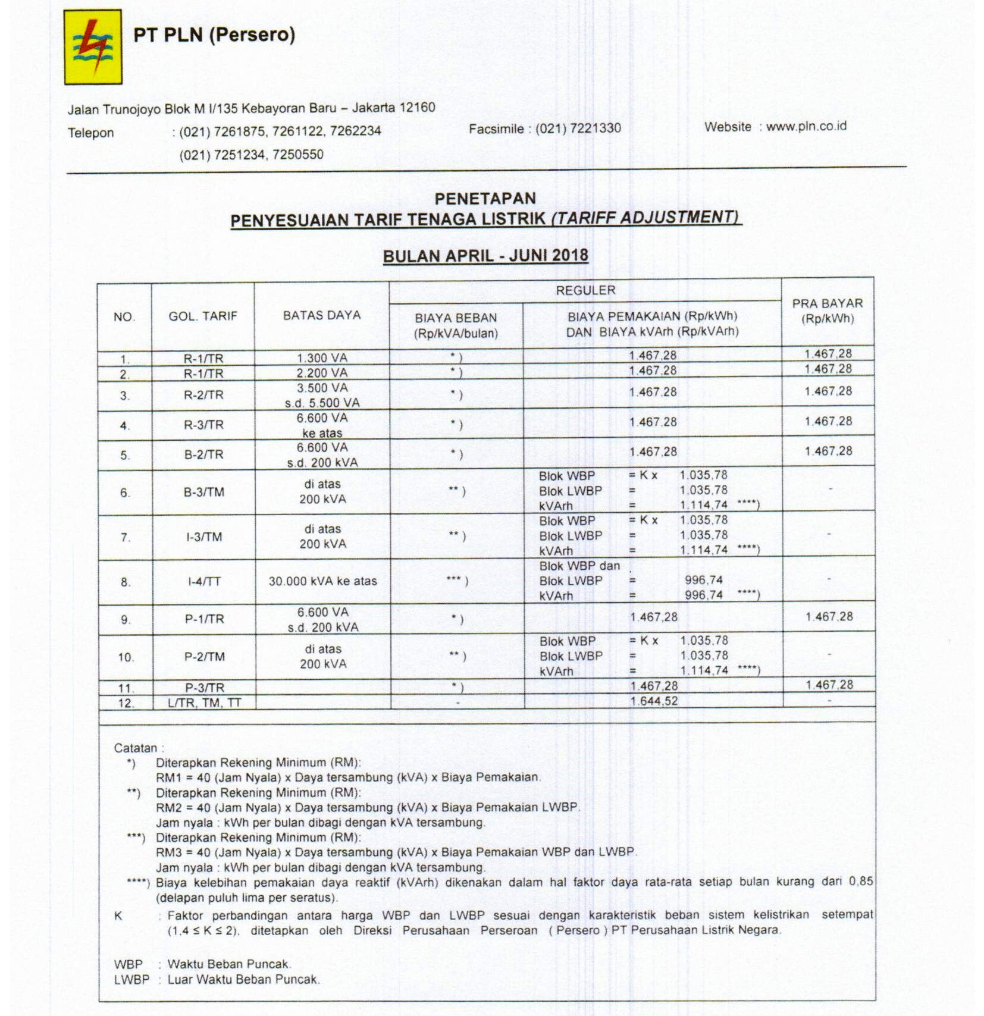

**Lampiran 6 - Respon Kuisioner Kedai Kopi “Yuk Ngopi?!”**

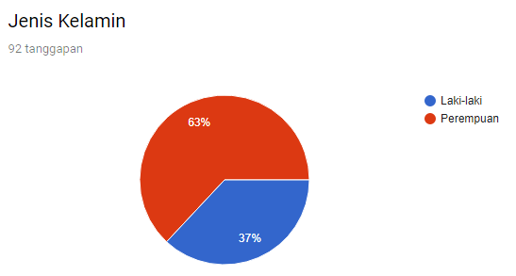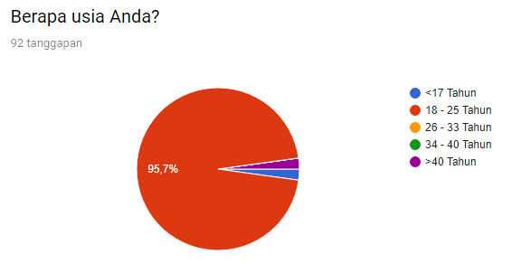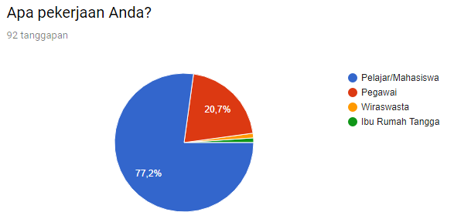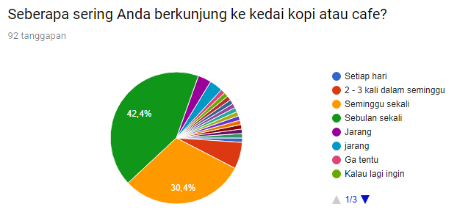

*Lanjutan lampiran 6*

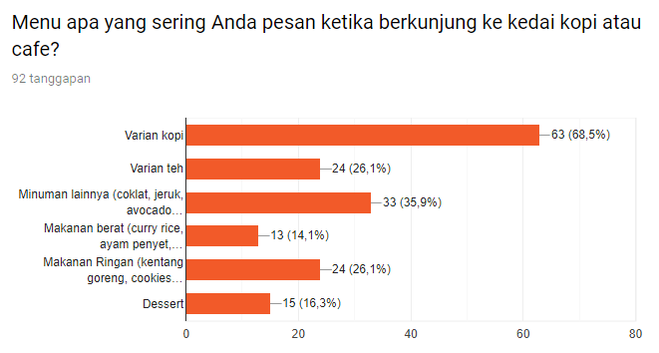

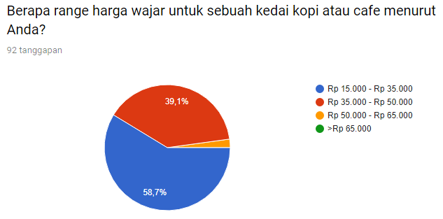



1 = sangat tidak penting, 6 = sangat penting

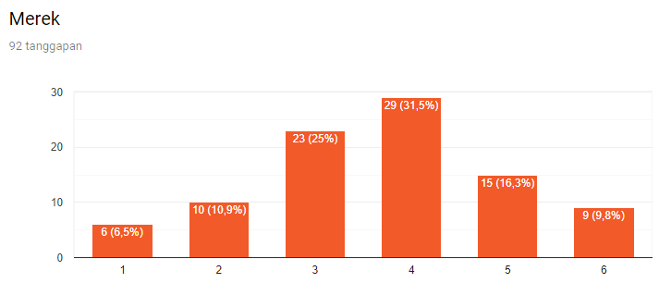

*Lanjutan lampiran 6*

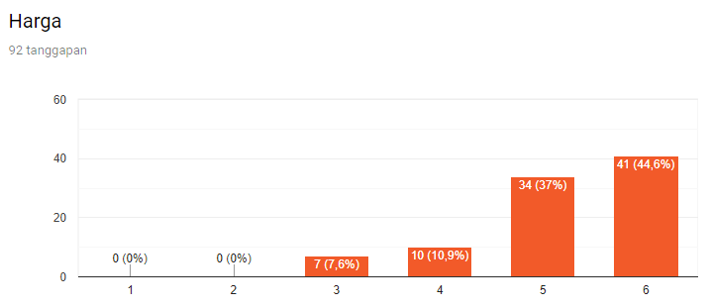

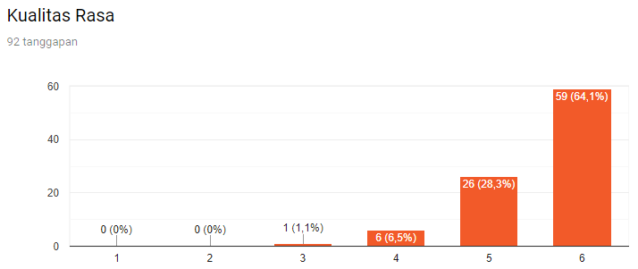

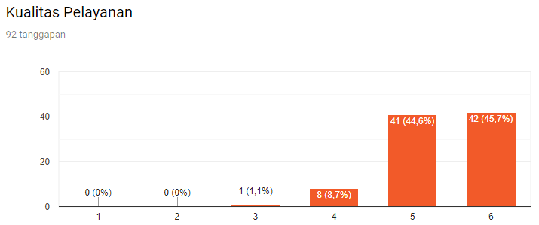

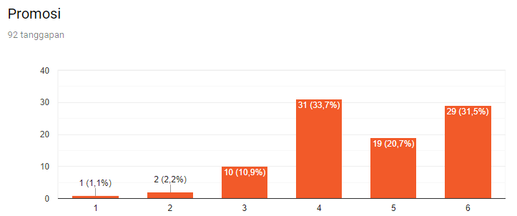

*Lanjutan lampiran 6*

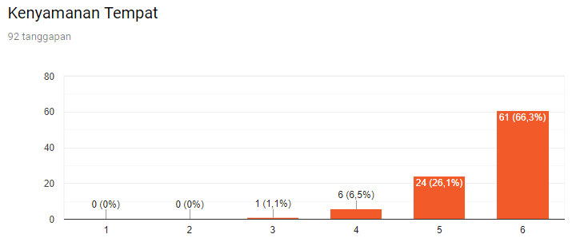

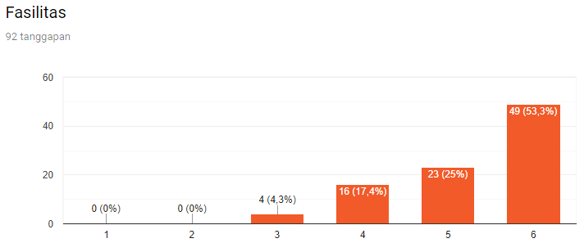

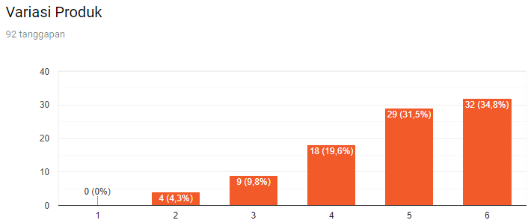

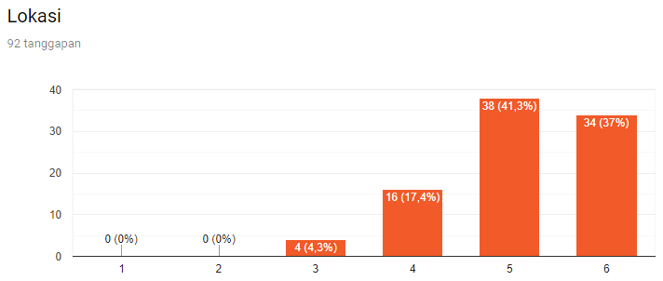

**Lampiran 7 – Desain Interior Klasik dan *Street Art* Kedai Kopi “Yuk Ngopi?!”**





**Lampiran 8 – *Partner* *Influencer Food Blogger* Kedai Kopi “Yuk Ngopi?!”**

Jktfooddestination Jktfoodbang

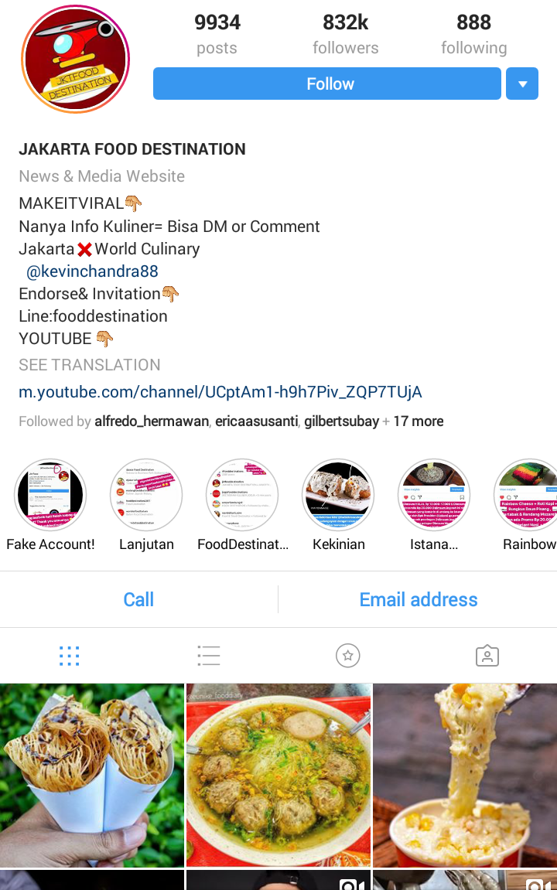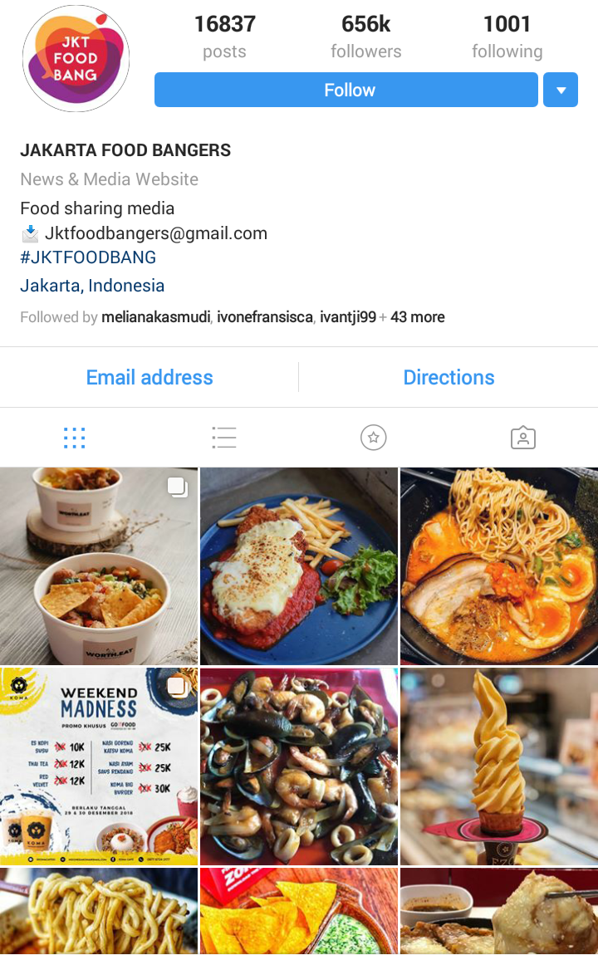

*Lanjutan lampiran 8*

Mgdalenaf Gedeinperut

