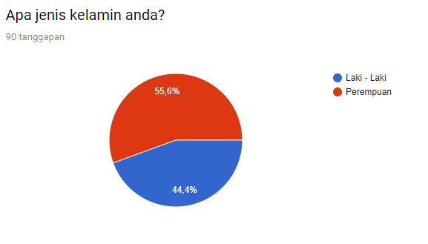
LAMPIRAN
Lampiran 1
Responden Kuesioner Coffee Shop Nā Kūlana
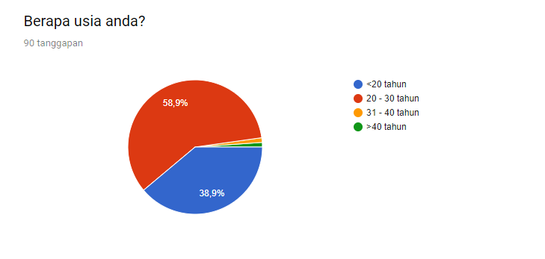

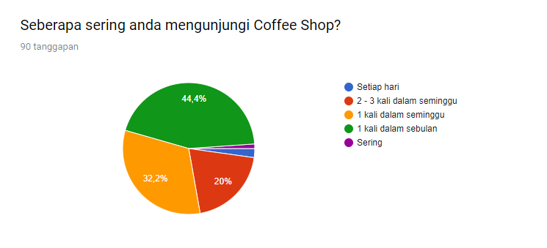

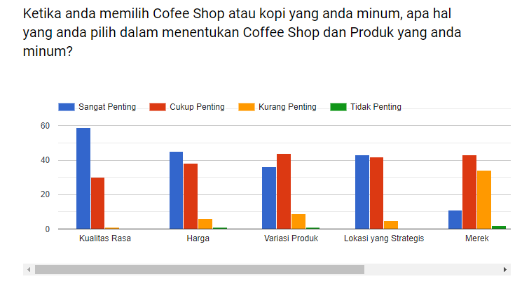
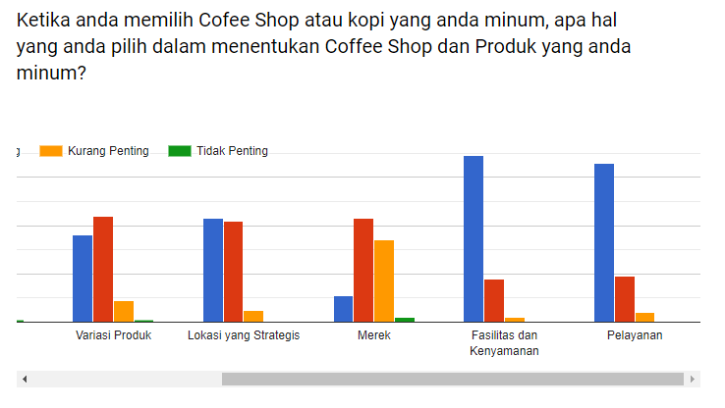

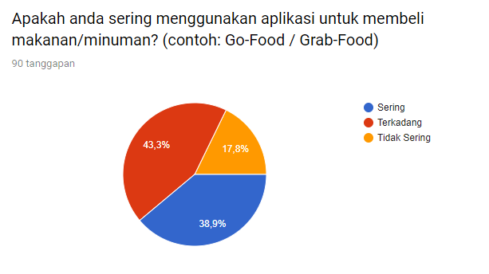

https://docs.google.com/forms/d/1X0WimM-rtkGxr1rjpk35xMZcj8KPkw0wgxPmNH3tNOw/edit#responses

