LAMPIRAN
Lampiran 1 Jenis Kelamin 86 Responden
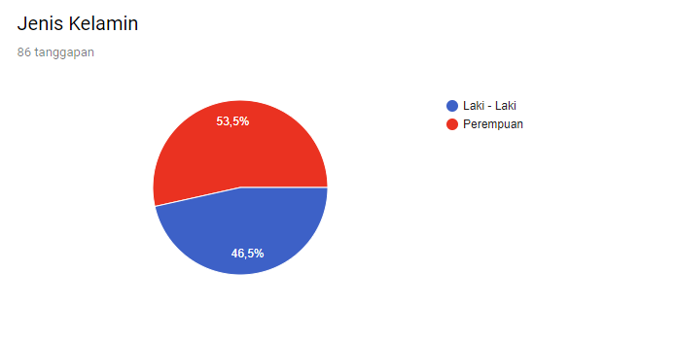

Lampiran 2 Usia 86 Responden
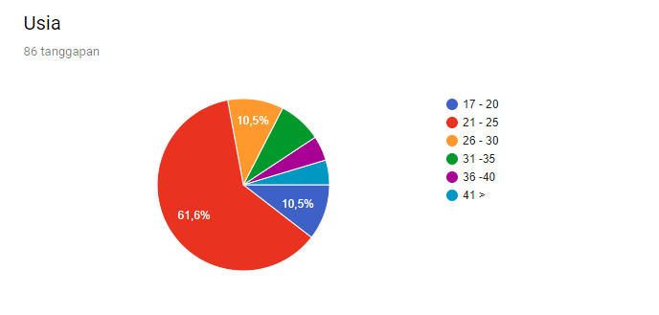

Lampiran 3 Pekerjaan 86 Responden
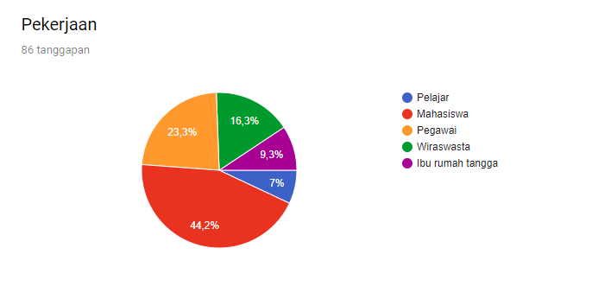

Lampiran 4 Opini 86 Responden Terhadap Kebutuhan Furnitur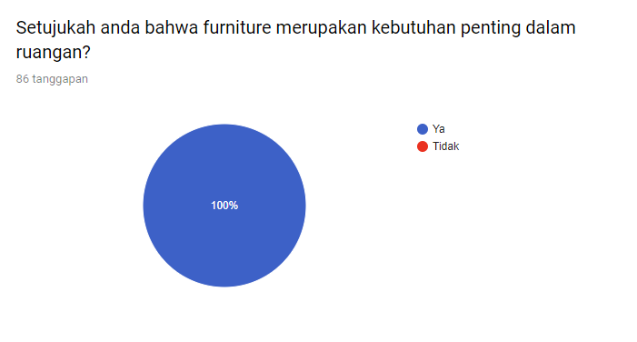

Lampiran 5 Opini 86 Responden Terhadap Kebutuhan Furnitur
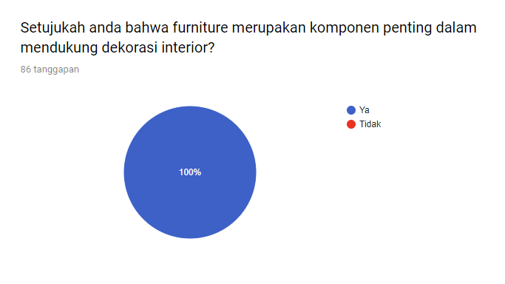

Lampiran 6 Opini 86 Responden Terhadap Harga Furnitur
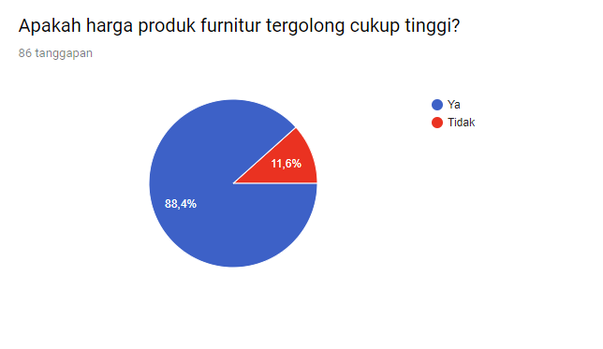

Lampiran 7 Prioritas Pertimbangan 86 Responden Terhadap Toko Furnitur
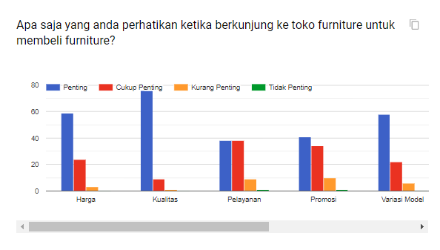

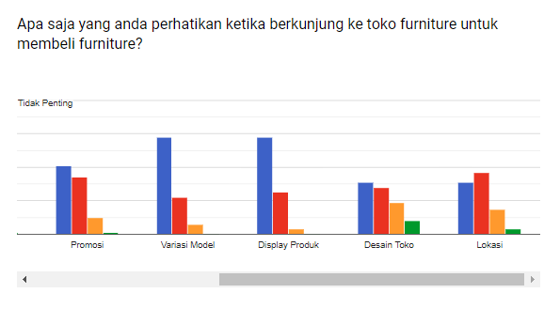

Lampiran 8 Harga Modal Produk Mebelloka Furnitur
No | Kode Produk | Harga
1 | ST-J | Rp2,525,000
2 | KT-MT | Rp2,650,000
3 | SKT-S | Rp2,750,000
4 | SK-L | Rp1,650,000
5 | SB-B | Rp1,500,000
6 | SB-L | Rp2,650,000
7 | MT | Rp710,000
8 | LH | Rp1,055,000
9 | BUF | Rp2,090,000
10 | RT-K | Rp435,000
11 | RT-J | Rp860,000
12 | MM-4k | Rp1,706,000
13 | MM-6k | Rp2,300,000
14 | KS-2pt | Rp1,361,000
15 | KS-3pt | Rp1,830,000
16 | RP-2Pt | Rp450,000
17 | RP-3pt | Rp550,000
18 | LS-2pt | Rp1,000,000
19 | LS-3pt | Rp1,200,000
20 | MB-K | Rp523,000
21 | MB-S | Rp827,000
22 | MB-B | Rp1,115,000
23 | MB-Kar | Rp1,061,000
24 | MK | Rp336,000
25 | MKK | Rp381,000
26 | RB | Rp430,000
27 | KP | Rp382,000
28 | LP-2pt | Rp1,400,000
29 | LP-3pt | Rp1,840,000
30 | LP-Kar | Rp1,573,000
31 | SBS-01 | Rp4,074,246
32 | SBS-02 | Rp4,328,886
33 | SBS-03 | Rp5,234,274
34 | SBS-04 | Rp5,394,604
35 | SBS-05 | Rp2,640,715
36 | SBS-06 | Rp2,937,795
37 | SBS-07 | Rp3,560,250
38 | SBS-08 | Rp3,692,285
39 | SBS-09 | Rp2,499,248
40 | SBS-10 | Rp2,546,404
41 | SBS-11 | Rp3,131,134
42 | SBS-12 | Rp3,201,867
43 | MR-01 | Rp1,052,000
44 | MR-02 | Rp1,599,000
45 | D-01 | Rp49,000
46 | D-02 | Rp189,000
47 | D-03 | Rp48,500
48 | D-04 | Rp69,000
49 | D-05 | Rp160,000
50 | D-06 | Rp150,000
51 | D-07 | Rp60,900

Lampiran 9 Inflasi di Indonesia per Tahun
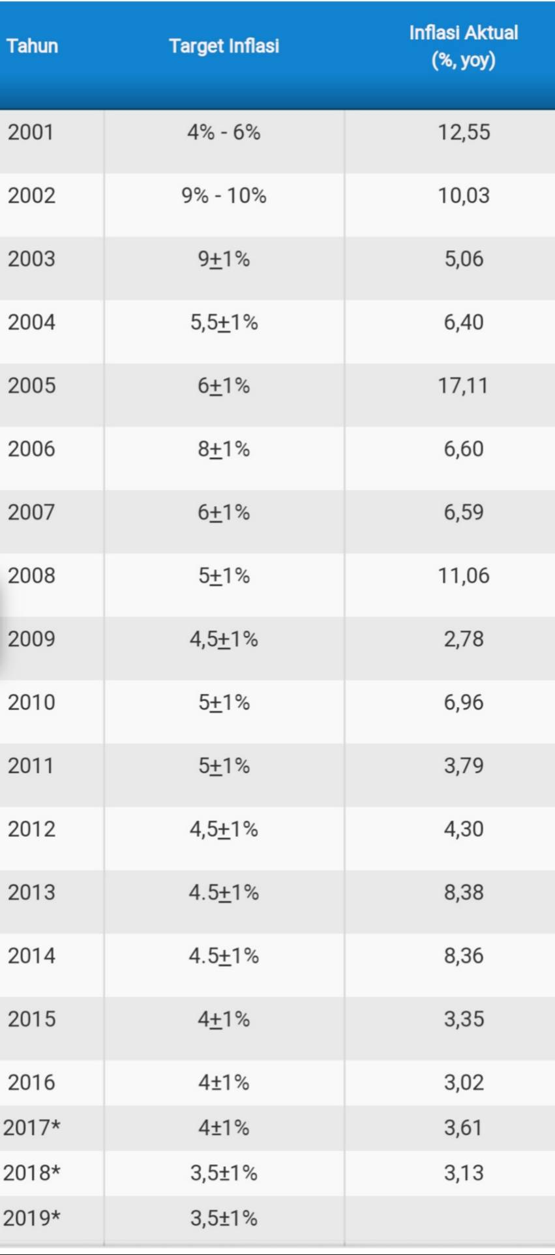

Lampiran 10 Desain Interior Kamar Tidur
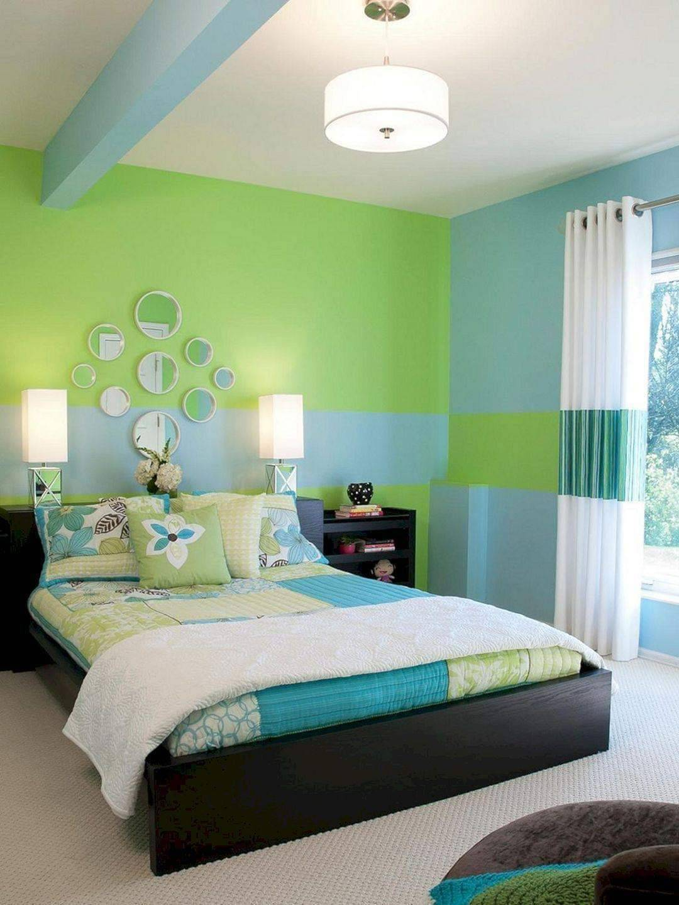

Lampiran 11 Desain Interior Ruang Tamu
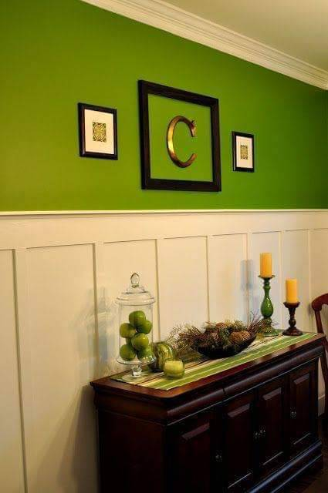

Lampiran 12 Desain Interior Ruang Tamu
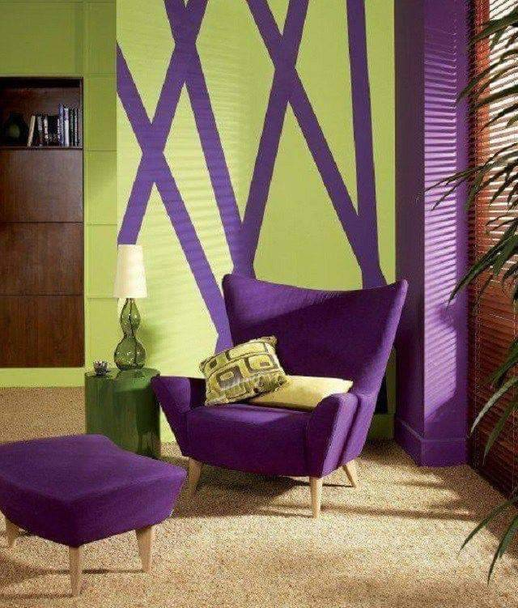

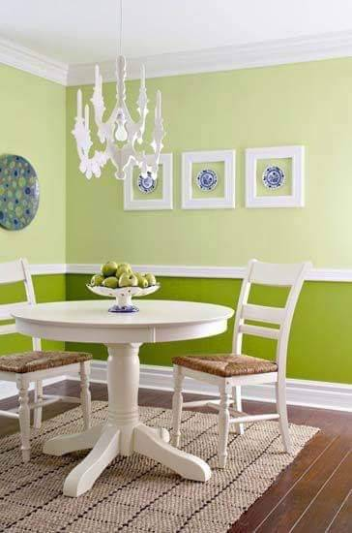
Lampiran 13 Desain Interior Ruang Makan

