LAMPIRAN

Lampiran 1
Tarif Air di DKI Jakarta
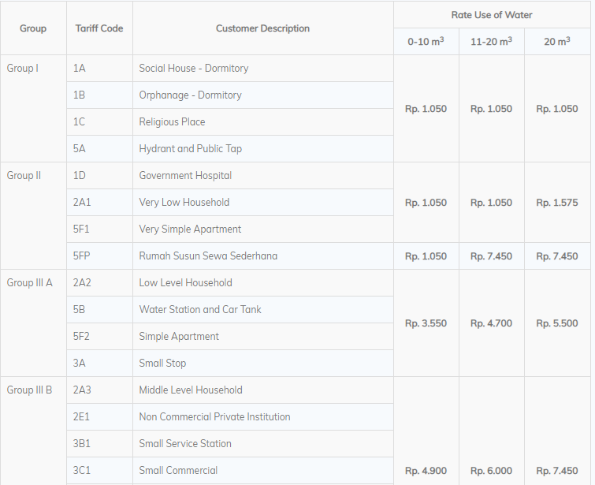
Sumber : http://pamjaya.co.id/id/customer-info/drinking-water-tariff

Lampiran 2
Rata-Rata Tingkat Suku Bunga Pinjaman Investasi Bank Swasta Nasional
Bulan | Suku Bunga (%)
Januari | 10,81
Februari | 10,72
Maret | 10,69
April | 10,65
Mei | 10,63
Juni | 10,67
Juli | 10,64
Agustus | 10,66
September | 11,02
Oktober | 10,67
Rata-Rata | 10,72
Sumber : https://www.bi.go.id/seki/tabel/TABEL1_26.pdf
Lampiran 3
Tarif Listrik
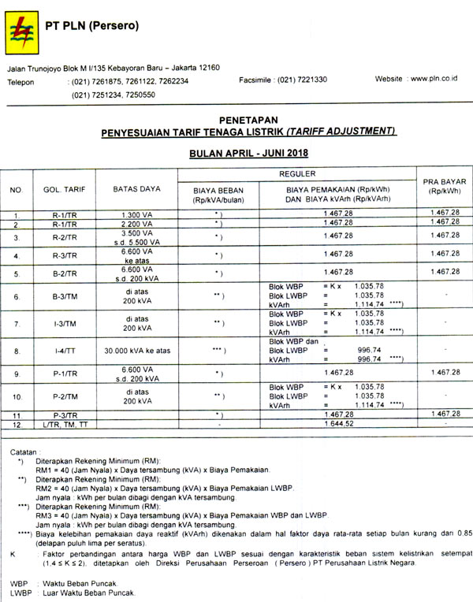
Sumber : http://www.pln.co.id/statics/uploads/2018/05/Tariff-Adjustment-April-Juni-2018-1.jpg

Lampiran 4
Responden Survey Studio Jeans

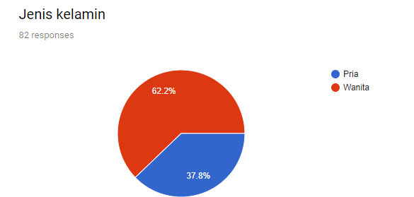

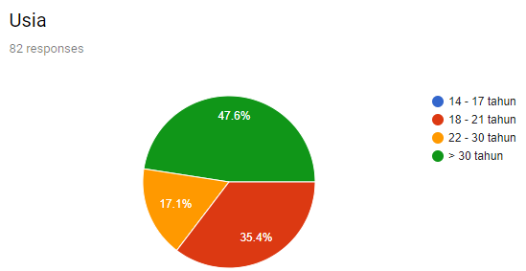
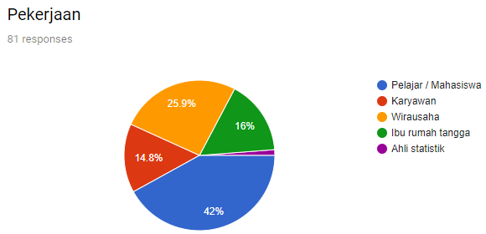
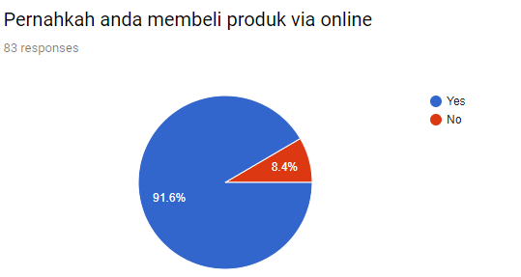
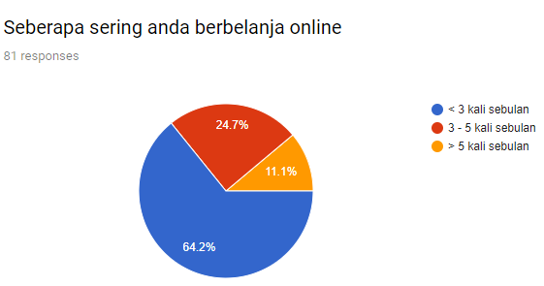
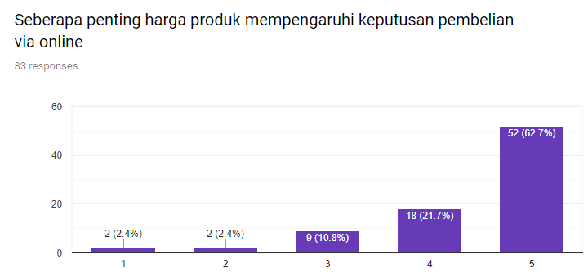
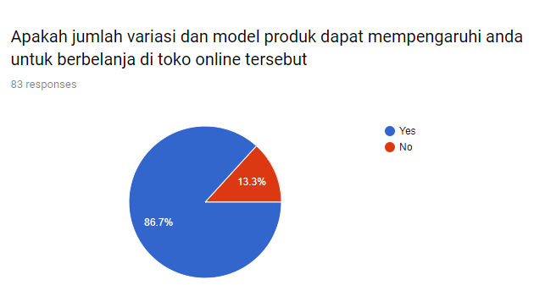
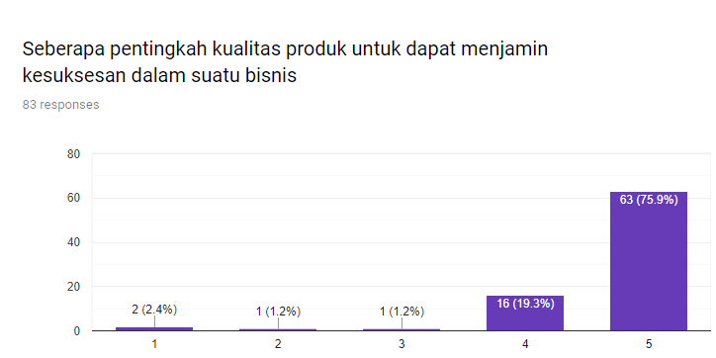
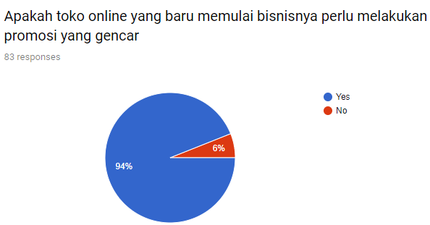

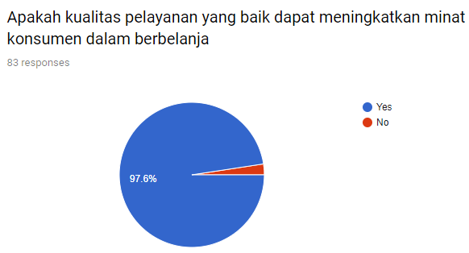
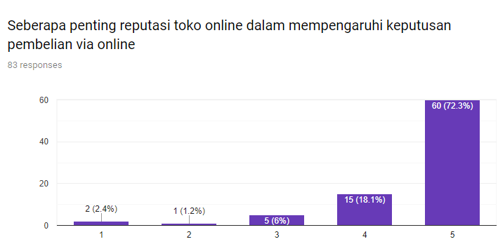
Sumber:https://docs.google.com/forms/d/1DbHqedslazj2gnKYNlLxKW6TkpflMW7sLst5rp10Qg/edit?vc=0&c=0&w=1#responses

