**LAMPIRAN**

**Lampiran 1 – Lokasi Pesaing Randori**

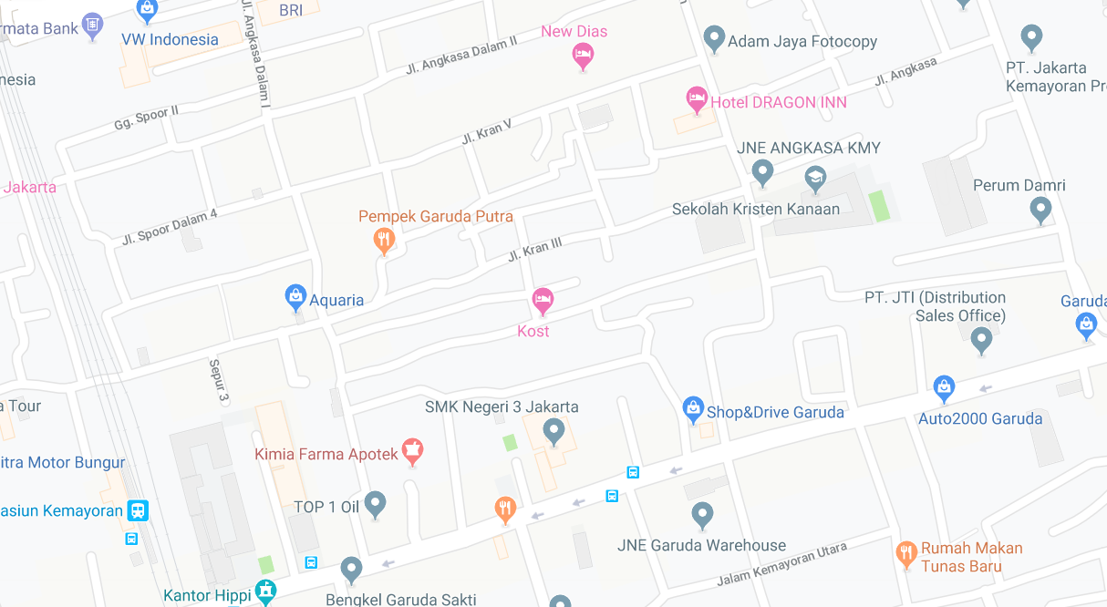

Randori

Alifah Laundry

USA Laundry

Rahayu Laundry

Leonora Laundry

**Lampiran 2 – Respon Kuesioner Randori**

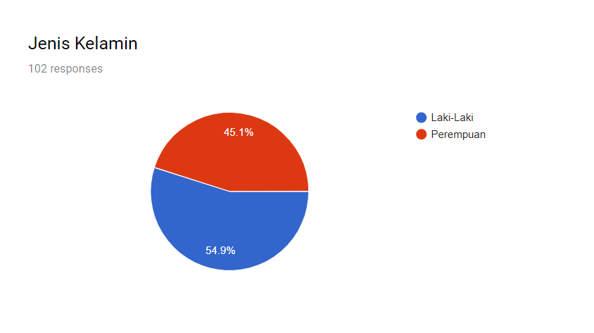

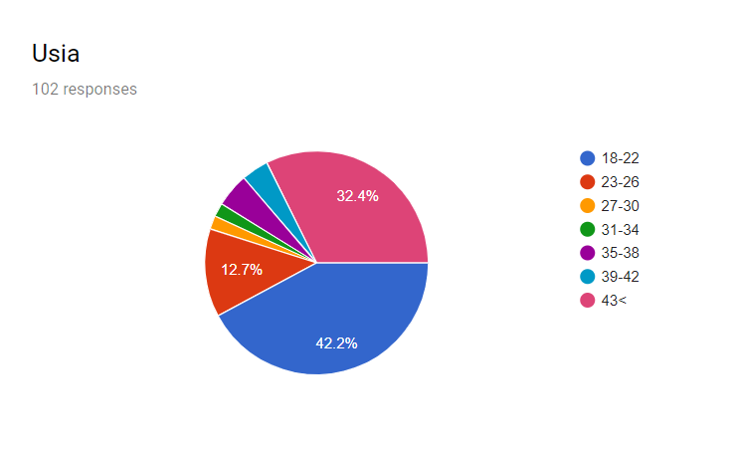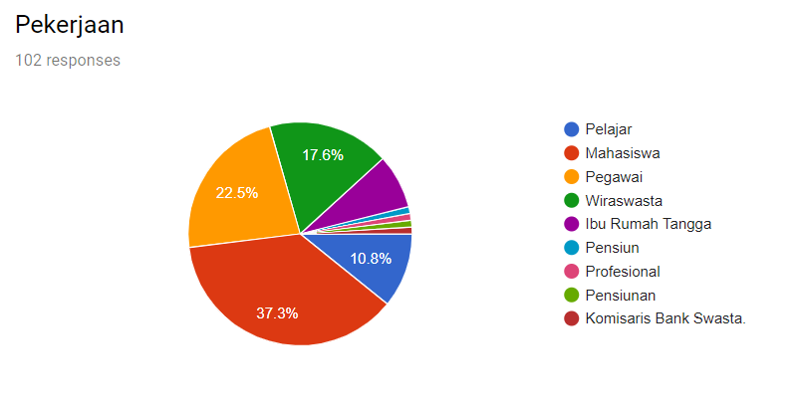

**Lampiran 3 – Anggaran Pendapatan Randori**