**LAMPIRAN**

**Lampiran 1 – Logo Usaha**



**Lampiran 2 – Brosur**



**Lampiran 3 – Biaya Bahan Baku**

|  |  |  |  |  |
| --- | --- | --- | --- | --- |
| No. | Keterangan | Harga (Rp) | Jumlah Unit | Total Harga (Rp) |
| 1 | Bibit ikan gurami 5cm | 200 | 30.000 ekor | 6.000.000 |
| 2 | Pakan apung | 10.000 | 1.250 kg | 12.500.000 |
| Total Bahan Baku | | | | 18.500.000 |

**Lampiran 4 – Tarif Listrik**

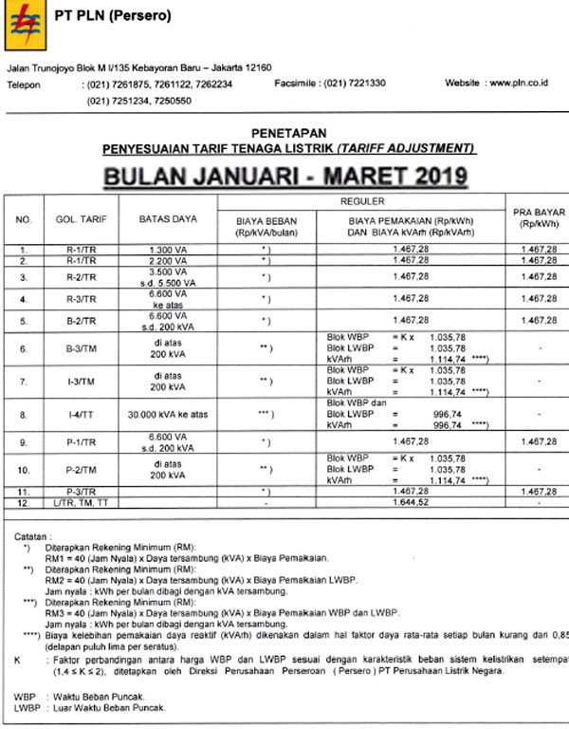

**Lampiran 5 – Respon Kuisioner Empang Gurami**



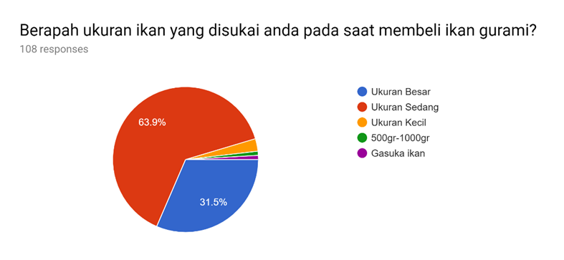

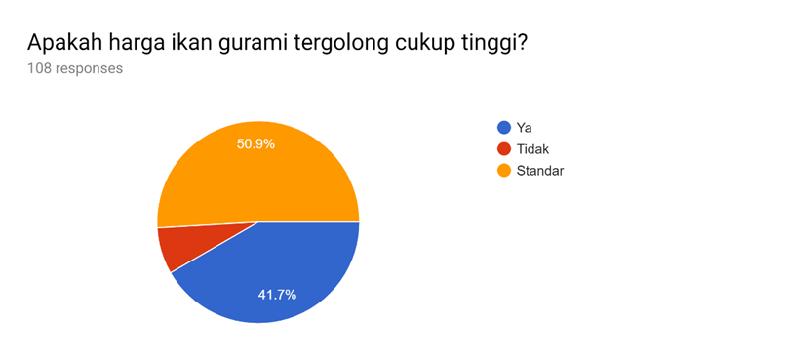

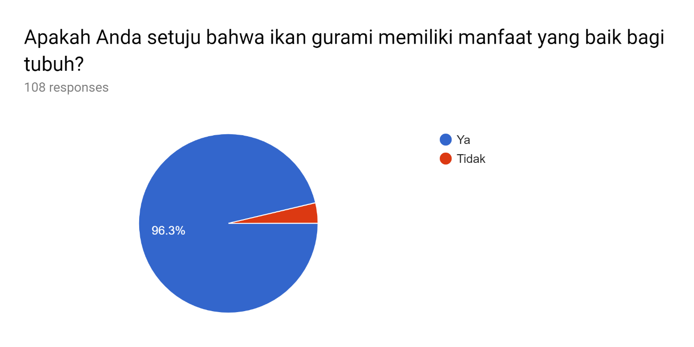

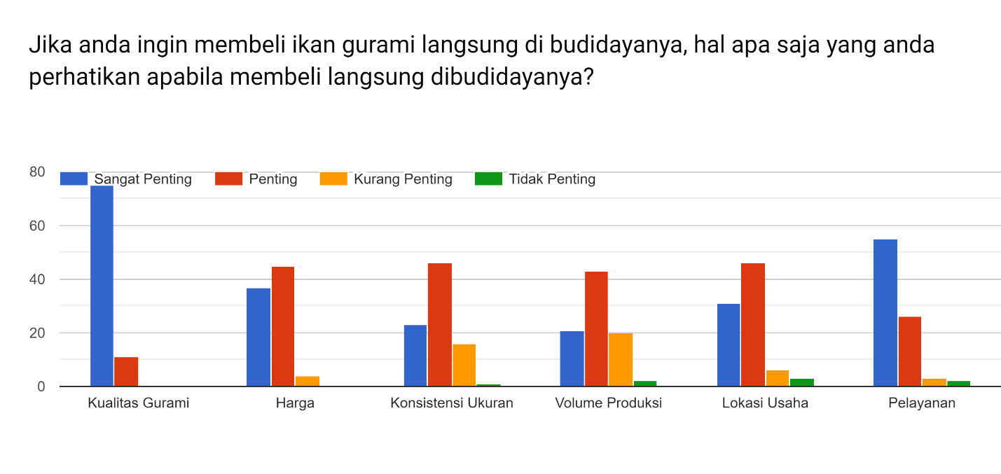

**Lampiran 6 – Produk Empang Gurami**

