DAFTAR LAMPIRAN

Lampiran 1

Kuesioner Shoesclean
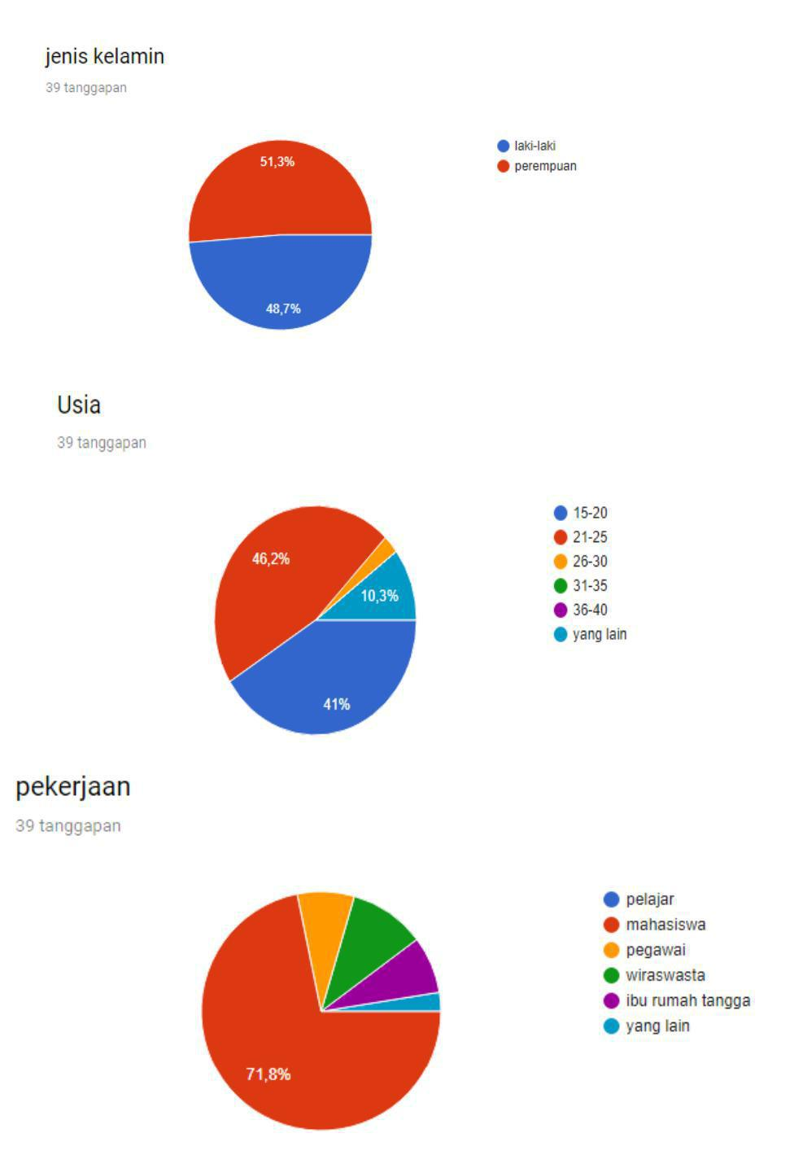

106

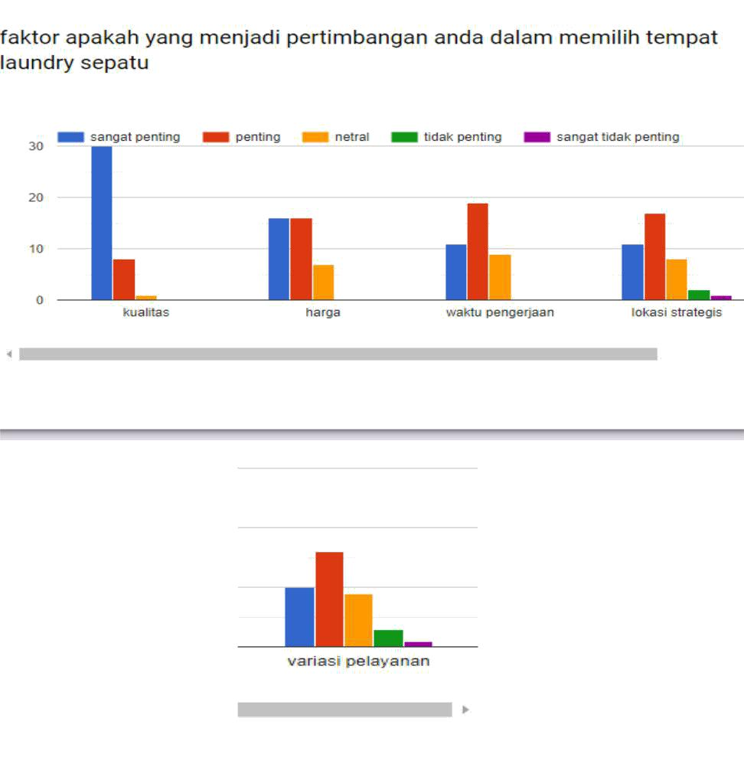

Lampiran 2

Anggaran Pendapatan Shoesclean
