**LAMPIRAN**

Lampiran 1

Ramalan Penjualan Bright English Course Tahun 2020



Lampiran 2

Respon Kuisioner *Bright English Course*

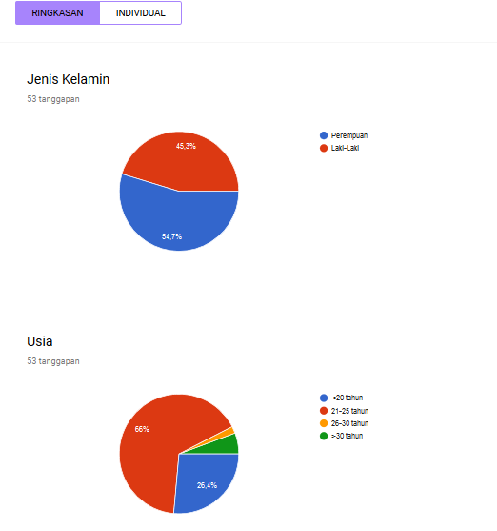

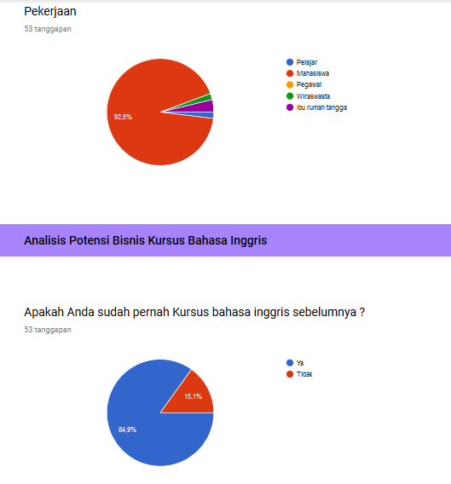

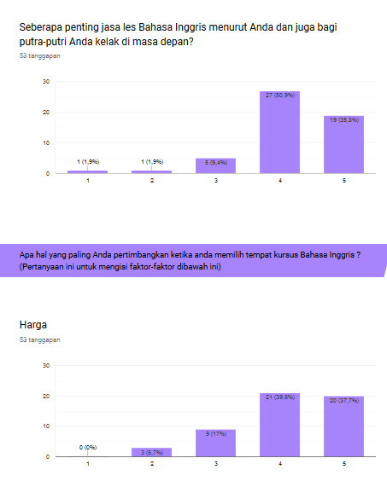

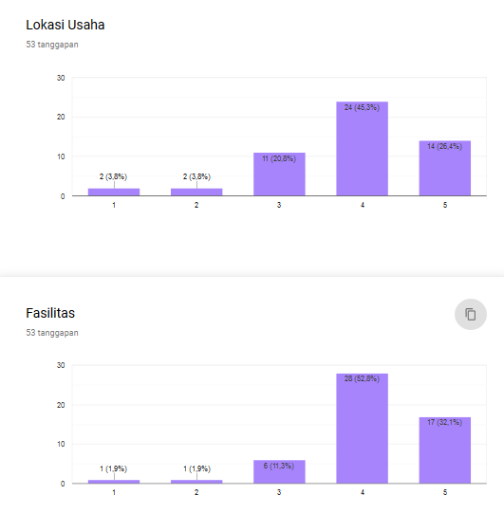

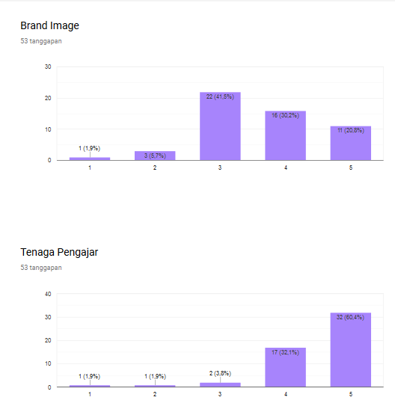

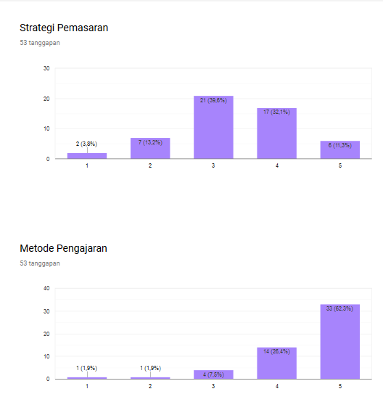

(<https://docs.google.com/forms/d/1i31yXyp_2ISa8tIHC6Sf97ZDLP3HfPaQI0bZCWS2akI/edit#responses>)

Lampiran 3

*Design* Kartu Nama *Bright English Course*

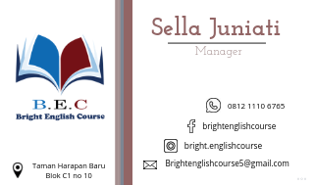

Lampiran 4

*Design* Spanduk *Bright English Course*

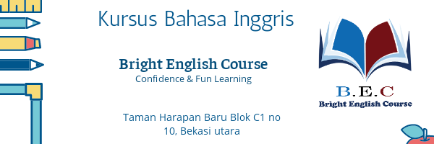

Lampiran 5

*Design* Brosur *Bright English Course*

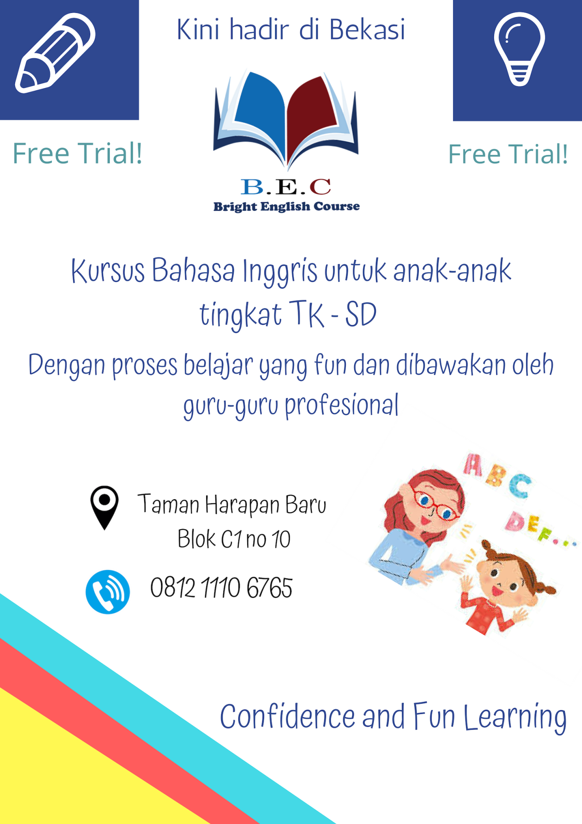

Lampiran 6

*Design* kaos *Bright English Course*

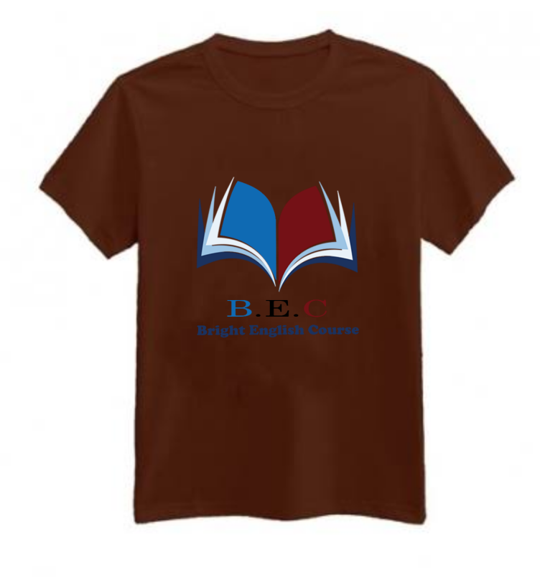

Lampiran 7

Tampilan *Instagram Bright English Course*

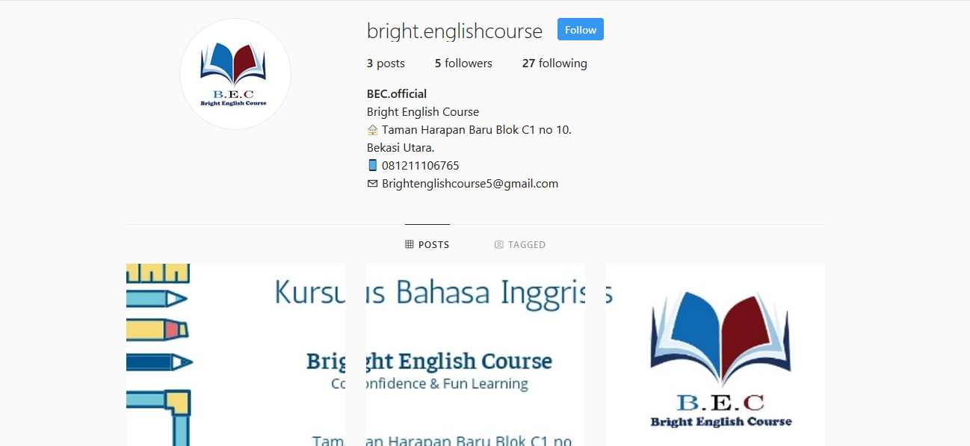

(<https://www.instagram.com/bright.englishcourse/>)

Lampiran 8

Tampilan *Facebook Bright English Course*

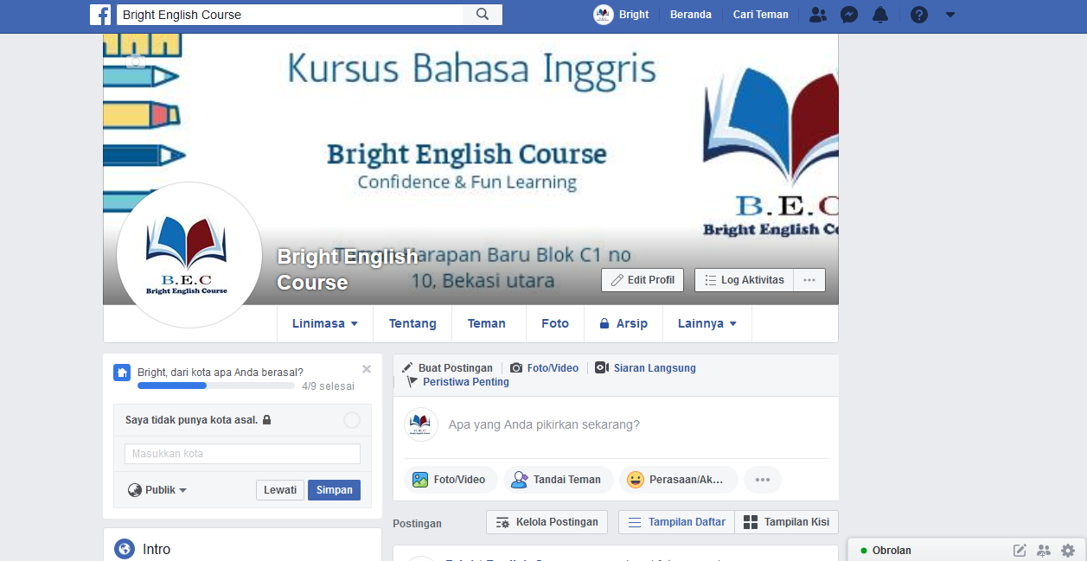

(<https://www.facebook.com/bright.englishcourse.9>)