LAMPIRAN

Lampiran 1 – Harga

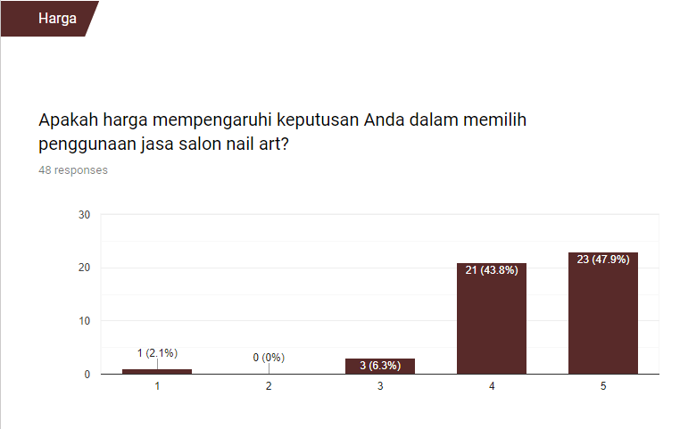
Lampiran 2 – Pelayanan
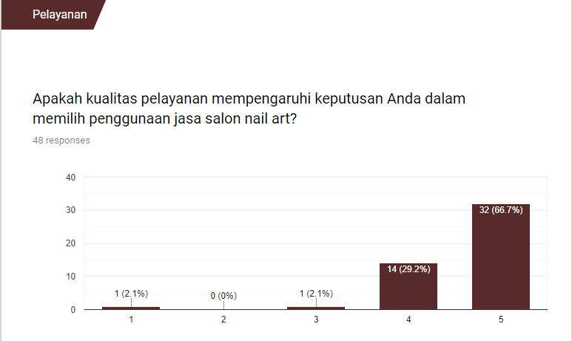

Lampiran 3 – Lokasi

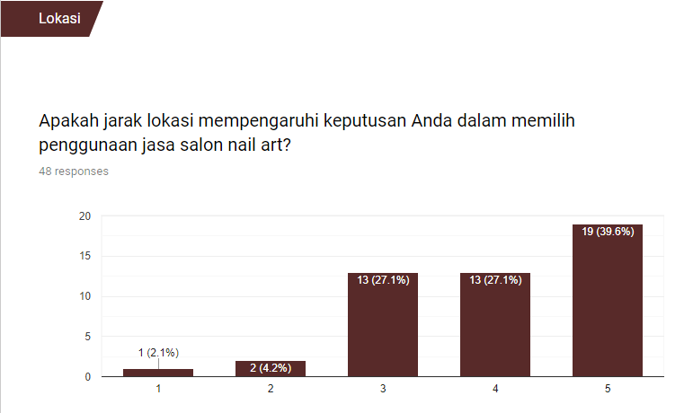
Lampiran 4 – Promosi
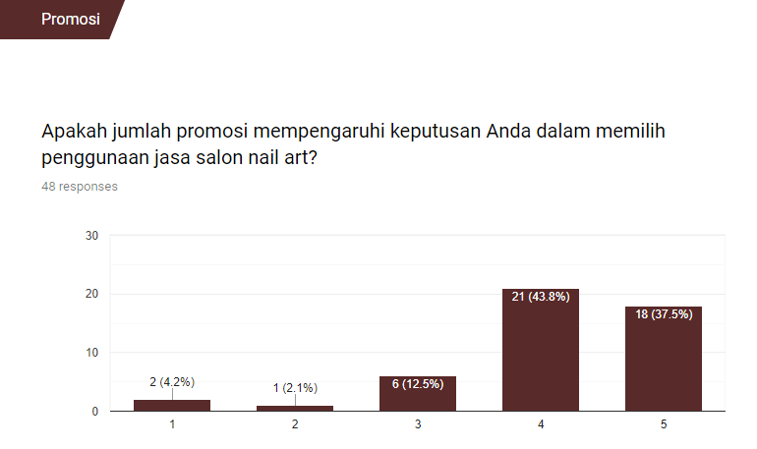

Lampiran 5 – Kualitas Bahan Baku

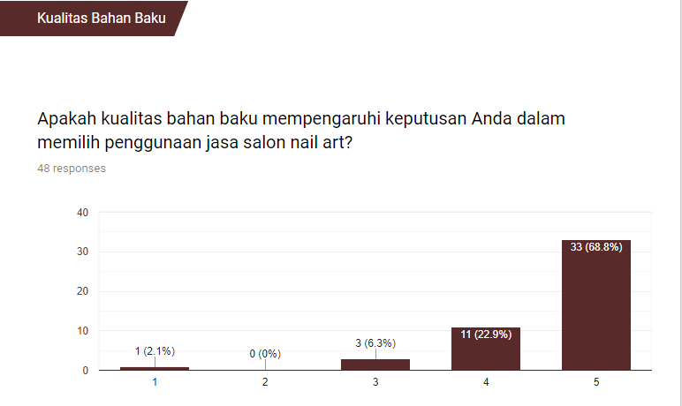
Lampiran 6 – Kualitas Hasil Jasa

