LAMPIRAN
Lampiran 1 : Kuesioner
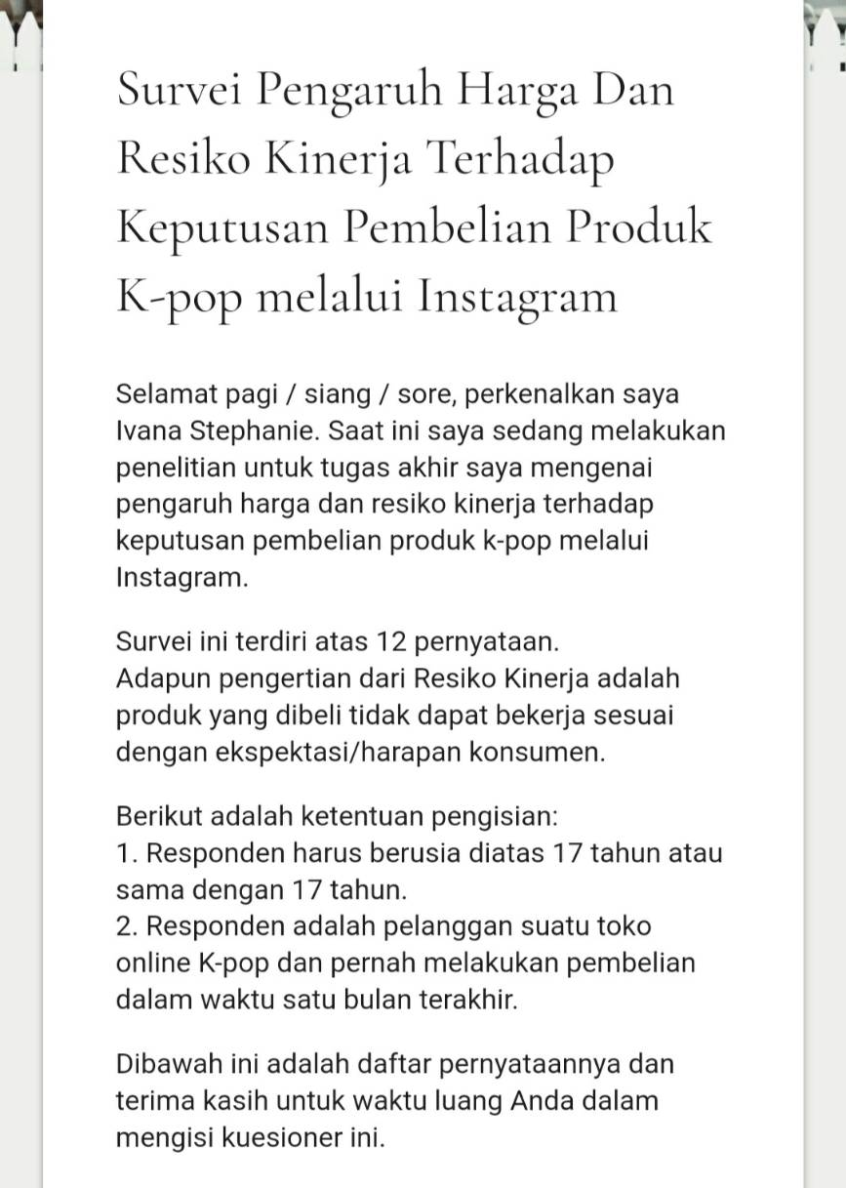
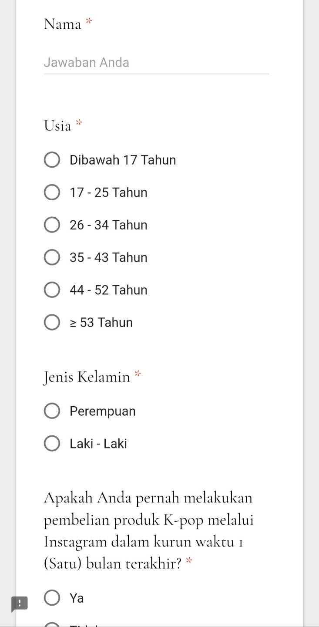

Lampiran 2 : Jawaban responden
No | X1a | X1b | X1c | X1d | X2a | X2b | X2c | Ya | Yb | Yc | Yd | Ye
1 | 4 | 4 | 5 | 5 | 5 | 4 | 3 | 4 | 4 | 4 | 5 | 5
2 | 5 | 5 | 4 | 4 | 4 | 4 | 4 | 4 | 5 | 5 | 5 | 5
3 | 4 | 4 | 4 | 4 | 4 | 4 | 4 | 4 | 4 | 4 | 4 | 4
4 | 1 | 1 | 1 | 1 | 1 | 1 | 1 | 1 | 1 | 3 | 1 | 5
5 | 3 | 4 | 4 | 4 | 4 | 3 | 4 | 3 | 4 | 3 | 5 | 4
6 | 4 | 4 | 4 | 3 | 3 | 3 | 3 | 4 | 4 | 3 | 3 | 3
7 | 3 | 4 | 4 | 4 | 4 | 4 | 5 | 5 | 5 | 3 | 5 | 5
8 | 4 | 3 | 5 | 5 | 5 | 5 | 5 | 4 | 5 | 3 | 5 | 5
9 | 3 | 3 | 4 | 3 | 2 | 2 | 2 | 3 | 3 | 1 | 4 | 4
10 | 5 | 5 | 5 | 4 | 5 | 4 | 4 | 4 | 5 | 3 | 5 | 5
11 | 3 | 5 | 4 | 4 | 5 | 5 | 5 | 5 | 5 | 5 | 5 | 5
12 | 5 | 4 | 5 | 5 | 5 | 5 | 5 | 5 | 5 | 5 | 5 | 5
13 | 3 | 4 | 3 | 3 | 5 | 5 | 4 | 4 | 4 | 4 | 4 | 4
14 | 3 | 3 | 4 | 4 | 2 | 2 | 3 | 4 | 4 | 3 | 5 | 5
15 | 3 | 4 | 5 | 4 | 3 | 3 | 4 | 2 | 4 | 4 | 5 | 5
16 | 4 | 4 | 4 | 3 | 3 | 3 | 3 | 4 | 5 | 3 | 5 | 4
17 | 5 | 5 | 4 | 4 | 3 | 4 | 3 | 3 | 5 | 5 | 5 | 5
18 | 2 | 4 | 5 | 2 | 4 | 3 | 5 | 4 | 5 | 4 | 5 | 5
19 | 3 | 4 | 5 | 4 | 3 | 3 | 4 | 4 | 5 | 3 | 5 | 3
20 | 1 | 4 | 4 | 4 | 2 | 2 | 4 | 2 | 4 | 2 | 4 | 2
21 | 4 | 5 | 4 | 4 | 5 | 5 | 5 | 5 | 2 | 1 | 5 | 3
22 | 3 | 3 | 3 | 2 | 3 | 3 | 4 | 3 | 3 | 3 | 3 | 4
23 | 4 | 3 | 4 | 4 | 4 | 4 | 4 | 4 | 4 | 4 | 4 | 5
24 | 5 | 5 | 5 | 5 | 5 | 5 | 5 | 5 | 5 | 5 | 5 | 5
25 | 3 | 4 | 3 | 4 | 4 | 3 | 3 | 3 | 3 | 3 | 3 | 3
26 | 4 | 4 | 5 | 4 | 4 | 4 | 4 | 3 | 5 | 3 | 5 | 5
27 | 4 | 4 | 4 | 4 | 5 | 4 | 5 | 5 | 5 | 4 | 5 | 5
28 | 2 | 4 | 4 | 3 | 4 | 5 | 4 | 3 | 5 | 2 | 5 | 5
29 | 4 | 5 | 5 | 4 | 4 | 5 | 5 | 4 | 5 | 4 | 5 | 5
30 | 4 | 4 | 4 | 5 | 4 | 4 | 5 | 5 | 5 | 3 | 5 | 4
31 | 5 | 5 | 5 | 5 | 5 | 5 | 5 | 5 | 5 | 5 | 5 | 5
32 | 3 | 4 | 3 | 2 | 3 | 3 | 3 | 4 | 3 | 3 | 5 | 1
33 | 3 | 5 | 4 | 5 | 3 | 3 | 4 | 4 | 5 | 4 | 5 | 5
34 | 4 | 4 | 5 | 5 | 3 | 5 | 5 | 5 | 4 | 3 | 3 | 3
35 | 3 | 3 | 5 | 3 | 4 | 4 | 3 | 3 | 5 | 3 | 5 | 3
36 | 3 | 3 | 4 | 3 | 3 | 3 | 3 | 3 | 4 | 3 | 5 | 5
37 | 4 | 4 | 5 | 4 | 4 | 4 | 4 | 3 | 4 | 4 | 5 | 3
38 | 4 | 4 | 3 | 5 | 3 | 3 | 2 | 5 | 4 | 4 | 4 | 3
39 | 3 | 5 | 5 | 3 | 4 | 3 | 2 | 4 | 5 | 3 | 5 | 5
40 | 4 | 4 | 5 | 4 | 4 | 3 | 4 | 4 | 4 | 4 | 5 | 5
41 | 5 | 5 | 4 | 5 | 5 | 5 | 4 | 4 | 5 | 5 | 5 | 5
42 | 3 | 3 | 2 | 4 | 3 | 3 | 3 | 4 | 4 | 4 | 4 | 5
43 | 3 | 4 | 4 | 3 | 4 | 3 | 4 | 4 | 5 | 4 | 5 | 5
44 | 4 | 4 | 4 | 4 | 4 | 4 | 5 | 4 | 5 | 3 | 5 | 5
45 | 5 | 4 | 5 | 5 | 4 | 4 | 5 | 5 | 5 | 5 | 5 | 4
46 | 3 | 4 | 5 | 5 | 3 | 3 | 4 | 5 | 5 | 4 | 5 | 5
47 | 4 | 5 | 5 | 5 | 4 | 4 | 3 | 4 | 5 | 4 | 5 | 5
48 | 3 | 4 | 4 | 4 | 3 | 3 | 4 | 4 | 4 | 3 | 4 | 4
49 | 4 | 4 | 5 | 5 | 5 | 5 | 5 | 5 | 4 | 4 | 5 | 5
50 | 5 | 5 | 5 | 5 | 5 | 5 | 5 | 5 | 5 | 5 | 5 | 5
51 | 4 | 4 | 4 | 4 | 4 | 4 | 4 | 3 | 5 | 3 | 5 | 5
52 | 4 | 3 | 4 | 5 | 1 | 1 | 3 | 5 | 2 | 3 | 5 | 5
53 | 1 | 4 | 4 | 4 | 2 | 2 | 3 | 5 | 4 | 2 | 4 | 5
54 | 3 | 5 | 4 | 4 | 3 | 3 | 5 | 5 | 5 | 2 | 5 | 2
55 | 4 | 3 | 5 | 4 | 4 | 4 | 4 | 4 | 5 | 3 | 5 | 4
56 | 3 | 5 | 5 | 5 | 3 | 3 | 4 | 4 | 5 | 3 | 5 | 4
57 | 5 | 5 | 5 | 5 | 5 | 5 | 5 | 5 | 5 | 5 | 5 | 5
58 | 3 | 4 | 3 | 3 | 4 | 3 | 3 | 5 | 5 | 5 | 5 | 5
59 | 3 | 4 | 4 | 3 | 3 | 3 | 4 | 3 | 5 | 3 | 5 | 5
60 | 5 | 5 | 5 | 4 | 2 | 2 | 4 | 5 | 5 | 2 | 5 | 2
61 | 3 | 4 | 4 | 4 | 3 | 5 | 5 | 4 | 5 | 3 | 4 | 3
62 | 3 | 5 | 5 | 3 | 5 | 5 | 5 | 3 | 5 | 5 | 5 | 5
63 | 3 | 3 | 4 | 4 | 3 | 2 | 3 | 2 | 5 | 3 | 3 | 2
64 | 3 | 3 | 4 | 3 | 4 | 4 | 3 | 4 | 4 | 2 | 4 | 4
65 | 3 | 2 | 3 | 3 | 4 | 4 | 3 | 3 | 4 | 2 | 5 | 5
66 | 2 | 4 | 5 | 3 | 3 | 4 | 4 | 5 | 5 | 3 | 5 | 5
67 | 4 | 5 | 5 | 5 | 5 | 5 | 5 | 3 | 5 | 5 | 5 | 5
68 | 1 | 5 | 5 | 1 | 5 | 5 | 5 | 5 | 5 | 1 | 5 | 5
69 | 4 | 4 | 4 | 4 | 5 | 5 | 4 | 5 | 5 | 5 | 5 | 4
70 | 3 | 4 | 5 | 3 | 4 | 4 | 4 | 4 | 5 | 3 | 5 | 5
71 | 5 | 5 | 5 | 4 | 5 | 5 | 4 | 2 | 5 | 4 | 5 | 5
72 | 4 | 5 | 4 | 4 | 5 | 5 | 5 | 5 | 5 | 4 | 5 | 5
73 | 4 | 4 | 4 | 3 | 3 | 3 | 3 | 3 | 4 | 3 | 5 | 3
74 | 3 | 4 | 4 | 4 | 1 | 1 | 3 | 5 | 5 | 5 | 5 | 5
75 | 3 | 3 | 3 | 4 | 3 | 4 | 3 | 4 | 4 | 3 | 4 | 4
76 | 4 | 4 | 4 | 4 | 3 | 4 | 4 | 4 | 4 | 3 | 5 | 2
77 | 3 | 4 | 5 | 4 | 3 | 3 | 4 | 4 | 5 | 3 | 5 | 3
78 | 3 | 3 | 3 | 3 | 2 | 3 | 3 | 3 | 3 | 2 | 4 | 3
79 | 5 | 5 | 5 | 5 | 5 | 5 | 5 | 5 | 5 | 5 | 5 | 5
80 | 5 | 5 | 5 | 5 | 5 | 5 | 3 | 5 | 5 | 3 | 5 | 5
81 | 3 | 3 | 4 | 3 | 5 | 5 | 4 | 3 | 3 | 2 | 5 | 5
82 | 3 | 4 | 5 | 4 | 3 | 5 | 5 | 4 | 5 | 4 | 5 | 5
83 | 4 | 4 | 5 | 5 | 4 | 3 | 4 | 5 | 5 | 3 | 5 | 5
84 | 3 | 5 | 4 | 4 | 3 | 3 | 4 | 5 | 5 | 3 | 5 | 5
85 | 3 | 4 | 4 | 4 | 4 | 4 | 4 | 3 | 4 | 4 | 5 | 4
86 | 3 | 3 | 3 | 3 | 3 | 4 | 3 | 3 | 3 | 3 | 3 | 3
87 | 5 | 4 | 5 | 5 | 5 | 5 | 5 | 5 | 5 | 3 | 5 | 4
88 | 3 | 4 | 4 | 3 | 3 | 3 | 3 | 4 | 4 | 4 | 5 | 4
89 | 4 | 5 | 4 | 5 | 4 | 3 | 3 | 5 | 5 | 5 | 5 | 5
90 | 3 | 3 | 4 | 4 | 3 | 3 | 3 | 3 | 3 | 3 | 3 | 5
91 | 4 | 5 | 5 | 4 | 4 | 5 | 4 | 4 | 5 | 4 | 4 | 5
92 | 3 | 3 | 4 | 3 | 4 | 4 | 4 | 3 | 4 | 3 | 4 | 5
93 | 5 | 4 | 5 | 5 | 5 | 5 | 4 | 5 | 5 | 4 | 5 | 5
94 | 3 | 4 | 5 | 5 | 4 | 4 | 4 | 5 | 5 | 5 | 5 | 5
95 | 4 | 4 | 4 | 4 | 3 | 3 | 4 | 4 | 4 | 4 | 5 | 4
96 | 4 | 5 | 5 | 3 | 3 | 4 | 5 | 4 | 5 | 4 | 5 | 3
97 | 4 | 3 | 5 | 4 | 4 | 4 | 4 | 5 | 5 | 3 | 5 | 4
98 | 3 | 4 | 4 | 4 | 3 | 3 | 4 | 4 | 5 | 4 | 5 | 5
99 | 4 | 4 | 5 | 5 | 5 | 5 | 5 | 5 | 5 | 3 | 5 | 3
100 | 3 | 4 | 4 | 3 | 4 | 4 | 4 | 2 | 3 | 2 | 4 | 3
101 | 3 | 4 | 4 | 3 | 4 | 4 | 4 | 4 | 3 | 3 | 5 | 4
102 | 1 | 5 | 5 | 3 | 4 | 4 | 5 | 1 | 5 | 5 | 5 | 5
103 | 4 | 4 | 5 | 4 | 4 | 3 | 4 | 4 | 3 | 3 | 4 | 4
104 | 3 | 4 | 2 | 1 | 1 | 1 | 5 | 5 | 5 | 1 | 5 | 5
105 | 3 | 5 | 5 | 3 | 4 | 3 | 4 | 4 | 5 | 3 | 5 | 2
106 | 3 | 4 | 4 | 3 | 2 | 3 | 3 | 4 | 4 | 3 | 5 | 5
107 | 4 | 4 | 4 | 4 | 4 | 4 | 4 | 4 | 4 | 4 | 4 | 4
108 | 3 | 3 | 3 | 4 | 2 | 2 | 3 | 4 | 4 | 3 | 5 | 5
109 | 3 | 4 | 4 | 4 | 4 | 3 | 3 | 4 | 4 | 4 | 5 | 3
110 | 4 | 4 | 5 | 4 | 3 | 4 | 4 | 4 | 5 | 3 | 5 | 5
111 | 5 | 3 | 5 | 4 | 2 | 4 | 5 | 4 | 5 | 5 | 5 | 3
112 | 3 | 5 | 5 | 5 | 2 | 2 | 5 | 5 | 5 | 5 | 5 | 5
113 | 5 | 5 | 5 | 5 | 5 | 5 | 5 | 5 | 5 | 5 | 5 | 5
114 | 3 | 5 | 5 | 4 | 3 | 3 | 5 | 2 | 5 | 3 | 5 | 5
115 | 2 | 5 | 5 | 2 | 5 | 3 | 2 | 3 | 5 | 3 | 5 | 5
116 | 3 | 3 | 3 | 2 | 2 | 2 | 3 | 2 | 2 | 2 | 5 | 5
117 | 5 | 4 | 4 | 5 | 3 | 4 | 4 | 5 | 5 | 5 | 5 | 5
118 | 3 | 3 | 5 | 4 | 3 | 3 | 4 | 3 | 4 | 4 | 5 | 3
119 | 3 | 3 | 5 | 4 | 4 | 5 | 5 | 3 | 5 | 5 | 5 | 3
120 | 4 | 4 | 5 | 4 | 3 | 4 | 4 | 3 | 5 | 3 | 5 | 4

Lampiran 3 : Uji Validitas dan Reliabilitas
Harga
Item-Total Statistics
 | Scale Mean if Item Deleted | Scale Variance if Item Deleted | Corrected Item-Total Correlation | Squared Multiple Correlation | Cronbach's Alpha if Item Deleted
X1a | 12.20 | 3.724 | .539 | .375 | .665
X1b | 11.67 | 4.543 | .438 | .252 | .718
X1c | 11.41 | 4.260 | .526 | .326 | .673
X1d | 11.85 | 3.591 | .604 | .428 | .622

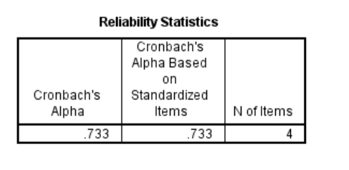

Resiko Kinerja
Item-Total Statistics
 | Scale Mean if Item Deleted | Scale Variance if Item Deleted | Corrected Item-Total Correlation | Squared Multiple Correlation | Cronbach's Alpha if Item Deleted
X2a | 7.63 | 2.856 | .706 | .649 | .707
X2b | 7.59 | 2.580 | .823 | .710 | .571
X2c | 7.32 | 3.936 | .507 | .315 | .892

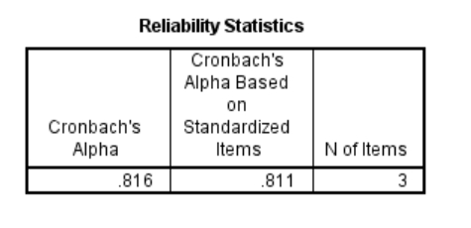

Keputusan Pembelian
Item-Total Statistics
 | Scale Mean if Item Deleted | Scale Variance if Item Deleted | Corrected Item-Total Correlation | Squared Multiple Correlation | Cronbach's Alpha if Item Deleted
Ya | 16.93 | 5.885 | .343 | .158 | .630
Yb | 16.43 | 5.541 | .563 | .410 | .527
Yc | 17.38 | 5.446 | .405 | .204 | .601
Yd | 16.17 | 6.375 | .487 | .341 | .579
Ye | 16.58 | 6.045 | .298 | .112 | .652

Item-Total Statistics
 | Scale Mean if Item Deleted | Scale Variance if Item Deleted | Corrected Item-Total Correlation | Squared Multiple Correlation | Cronbach's Alpha if Item Deleted
Ya | 12.63 | 3.730 | .372 | .158 | .632
Yb | 12.13 | 3.511 | .595 | .409 | .474
Yc | 13.08 | 3.640 | .350 | .162 | .657
Yd | 11.88 | 4.295 | .485 | .328 | .572

Item-Total Statistics
 | Scale Mean if Item Deleted | Scale Variance if Item Deleted | Corrected Item-Total Correlation | Squared Multiple Correlation | Cronbach's Alpha if Item Deleted
Ya | 9.14 | 1.719 | .392 | .154 | .702
Yb | 8.64 | 1.778 | .533 | .343 | .471
Yd | 8.38 | 2.188 | .527 | .328 | .524

Reliability Statistics
Cronbach's Alpha | Cronbach's Alpha Based on Standardized Items | N of Items
.657 | .680 | 3

Lampiran 4 : Analisa Deskriptif
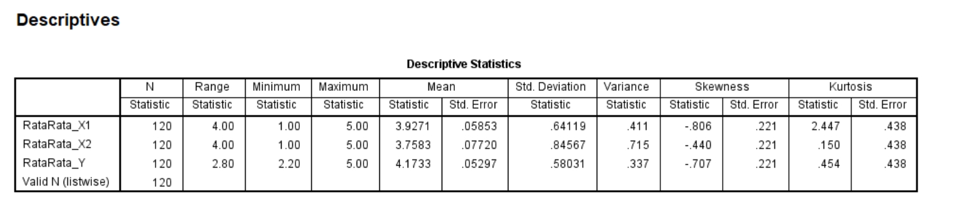

One-Sample Test
 | Test Value = 0
 | t | df | Sig. (2-tailed) | Mean Difference | 95% Confidence Interval of the Difference
 |  |  |  |  | Lower | Upper
RataRata_X1 | 67.092 | 119 | .000 | 3.92708 | 3.8112 | 4.0430
RataRata_X2 | 48.684 | 119 | .000 | 3.75833 | 3.6055 | 3.9112
RataRata_Y | 78.779 | 119 | .000 | 4.17333 | 4.0684 | 4.2782

Lampiran 5 : Hasil Analisis Regresi Berganda
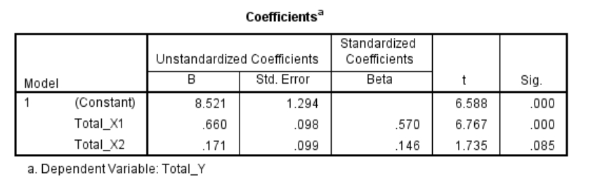
Lampiran 6 : Uji Normalitas
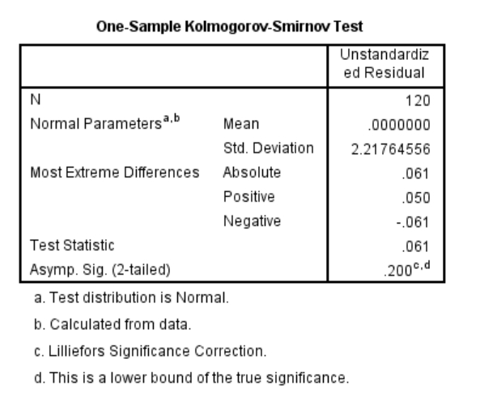
Lampiran 7 : Uji Otokolerasi
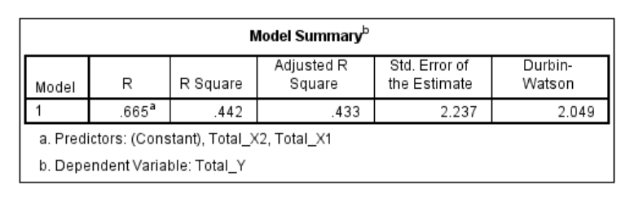

Lampiran 8 : Uji Heteroskedastisitas
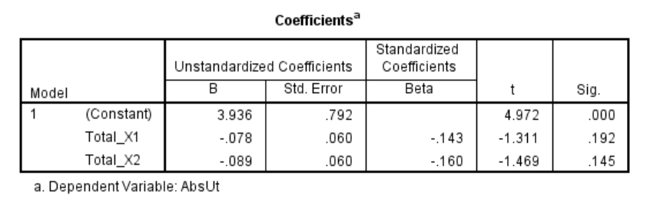
Lampiran 9 : Uji Multikolinearitas
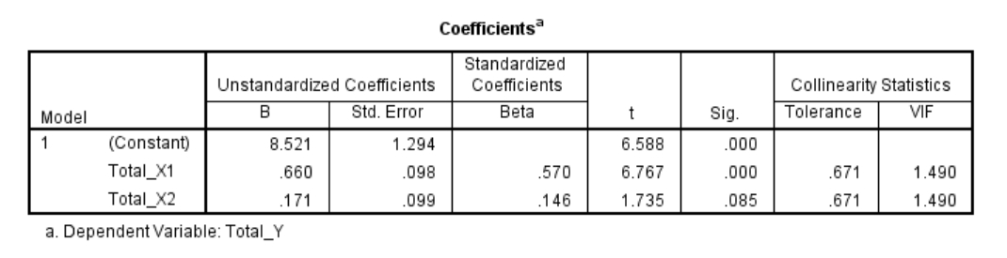
Lampiran 10 : Uji F
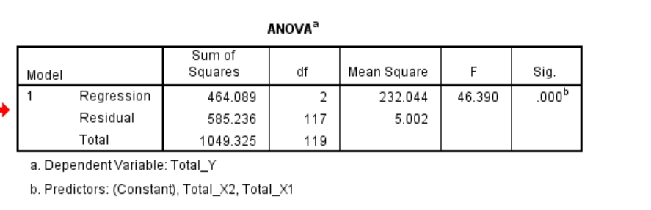

Lampiran 11 : Uji t
