# **LAMPIRAN**

**Lampiran 1. Kuisioner Penelitian**

**KUISIONER PENILITIAN**

Bapak/Ibu/saudara/i yang terhormat, Saya bernama Jireh Benyamin, Mahasiswa Program Sarjana Administrasi Bisnis Kwik Kian Gie School of Business sedang melakukan penelitian untuk menyusun skripsi yang berjudul “PENGARUH KEGUNAAN, KEMUDAHAN, RISIKO DAN KEPERCAYAAN TERHADAP MINAT PENGGUNAAN OVO SEBAGAI ALAT PEMBAYARAN”. Saya mohon kesediaan Bapak/Ibu/saudara/i untuk berpartisipasi mengisi kuesioner ini secara lengkap dan benar agar informasi yang disajikan dapat dipertanggungjawabkan dan tercapainya hasil yang diinginkan. Informasi yang diterima dari kuesioner ini bersifat rahasia dan hanya digunakan untuk kepentingan akademis. Atas perhatian Bapak/Ibu/saudara/i, saya ucapkan terima kasih.

**Petunjuk Pengisian**: tandailah pada salah satu jawaban yang Anda pilih di bawah ini.

1. **IDENTITAS RESPONDEN**

**Nama:**

**Jenis Kelamin:**

a. Pria b. Wanita

**Usia:**

a. < 17 tahun d. 31-40 tahun

b. 17-22 tahun e. > 40 tahun

c. 23-30 tahun

**Pekerjaan:**

a. Mahasiwa/Pelajaran d. Pegawa Negeri Sipil

b. Pegawai Swasta e. Ibu Rumah Tangga

c. Wirawasta f. Tidak Bekerja

**II. PENGARUH PERSEPSI KEGUNAAN, PERSEPSI KEMUDAHAN, RISIKO DAN KEPERCAYAAN MINAT PENGGUNAAN OVO**

**Petunjuk:** Mohon diisi seusai dengan memberi tanda (X) pada kolom yang telah disediakan sesuai dengan pendatap anda.

**Keterangan:** SP : Sangat Setuju S : Setuju TS : Tidak Setuju STS : Sangat Tidak Setuju



**Lampiran 2. Hasil Tabulasi Kuisioner**

|  |  |  |  |  |  |  |  |  |  |  |  |  |  |  |  |  |  |  |
| --- | --- | --- | --- | --- | --- | --- | --- | --- | --- | --- | --- | --- | --- | --- | --- | --- | --- | --- |
| No | PU  1 | PU  2 | PU  3 | PU  4 | PE  1 | PE  2 | PE  3 | PE  4 | R  1 | R  2 | R  3 | R  4 | K  1 | K  2 | K  3 | Y  1 | Y  2 | Y  3 |
| 1 | 2 | 3 | 2 | 4 | 4 | 3 | 3 | 3 | 4 | 3 | 3 | 2 | 2 | 4 | 4 | 2 | 2 | 2 |
| 2 | 3 | 3 | 4 | 3 | 3 | 4 | 3 | 3 | 3 | 3 | 2 | 2 | 3 | 4 | 4 | 2 | 1 | 2 |
| 3 | 3 | 3 | 3 | 3 | 4 | 4 | 4 | 4 | 3 | 2 | 2 | 2 | 3 | 3 | 3 | 3 | 3 | 2 |
| 4 | 4 | 4 | 3 | 4 | 4 | 4 | 4 | 4 | 3 | 3 | 4 | 4 | 4 | 4 | 4 | 4 | 4 | 4 |
| 5 | 3 | 4 | 3 | 3 | 3 | 4 | 4 | 4 | 3 | 3 | 3 | 3 | 3 | 3 | 3 | 3 | 3 | 2 |
| 6 | 4 | 4 | 3 | 4 | 3 | 3 | 4 | 4 | 4 | 4 | 3 | 4 | 4 | 4 | 4 | 4 | 4 | 4 |
| 7 | 3 | 4 | 3 | 3 | 2 | 3 | 3 | 4 | 3 | 4 | 3 | 4 | 3 | 3 | 4 | 3 | 4 | 3 |
| 8 | 4 | 3 | 4 | 4 | 4 | 3 | 4 | 4 | 4 | 4 | 4 | 4 | 4 | 4 | 4 | 3 | 4 | 4 |
| 9 | 4 | 4 | 3 | 4 | 4 | 4 | 4 | 3 | 4 | 4 | 4 | 4 | 4 | 4 | 4 | 4 | 4 | 4 |
| 10 | 2 | 2 | 2 | 3 | 3 | 4 | 3 | 3 | 3 | 3 | 2 | 2 | 4 | 4 | 4 | 2 | 1 | 1 |
| 11 | 4 | 4 | 3 | 4 | 4 | 4 | 4 | 3 | 4 | 4 | 4 | 3 | 4 | 4 | 4 | 4 | 4 | 4 |
| 12 | 3 | 3 | 3 | 3 | 3 | 4 | 3 | 4 | 3 | 3 | 3 | 3 | 3 | 4 | 4 | 3 | 3 | 3 |
| 13 | 3 | 3 | 3 | 3 | 3 | 3 | 3 | 3 | 4 | 4 | 4 | 4 | 3 | 4 | 4 | 4 | 3 | 2 |
| 14 | 3 | 3 | 2 | 3 | 2 | 3 | 3 | 3 | 2 | 2 | 3 | 2 | 3 | 4 | 4 | 3 | 2 | 2 |
| 15 | 4 | 3 | 3 | 4 | 3 | 3 | 4 | 4 | 3 | 4 | 3 | 4 | 4 | 4 | 3 | 3 | 4 | 4 |
| 16 | 3 | 3 | 4 | 4 | 2 | 4 | 3 | 3 | 4 | 2 | 4 | 3 | 4 | 4 | 4 | 3 | 2 | 3 |
| 17 | 3 | 3 | 3 | 3 | 3 | 3 | 3 | 3 | 3 | 3 | 2 | 3 | 2 | 4 | 4 | 3 | 2 | 2 |
| 18 | 1 | 2 | 2 | 2 | 2 | 2 | 3 | 2 | 1 | 2 | 3 | 2 | 2 | 2 | 2 | 2 | 2 | 2 |
| 19 | 3 | 3 | 3 | 3 | 2 | 2 | 3 | 3 | 4 | 1 | 3 | 3 | 3 | 4 | 4 | 3 | 1 | 2 |
| 20 | 2 | 2 | 2 | 3 | 2 | 3 | 3 | 4 | 1 | 1 | 3 | 2 | 3 | 4 | 4 | 3 | 3 | 2 |
| 21 | 3 | 3 | 3 | 4 | 3 | 3 | 4 | 3 | 2 | 2 | 2 | 1 | 3 | 3 | 4 | 4 | 4 | 3 |
| 22 | 3 | 3 | 3 | 4 | 4 | 4 | 4 | 4 | 2 | 2 | 2 | 3 | 4 | 4 | 3 | 4 | 2 | 3 |
| 23 | 3 | 3 | 3 | 3 | 4 | 4 | 4 | 4 | 4 | 4 | 4 | 4 | 3 | 3 | 2 | 4 | 3 | 3 |
| 24 | 3 | 2 | 2 | 3 | 3 | 4 | 4 | 3 | 3 | 3 | 2 | 3 | 3 | 4 | 4 | 3 | 3 | 2 |
| 25 | 3 | 3 | 3 | 3 | 3 | 3 | 3 | 3 | 3 | 2 | 3 | 3 | 3 | 3 | 4 | 3 | 3 | 3 |
| 26 | 2 | 2 | 3 | 4 | 3 | 4 | 4 | 4 | 3 | 1 | 2 | 3 | 4 | 4 | 4 | 3 | 1 | 3 |
| 27 | 3 | 3 | 3 | 3 | 3 | 3 | 3 | 3 | 3 | 2 | 3 | 3 | 2 | 2 | 3 | 3 | 3 | 2 |
| 28 | 2 | 1 | 1 | 2 | 3 | 3 | 4 | 2 | 1 | 3 | 4 | 3 | 2 | 4 | 4 | 1 | 1 | 2 |
| 29 | 4 | 3 | 4 | 4 | 4 | 4 | 4 | 3 | 3 | 3 | 3 | 3 | 4 | 4 | 4 | 4 | 4 | 4 |
| 30 | 4 | 4 | 4 | 4 | 4 | 4 | 4 | 3 | 3 | 3 | 4 | 3 | 3 | 4 | 4 | 3 | 3 | 2 |
| 31 | 3 | 3 | 2 | 4 | 4 | 4 | 4 | 3 | 4 | 2 | 3 | 4 | 3 | 4 | 4 | 2 | 1 | 2 |
| 32 | 1 | 1 | 1 | 1 | 2 | 1 | 1 | 1 | 3 | 3 | 2 | 3 | 1 | 4 | 4 | 1 | 3 | 1 |
| 33 | 3 | 3 | 3 | 4 | 3 | 4 | 4 | 4 | 3 | 3 | 3 | 3 | 3 | 4 | 4 | 4 | 3 | 3 |
| 34 | 3 | 3 | 3 | 3 | 3 | 3 | 3 | 3 | 3 | 3 | 3 | 3 | 3 | 3 | 4 | 3 | 3 | 3 |
| 35 | 3 | 3 | 3 | 4 | 3 | 3 | 4 | 3 | 4 | 3 | 3 | 2 | 3 | 3 | 3 | 4 | 4 | 3 |
| 36 | 3 | 3 | 3 | 3 | 3 | 3 | 3 | 3 | 3 | 3 | 3 | 3 | 3 | 3 | 3 | 3 | 3 | 3 |
| 37 | 3 | 3 | 3 | 3 | 3 | 3 | 3 | 3 | 3 | 3 | 3 | 3 | 3 | 3 | 3 | 3 | 3 | 3 |
| 38 | 4 | 4 | 4 | 4 | 4 | 4 | 4 | 4 | 3 | 4 | 4 | 3 | 4 | 4 | 4 | 4 | 4 | 4 |
| 39 | 3 | 2 | 3 | 3 | 3 | 3 | 3 | 3 | 2 | 3 | 2 | 3 | 2 | 3 | 3 | 3 | 2 | 2 |
| 40 | 3 | 3 | 3 | 4 | 3 | 3 | 4 | 3 | 3 | 3 | 3 | 4 | 3 | 4 | 4 | 3 | 3 | 3 |
| 41 | 3 | 3 | 3 | 3 | 3 | 3 | 3 | 3 | 3 | 3 | 3 | 3 | 3 | 3 | 3 | 3 | 3 | 3 |
| 42 | 2 | 2 | 2 | 3 | 3 | 3 | 3 | 3 | 2 | 2 | 2 | 2 | 3 | 3 | 3 | 3 | 3 | 3 |
| 43 | 3 | 3 | 4 | 4 | 3 | 3 | 3 | 3 | 2 | 4 | 4 | 3 | 3 | 4 | 3 | 3 | 2 | 3 |
| 44 | 2 | 3 | 3 | 3 | 3 | 3 | 3 | 3 | 3 | 3 | 3 | 2 | 3 | 4 | 4 | 3 | 2 | 2 |
| 45 | 2 | 3 | 3 | 3 | 3 | 2 | 3 | 2 | 2 | 2 | 2 | 3 | 2 | 3 | 3 | 3 | 2 | 2 |
| 46 | 3 | 2 | 2 | 3 | 4 | 3 | 4 | 3 | 3 | 3 | 3 | 2 | 3 | 4 | 4 | 3 | 2 | 2 |
| 47 | 3 | 2 | 3 | 3 | 3 | 4 | 2 | 3 | 1 | 4 | 4 | 4 | 1 | 3 | 3 | 3 | 1 | 1 |
| 48 | 3 | 2 | 4 | 4 | 4 | 4 | 4 | 4 | 3 | 2 | 1 | 1 | 3 | 4 | 4 | 4 | 2 | 2 |
| 49 | 1 | 1 | 3 | 4 | 4 | 4 | 4 | 4 | 3 | 3 | 3 | 3 | 4 | 4 | 4 | 4 | 2 | 3 |
| 50 | 3 | 3 | 3 | 3 | 3 | 3 | 3 | 3 | 2 | 2 | 2 | 2 | 3 | 3 | 3 | 3 | 3 | 3 |
| 51 | 3 | 3 | 3 | 3 | 3 | 3 | 3 | 3 | 2 | 2 | 2 | 2 | 3 | 3 | 3 | 3 | 3 | 3 |
| 52 | 3 | 2 | 2 | 3 | 4 | 4 | 4 | 4 | 4 | 4 | 4 | 4 | 3 | 4 | 4 | 4 | 3 | 3 |
| 53 | 2 | 2 | 2 | 4 | 3 | 3 | 4 | 3 | 3 | 3 | 2 | 3 | 4 | 4 | 4 | 4 | 2 | 2 |
| 54 | 3 | 3 | 3 | 3 | 3 | 3 | 3 | 3 | 3 | 3 | 3 | 3 | 3 | 3 | 3 | 3 | 3 | 3 |
| 55 | 4 | 4 | 4 | 4 | 4 | 4 | 4 | 4 | 4 | 3 | 4 | 4 | 4 | 4 | 4 | 4 | 3 | 3 |
| 56 | 2 | 2 | 2 | 3 | 3 | 4 | 4 | 3 | 2 | 1 | 1 | 1 | 3 | 4 | 4 | 4 | 4 | 4 |
| 57 | 3 | 3 | 3 | 3 | 3 | 3 | 3 | 3 | 3 | 3 | 2 | 2 | 3 | 3 | 3 | 3 | 3 | 3 |
| 58 | 3 | 4 | 3 | 2 | 4 | 3 | 3 | 4 | 3 | 4 | 1 | 3 | 4 | 4 | 3 | 3 | 4 | 4 |
| 59 | 3 | 4 | 3 | 4 | 4 | 3 | 4 | 4 | 3 | 2 | 4 | 4 | 3 | 4 | 4 | 3 | 4 | 3 |
| 60 | 4 | 3 | 4 | 4 | 2 | 4 | 3 | 4 | 3 | 3 | 4 | 3 | 2 | 3 | 2 | 4 | 3 | 4 |
| 61 | 4 | 4 | 3 | 4 | 2 | 3 | 4 | 4 | 3 | 4 | 3 | 4 | 2 | 4 | 3 | 2 | 3 | 2 |
| 62 | 3 | 4 | 4 | 3 | 2 | 3 | 3 | 2 | 3 | 4 | 3 | 4 | 3 | 4 | 4 | 3 | 3 | 4 |
| 63 | 3 | 2 | 3 | 3 | 4 | 3 | 2 | 3 | 3 | 4 | 3 | 3 | 3 | 4 | 3 | 4 | 3 | 4 |
| 64 | 2 | 3 | 3 | 4 | 3 | 2 | 3 | 3 | 4 | 3 | 3 | 2 | 4 | 2 | 3 | 3 | 4 | 3 |
| 65 | 4 | 4 | 4 | 4 | 4 | 4 | 4 | 4 | 4 | 4 | 4 | 4 | 4 | 4 | 4 | 4 | 4 | 4 |
| 66 | 2 | 2 | 3 | 3 | 3 | 2 | 3 | 3 | 2 | 2 | 3 | 3 | 2 | 4 | 4 | 2 | 2 | 2 |
| 67 | 3 | 4 | 3 | 3 | 3 | 2 | 3 | 3 | 2 | 3 | 2 | 2 | 3 | 4 | 4 | 3 | 2 | 3 |
| 68 | 3 | 3 | 3 | 4 | 4 | 4 | 3 | 3 | 4 | 4 | 4 | 3 | 3 | 4 | 4 | 3 | 3 | 2 |
| 69 | 3 | 2 | 3 | 2 | 3 | 2 | 3 | 3 | 4 | 3 | 3 | 3 | 4 | 4 | 4 | 3 | 2 | 2 |
| 70 | 3 | 3 | 3 | 3 | 2 | 2 | 3 | 2 | 3 | 3 | 3 | 4 | 4 | 4 | 4 | 3 | 2 | 2 |
| 71 | 4 | 4 | 4 | 4 | 4 | 4 | 4 | 3 | 3 | 2 | 2 | 2 | 3 | 4 | 4 | 4 | 3 | 3 |
| 72 | 3 | 3 | 3 | 3 | 3 | 3 | 3 | 3 | 3 | 3 | 3 | 3 | 3 | 4 | 4 | 3 | 4 | 4 |
| 73 | 2 | 2 | 2 | 3 | 3 | 3 | 3 | 3 | 3 | 2 | 2 | 2 | 2 | 4 | 4 | 3 | 2 | 2 |
| 74 | 3 | 4 | 4 | 4 | 4 | 4 | 3 | 3 | 2 | 1 | 2 | 2 | 3 | 4 | 4 | 3 | 3 | 2 |
| 75 | 3 | 3 | 3 | 4 | 4 | 4 | 4 | 4 | 3 | 2 | 3 | 3 | 4 | 3 | 4 | 4 | 4 | 3 |
| 76 | 2 | 2 | 2 | 3 | 3 | 3 | 3 | 2 | 3 | 3 | 3 | 3 | 3 | 4 | 4 | 3 | 2 | 2 |
| 77 | 2 | 2 | 2 | 3 | 3 | 4 | 4 | 3 | 3 | 2 | 3 | 3 | 3 | 3 | 4 | 3 | 2 | 2 |
| 78 | 2 | 2 | 2 | 3 | 3 | 3 | 3 | 3 | 3 | 3 | 3 | 3 | 3 | 3 | 3 | 3 | 2 | 2 |
| 79 | 4 | 4 | 4 | 4 | 4 | 4 | 4 | 4 | 4 | 4 | 4 | 4 | 4 | 4 | 4 | 4 | 4 | 4 |
| 80 | 3 | 3 | 3 | 4 | 4 | 4 | 4 | 3 | 3 | 3 | 3 | 2 | 4 | 4 | 4 | 3 | 3 | 3 |
| 81 | 2 | 2 | 4 | 4 | 4 | 4 | 4 | 4 | 4 | 4 | 4 | 4 | 4 | 4 | 2 | 4 | 4 | 2 |
| 82 | 1 | 2 | 2 | 3 | 3 | 3 | 3 | 2 | 3 | 3 | 3 | 3 | 3 | 4 | 4 | 3 | 3 | 3 |
| 83 | 4 | 4 | 4 | 4 | 4 | 4 | 4 | 4 | 4 | 4 | 3 | 2 | 4 | 4 | 4 | 3 | 2 | 2 |
| 84 | 2 | 2 | 2 | 3 | 3 | 4 | 4 | 4 | 4 | 4 | 4 | 3 | 3 | 4 | 2 | 4 | 3 | 3 |
| 85 | 3 | 3 | 4 | 2 | 2 | 3 | 3 | 3 | 2 | 3 | 2 | 3 | 3 | 3 | 2 | 4 | 3 | 3 |
| 86 | 3 | 3 | 3 | 3 | 3 | 3 | 3 | 2 | 3 | 2 | 2 | 2 | 3 | 3 | 3 | 3 | 2 | 2 |
| 87 | 2 | 2 | 2 | 2 | 3 | 3 | 3 | 3 | 3 | 2 | 2 | 2 | 3 | 3 | 4 | 3 | 2 | 3 |
| 88 | 3 | 3 | 3 | 3 | 3 | 4 | 3 | 3 | 3 | 3 | 2 | 3 | 2 | 4 | 3 | 3 | 2 | 2 |
| 89 | 3 | 3 | 3 | 4 | 4 | 3 | 3 | 3 | 3 | 3 | 3 | 3 | 3 | 4 | 4 | 3 | 3 | 3 |
| 90 | 3 | 3 | 3 | 4 | 4 | 4 | 4 | 3 | 3 | 3 | 2 | 2 | 2 | 4 | 4 | 3 | 2 | 2 |
| 91 | 2 | 2 | 2 | 3 | 4 | 4 | 4 | 3 | 3 | 3 | 2 | 2 | 3 | 4 | 3 | 4 | 4 | 3 |
| 92 | 3 | 3 | 3 | 3 | 3 | 3 | 3 | 3 | 3 | 2 | 3 | 2 | 3 | 4 | 4 | 3 | 3 | 3 |
| 93 | 3 | 3 | 3 | 4 | 4 | 4 | 4 | 4 | 2 | 2 | 2 | 2 | 3 | 4 | 4 | 4 | 4 | 3 |
| 94 | 3 | 3 | 3 | 4 | 4 | 4 | 4 | 4 | 4 | 4 | 4 | 4 | 4 | 4 | 4 | 4 | 3 | 3 |
| 95 | 3 | 3 | 3 | 4 | 3 | 4 | 3 | 3 | 3 | 2 | 3 | 3 | 3 | 3 | 3 | 3 | 2 | 2 |
| 96 | 1 | 1 | 1 | 4 | 3 | 3 | 4 | 3 | 3 | 3 | 4 | 3 | 3 | 4 | 4 | 4 | 2 | 3 |
| 97 | 3 | 3 | 3 | 4 | 4 | 4 | 4 | 2 | 3 | 1 | 1 | 2 | 3 | 4 | 4 | 4 | 3 | 3 |
| 98 | 4 | 4 | 4 | 4 | 4 | 4 | 4 | 4 | 4 | 4 | 4 | 4 | 4 | 4 | 4 | 4 | 4 | 4 |
| 99 | 3 | 3 | 3 | 4 | 3 | 3 | 4 | 3 | 2 | 2 | 3 | 3 | 3 | 3 | 3 | 3 | 3 | 2 |
| 100 | 4 | 1 | 1 | 1 | 4 | 1 | 4 | 4 | 4 | 4 | 4 | 4 | 1 | 4 | 4 | 4 | 1 | 1 |
| 101 | 3 | 2 | 3 | 4 | 4 | 4 | 4 | 4 | 4 | 4 | 2 | 2 | 3 | 3 | 3 | 3 | 3 | 2 |
| 102 | 3 | 3 | 3 | 3 | 3 | 3 | 3 | 3 | 2 | 2 | 2 | 2 | 3 | 4 | 3 | 2 | 2 | 2 |
| 103 | 2 | 1 | 3 | 4 | 4 | 4 | 4 | 4 | 3 | 4 | 3 | 4 | 4 | 4 | 4 | 2 | 1 | 1 |
| 104 | 3 | 3 | 3 | 3 | 4 | 4 | 4 | 4 | 3 | 3 | 4 | 3 | 4 | 3 | 3 | 4 | 3 | 4 |
| 105 | 4 | 4 | 4 | 3 | 4 | 3 | 4 | 3 | 4 | 3 | 2 | 2 | 3 | 3 | 4 | 3 | 3 | 4 |
| 106 | 3 | 3 | 4 | 3 | 2 | 3 | 2 | 2 | 2 | 3 | 3 | 2 | 3 | 4 | 4 | 3 | 3 | 1 |
| 107 | 2 | 2 | 2 | 3 | 3 | 3 | 3 | 2 | 2 | 2 | 3 | 2 | 2 | 4 | 4 | 3 | 1 | 1 |
| 108 | 2 | 2 | 3 | 3 | 3 | 3 | 3 | 3 | 3 | 3 | 3 | 3 | 3 | 4 | 4 | 3 | 3 | 3 |
| 109 | 2 | 2 | 3 | 3 | 3 | 3 | 3 | 3 | 3 | 3 | 3 | 2 | 3 | 3 | 3 | 3 | 2 | 2 |
| 110 | 3 | 3 | 3 | 3 | 4 | 4 | 4 | 4 | 3 | 3 | 3 | 3 | 3 | 4 | 4 | 4 | 3 | 3 |

**Lampiran 3. Hasil Uji Validitas**

|  |  |  |  |  |
| --- | --- | --- | --- | --- |
| **Variabel Persepsi Kegunaan** | | | | |
|  | Scale Mean if Item Deleted | Scale Variance if Item Deleted | Corrected Item-Total Correlation | Cronbach's Alpha if Item Deleted |
| PU1 | 11.17 | 3.040 | .554 | .762 |
| PU2 | 11.33 | 3.195 | .717 | .677 |
| PU3 | 11.20 | 3.131 | .617 | .721 |
| PU4 | 10.70 | 3.666 | .514 | .771 |

|  |  |  |  |  |
| --- | --- | --- | --- | --- |
| **Variabel Persepsi Kemudahan** | | | | |
|  | Scale Mean if Item Deleted | Scale Variance if Item Deleted | Corrected Item-Total Correlation | Cronbach's Alpha if Item Deleted |
| PE1 | 12.40 | 1.972 | .670 | .663 |
| PE2 | 12.20 | 2.372 | .558 | .725 |
| PE3 | 12.33 | 2.092 | .685 | .654 |
| PE4 | 12.37 | 2.861 | .402 | .794 |

|  |  |  |  |  |
| --- | --- | --- | --- | --- |
| **Variabel Risiko** | | | | |
|  | Scale Mean if Item Deleted | Scale Variance if Item Deleted | Corrected Item-Total Correlation | Cronbach's Alpha if Item Deleted |
| R1 | 11.17 | 3.178 | .435 | .746 |
| R2 | 11.27 | 3.237 | .683 | .602 |
| R3 | 11.10 | 2.990 | .619 | .623 |
| R4 | 10.67 | 3.747 | .429 | .730 |

|  |  |  |  |  |
| --- | --- | --- | --- | --- |
| **Variabel Kepercayaan (Sebelum Validitas)** | | | | |
|  | Scale Mean if Item Deleted | Scale Variance if Item Deleted | Corrected Item-Total Correlation | Cronbach's Alpha if Item Deleted |
| K1 | 12.30 | 2.424 | .515 | .710 |
| K2 | 12.10 | 2.369 | .691 | .613 |
| K3 | 12.23 | 2.323 | .660 | .625 |
| K4 | 12.37 | 2.861 | .347 | .794 |

|  |  |  |  |  |
| --- | --- | --- | --- | --- |
| **Variabel Kepercayaan (Setelah Validitas)** | | | | |
|  | Scale Mean if Item Deleted | Scale Variance if Item Deleted | Corrected Item-Total Correlation | Cronbach's Alpha if Item Deleted |
| K1 | 8.33 | 1.333 | .610 | .755 |
| K2 | 8.13 | 1.499 | .633 | .727 |
| K3 | 8.27 | 1.375 | .676 | .679 |

|  |  |  |  |  |
| --- | --- | --- | --- | --- |
| **Variabel Minat** | | | | |
|  | Scale Mean if Item Deleted | Scale Variance if Item Deleted | Corrected Item-Total Correlation | Cronbach's Alpha if Item Deleted |
| Y1 | 7.67 | 1.609 | .705 | .669 |
| Y2 | 7.53 | 1.499 | .636 | .742 |
| Y3 | 7.07 | 1.720 | .603 | .770 |

**Lampiran 4. Hasil uji Reliabilitas**

|  |  |
| --- | --- |
| **Reliability Statistics** | |
| Cronbach's Alpha | N of Items |
| .800 | 3 |

|  |  |
| --- | --- |
| **Persepsi Kepercayaan** | |
| Cronbach's Alpha | N of Items |
| .794 | 3 |

|  |  |
| --- | --- |
| **Persepsi Kegunaan** | |
| Cronbach's Alpha | N of Items |
| .786 | 4 |

|  |  |
| --- | --- |
| **Persepsi Kemudahan** | |
| Cronbach's Alpha | N of Items |
| .772 | 4 |

|  |  |
| --- | --- |
| **Persepsi Risiko** | |
| Cronbach's Alpha | N of Items |
| .737 | 4 |

**Lampiran 5. Hasil Uji Asumsi Klasik**

**Uji Normalitas**

|  |  |  |
| --- | --- | --- |
| **One-Sample Kolmogorov-Smirnov Test** | | |
|  | | Unstandardized Residual |
| N | | 110 |
| Normal Parametersa,b | Mean | .0000000 |
| Std. Deviation | .55252185 |
| Most Extreme Differences | Absolute | .083 |
| Positive | .048 |
| Negative | -.083 |
| Kolmogorov-Smirnov Z | | .869 |
| Asymp. Sig. (2-tailed) | | .437 |
| a. Test distribution is Normal. | | |
| b. Calculated from data. | | |

**Uji Multikoliniaritas**

|  |  |  |  |  |  |  |  |  |  |
| --- | --- | --- | --- | --- | --- | --- | --- | --- | --- |
| **Coefficientsa** | | | | | | | | | |
| Model | | Unstandardized Coefficients | | Standardized Coefficients | t | Sig. | Collinearity Statistics | |
| B | Std. Error | Beta | Tolerance | VIF |
| 1 | (Constant) | .198 | .486 |  | .408 | .684 |  |  |
| Mean_PU | .420 | .105 | .370 | 4.011 | .000 | .749 | 1.335 |
| Mean_PE | .315 | .125 | .240 | 2.523 | .013 | .703 | 1.423 |
| Mean_R | .117 | .093 | .108 | 1.259 | .211 | .867 | 1.153 |
| Mean_K | .013 | .134 | .008 | .094 | .925 | .827 | 1.209 |
| a. Dependent Variable: Mean_Y | | | | | | | | | |

**Uji Heterokesdastisitas**

|  |  |  |  |  |  |  |
| --- | --- | --- | --- | --- | --- | --- |
| **Coefficientsa** | | | | | | |
| Model | | Unstandardized Coefficients | | Standardized Coefficients | t | Sig. |
| B | Std. Error | Beta |
| 1 | (Constant) | .236 | .286 |  | .823 | .412 |
| Mean_PU | -.069 | .062 | -.124 | -1.121 | .265 |
| Mean_PE | .120 | .074 | .186 | 1.635 | .105 |
| Mean_R | -.058 | .055 | -.109 | -1.061 | .291 |
| Mean_K | .052 | .079 | .070 | .665 | .508 |
| a. Dependent Variable: abres | | | | | | |

**Uji Autokorelasi**

|  |  |  |  |  |  |
| --- | --- | --- | --- | --- | --- |
| **Model Summaryb** | | | | | |
| Model | R | R Square | Adjusted R Square | Std. Error of the Estimate | Durbin-Watson |
| 1 | .575a | .331 | .306 | .56295 | 1.997 |
| a. Predictors: (Constant), Mean_K, Mean_R, Mean_PU, Mean_PE | | | | | |
| b. Dependent Variable: Mean_Y | | | | | |

**Lampiran 6. Uji F**

|  |  |  |  |  |  |  |
| --- | --- | --- | --- | --- | --- | --- |
| **ANOVAa** | | | | | | |
| Model | | Sum of Squares | df | Mean Square | F | Sig. |
| 1 | Regression | 16.471 | 4 | 4.118 | 12.993 | .000b |
| Residual | 33.276 | 105 | .317 |  |  |
| Total | 49.746 | 109 |  |  |  |
| a. Dependent Variable: Mean_Y | | | | | | |
| b. Predictors: (Constant), Mean_K, Mean_R, Mean_PU, Mean_PE | | | | | | |

**Lampiran 7. Uji t**

|  |  |  |  |  |  |  |
| --- | --- | --- | --- | --- | --- | --- |
| Model | | Unstandardized Coefficients | | Standardized Coefficients | t | Sig. |
| B | Std. Error | Beta |
| 1 | (Constant) | .198 | .486 |  | .408 | .684 |
| Mean_PU | .420 | .105 | .370 | 4.011 | .000 |
| Mean_PE | .315 | .125 | .240 | 2.523 | .013 |
| Mean_R | .117 | .093 | .108 | 1.259 | .211 |
| Mean_K | .013 | .134 | .008 | .094 | .925 |

**Lampiran 8. Uji Koefisien Determinasi**

|  |  |  |  |  |  |
| --- | --- | --- | --- | --- | --- |
| **Model Summaryb** | | | | | |
| Model | R | R Square | Adjusted R Square | Std. Error of the Estimate | Durbin-Watson |
| 1 | .575a | .331 | .306 | .56295 | 1.997 |
| a. Predictors: (Constant), Mean_K, Mean_R, Mean_PU, Mean_PE | | | | | |
| b. Dependent Variable: Mean_Y | | | | | |

**Lampiran 7. Tabel Nilai**

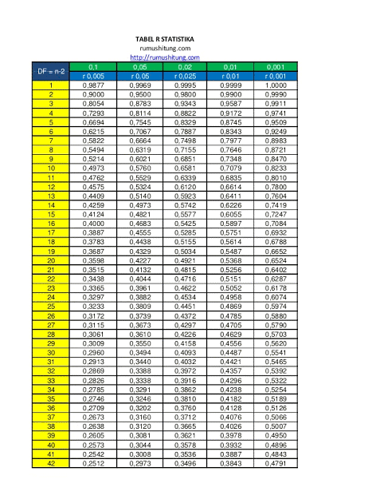

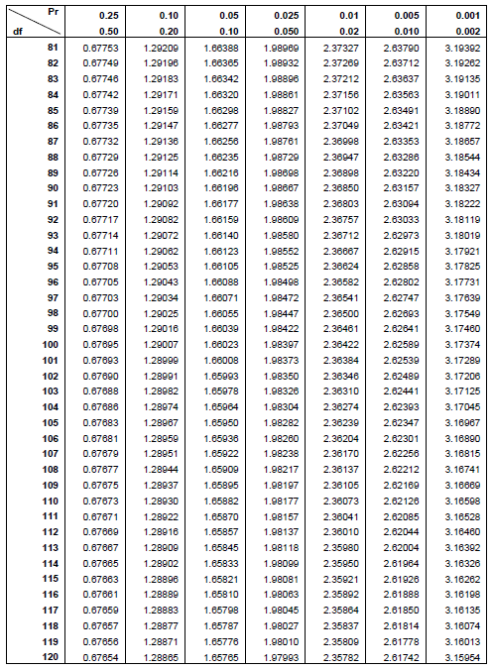**Tabel Nilai Kritis Distribusi T**

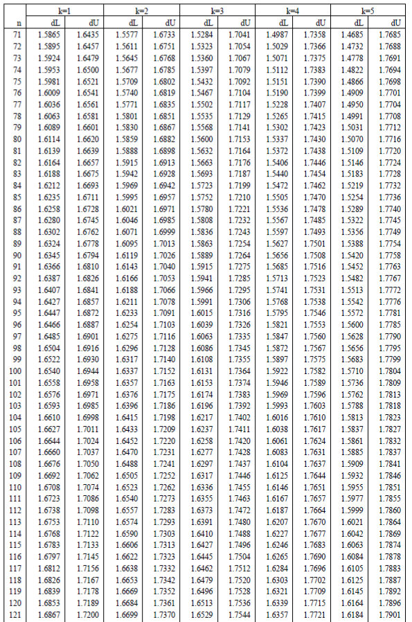**Tabel Durbin-Watson**